Module: Phonetics
Level: L1- FILA
Time Allotted: 90 min
Instructor: Dr Fatma KHERBACHE
E-mail: socioling70@gmail.com
Lecture 4: English Vowels

Introduction
We use three (3) principles (tongue-height/frontness vs. backness/ lip-position) to describe the English vowels. There is a large number of vowel sounds with different degrees of the length (short or long) described in relation to the cardinal vowels.
A-Short vowels: the symbols for these short vowels are: ɪ - e - æ - Ʌ - ɒ - ʊ - ə
1- ɪ as in fish, rich, dish, give.
The diagram below (figure 5) shows that this vowel is in the close front area. The lips are slightly spread.
2- e as in yes, men, rest, beg, tell, sell. This is a front vowel between half close and half open. The lips are slightly spread.
3- æ as in cat, fat, bat, hat. This vowel is front open. The lips are slightly spread. 4- Ʌ as in but, cut, dust, rush, some, sun, cup. This is a central vowel between half open and open. The lips are neutral.
5-ɒ as in not, hot, dog, rock, top, gone, cross, lot. The vowel is back between half open and open. The lips are slightly rounded.
6- ʊ as in put, push, should, could, book, look. It is near to the cardinal vowel [u] but it is more open . The lips are rounded.
7- ə as in oppose, perhaps, teacher, It is a central vowel with neutral lips. It is called schwa.

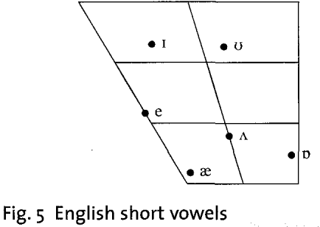

B- Long vowels: there are five (5) long vowels. They tend to be longer than the short vowels. The symbols for these long vowels are: i: - ɜ: - a: - ͻ: - u:
- i: as in see, free, peace, leave, speech. This vowel is near to the cardinal vowel [i]. It is close front. The lips are slightly spread.
- ɜ: as in first, third, girl, earth, learns. This is a central vowel with neutral lips.
- a: as in dark, arm, large, half, mark, car. This is an open back vowel near to the cardinal vowel [a]. The lip-position is neutral.
- ͻ: as in daughter, more, short, for. This is a back vowel between half close and half open. The lips are rounded
- u: as in food, tool, soon, wood, rule, blue, choose. This vowel is back close with rounded lips. It is near to the cardinal vowel [u].
The long vowels are different from the short vowels not only in length but also in quality (tongue shape and position and lip position). If we compare short ɪ with long i: or short ʊ with long u: or short æ with long a:, we can see differences in tongue shape and position and lip-position, as well as in length.

C- Diphthongs

R.P English has a large number of diphthongs. They are sounds which consist of a movement or a glide from one vowel to another vowel. They are like the long vowels in terms of length. The most important thing to remember about the diphthongs is that the first part is much longer and stronger than the second part. The total number of diphthongs is eight (8) as shown below:
Diphthongs
3 centring 5 closing

ending in ə ending in ɪ ending in ʊ

ɪə eə ʊə eɪ aɪ ͻɪ əʊ aʊ
Figure 7. Diphthongs

Centring diphthongs
The centring diphthongs glide towards the schwa vowel as it is indicated in the diagram below.
ɪə near, here, fear
eə fair, air, where, there
ʊə tour, moor

Closing diphthongs
The closing diphthongs have the characteristic that they all end with a glide towards a close vowel:
*Three of the diphthongs glide towards short ɪ as described below:
eɪ stay, play, main, face
aɪ glide, ice, time, nice, five
ͻɪ oil, boy, voice, join, coin
*Two diphthongs glide towards ʊ
əʊ show, go, most, window - bet
aʊ out, now, house

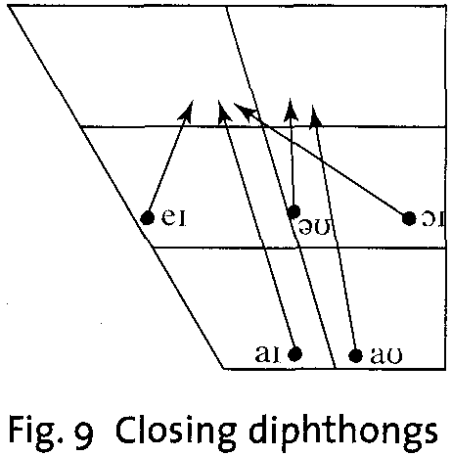

D- Triphthongs
They are the most complex English sounds of the vowel type, because they are difficult to pronounce and recognize. A triphthong is a glide from one vowel to another and then to a third, all produced rapidly and without interruption. The triphthongs are composed of five closing diphthongs plus (+) schwa added to the end. Thus, we got: eɪə - aɪə - ͻɪə - əʊə - aʊə.
eɪə player- layer
aɪə liar-fire- empire
ͻɪə loyal - royal
əʊə lower - mower
aʊə power - hour – flower

