Ministry of Higher Education and Scientific Research University of Tlemcen- Faculty of Nature and Life Sciences of the Earth and Universe Sciences  Department of Earth and Universe Sciences. | English for students (M2) of Geology
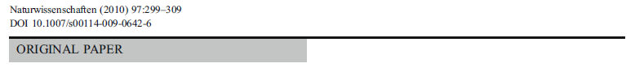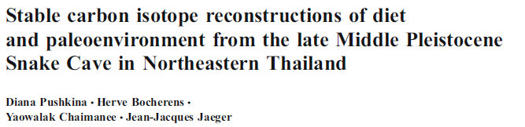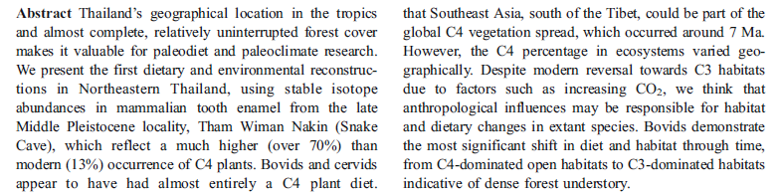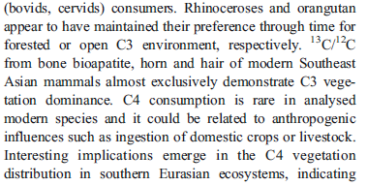

Questions :

Give five (5) keywords for the abstract :
………………………………………………………………………………………………………………

In which journal was this article published?
………………………………………………………………………………………………………………

Establish the bibliographic reference of this article
………………………………………………………………………………………………………………
………………………………………………………………………………………………………………

