Chapter 1: Recognizing Claims and Reasons

Dr. Fayza BOUZAKI

Table of contents

- Chapter 1: Recognizing Claims and Reasons

  - Text 1: Addicted to Tech?

Task Type 1: Identifying the Writer's Views and Claims
This activity focuses on identifying if there is a claim about the statement in the text and whether the statements report the writer's claims or views as expressed in the text or not.
    - Introduction
Definition
The identifying the writer's views and claims task tests your ability to identify the views and claims of the writer in a text. It's often used to test the student's understanding of a passage in which the writer is presenting an argument or where different ideas about a certain topic are compared or analysed.
Fundamental
There are a set of statements that report information and ideas from the text. The students' job is to read the passage and decide if the statements are reporting the information and ideas correctly or not.
Method
For each statement, there are three possible answers:
- YES: if the statement agrees with the views of the writer.
- NO: if the statement contradicts the views of the writer.
- NOT GIVEN: if it is impossible to say what the writer thinks about this.
    - The Basic Rules for the Identifying the Writer's Views and Claims Task
Fundamental
- The statements follow the order of information in the text.
- The wording of the statements is not exactly the same as the wording in the text, but they contain the same information and ideas.
- The statements include some words and names that are also used in the text. These help to locate the relevant information and ideas.
    - Tips and Tactics for the Task
Advice
- Before you read the passage, read the statements and think about what you are going to read.
- Do not use your own opinions or knowledge of the topic to decide the answer.
- Re-read both the statement and the section of the text and think about the meaning of both (same ideas, contradiction, missing ideas).
    - Quiz
Is this the task where the answers are all facts and figures?
Do the statements come in the same order as the information in the passage?
Do the statements include words from the passage?
    - Practice
      - Pre-reading Text
Have a look at the pictures below and guess what is the text about?







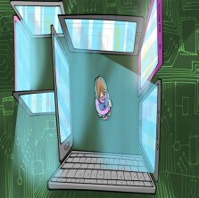

Decide if the expressions in bold suggest the writer is in favour of or against an argument:
- Digital Vertigo is equally unconvincing.
- Rosen fails to convince their incidence is on the rise.
- Over-reliance on technology can cause problems, but I struggled to find a causal link
- Keen's argument left me unconvinced.
- I am entirely sympathetic with.

Against | Against | Against | In favour of | Against
      - While-reading Text
Read the text and answer the questions

Text_Addicted_to_Tech.docx

      - Post-reading Text
Debate
Working in pairs, perform a debate about the impact of technology use.

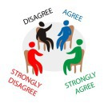

    - Self-evaluation
Which statement best describes how you feel about identifying the writer's views and claims task ?
- I feel confident about doing Yes/No/Not Given task
- I did OK, but I still need to do more work on Yes/No/Not Given tasks
- I need more practice with Yes/No/Not Given tasks. I need to focus on ...

  - Text 2: The Meaning of dreams

Task type 2: Matching Sentence Endings
The focus in this activity is to identify the suitable sentece ending for each sentence beginning to report the writer's views and claims made in the text.
    - Introduction
Definition
This task tests your ability to identify the views of the writer and the claims made in a text. It is often used to test your understanding of a passage in which the writer is presenting an argument or where different ideas about a subject are compared and analysed.

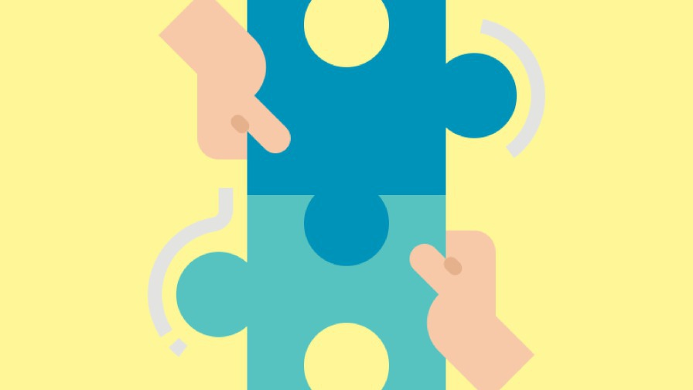

Method
There is a set of sentences and there are also different sentence endings. Your job is to read the text and decide which of the options completes each of the numbered sentences. The complete sentence must report the ideas and information from the passage exactly
    - The Basic Rules for the Matching Sentence Endings Task
- The numbered sentence beginnings follow the order of information in the passage.
- The options are in random order. There are more options than you need to answer all the questions.
- The wording of the sentence beginnings and options is not exactly the same as the wording in the passage, but they contain information and ideas from the text.
- The sentence beginnings include some words and names that are used in the text. These help you to find the relevant section.
- Read this section carefully and then decide which of the sentence endings exactly reports the writer's views and claims.
- All the options create grammatically correct sentences, but only one of the endings creates a sentence that reports the exact meaning.
    - Skills-building exercises
While matching sentence endings, you are mostly reading
 | for facts and figures
 | for ideas and opinions
The numbered sentence beginnings are in
random order
same order
Fill-in the gaps with the suitable word:
In matching sentence endings activity, there are options than the number of questions. The sentence beginnings include the same words that you find in the passage. of the options will create gramatically incorrect sentences.
    - Practice
      - Pre-reading Text
Schema Activation
- How do we call what comes to our minds while sleeping?
- Do you believe that dreams try to tell us something?
- Do you look for the interpretation of your dream when you get up?
Warming-up :
Click here to see video
      - While-reading Text
Read the text and answer the questions

The Meaning of Dreams.docx

      - Post-reading Text
KWL Strategy
What I know | What I want to know | What I learnt
Story-telling
Tell your classmates the story of a dream that you had already and its interpretation.

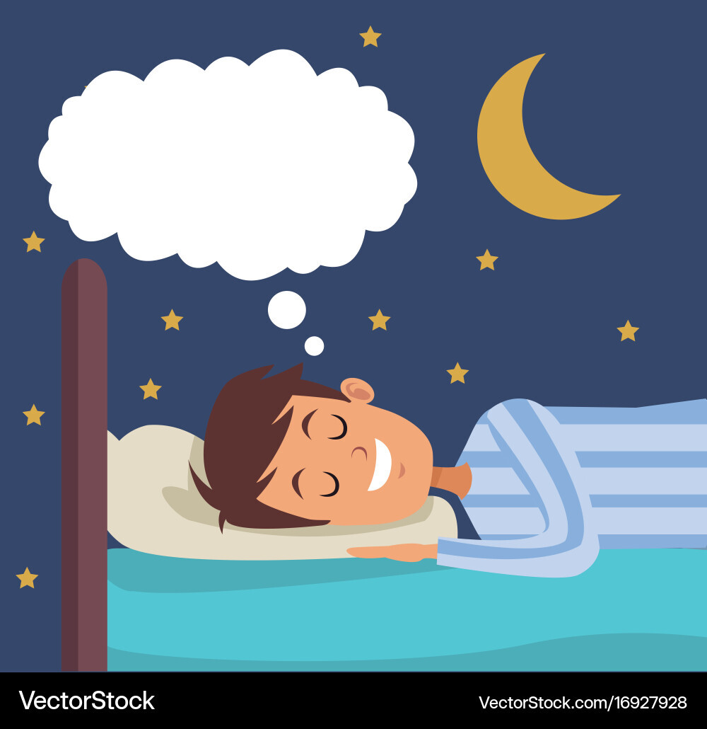

    - Self-evaluation
Which statement best describes how you feel about matching sentence endings task ?
- I feel confident about doing Yes/No/Not Given task
- I did OK, but I still need to do more work on Yes/No/Not Given tasks
- I need more practice with Yes/No/Not Given tasks. I need to focus on ...

https://www.youtube.com/watch?v=lIaZ5y2ovsw&pp=ygUPd2h5IGRvIHdlIGRyZWFt

