31-07-2025

Dr. Fayza BOUZAKI

Chapter 2: Analysing Arguments

Table of contents
I. Chapter 2: Analysing Arguments 3
1. Text 1: The Amazing Brains of Babies 3
1.1. Introduction 3
1.2. The Basic Rules for the Summary Completion Task 3
1.3. Tips and Tactics for the Summary Completion Task 3
1.4. Quiz 4
1.5. Practice 4
1.6. Self-evaluation 6
2. Text 2: Sugar and Society 6
2.1. Introduction 6
2.2. The Basic Rules for the Multiple Choice Task 6
2.3. Quiz 7
2.4. Practice 7
2.5. Self-evaluation 7

- Chapter 2: Analysing Arguments

  - Text 1: The Amazing Brains of Babies

Task type 3: Summary Completion
The focus while working on this task is to identify what information is missing.
    - Introduction
Definition
The summary completion task tests the students' ability to locate ideas in a reading text and use them to complete a summary of that text. It is often used to test the students' understanding of a passage where different ideas about a subject are presented.
Fundamental
The summary usually includes the main points of information from one section in the passage.
Advice
Your job is to read both the passage and the summary and choose which words from a list complete the gaps in the summary.
    - The Basic Rules for the Summary Completion Task
- The summary reports the main ideas from the relevant section of the passage, but the information may not be presented in the same order.
- The missing words are listed, you choose one word to complete each gap in the summary.
- The wording of the summary is not exactly the same as the passage, but it contains the same information and ideas.
- When you read the passage, you sometimes see the words from the box, but sometimes the words are different becuase the summary is reporting the main ideas using different language.
    - Tips and Tactics for the Summary Completion Task

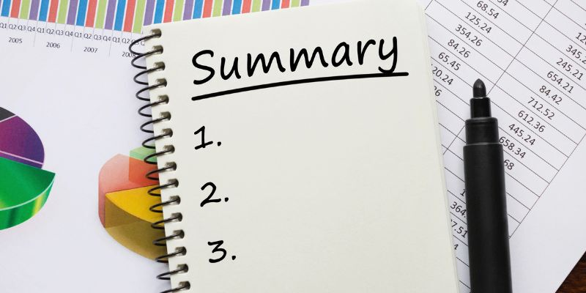

- Before you look at the passage, read the summary and underline the main words and ideas.
- Think about the type of information that is missing in each gap.
- Go through the summary gap by gap and read the relevant sections of the passage.
- A number of words will fit each gap logically and grammatically. You have to choose the one that reports the meaning exactly.
- Remember that sometimes you may need to choose a word that has a different form to the way it is used in the passage to complete the summary.
    - Quiz
Read the summary and think about the type of information that is needed to complete each gap:
a. a number
b. a place name
c. a specific term
d. a plural noun
Around 50000 years ago, Australia was inhabited by as many as different giant animal species, which included both mammals and . For many years, scientists have linked their extinction to the arrival of humans on the continent , who may have started and also hunted the animals for food. But recent research suggests that climate change is a more likely explanation.
Evidence suggests that Australia's climate gradually changed into the type known as , and a process of followed as a result.
Does the summary always relate to the whole text?
Are the questions (gaps) in the same order as the information in the passage?
    - Practice
      - Pre-reading Text
Text surveying
Read the title of the text "The Amazing Brains of Babies" and see the structure of the text.
      - While-reading Text
Read the text entitled 'The Amazing Brains of Babies' and answer the questions:

The amazing brains of babies.docx

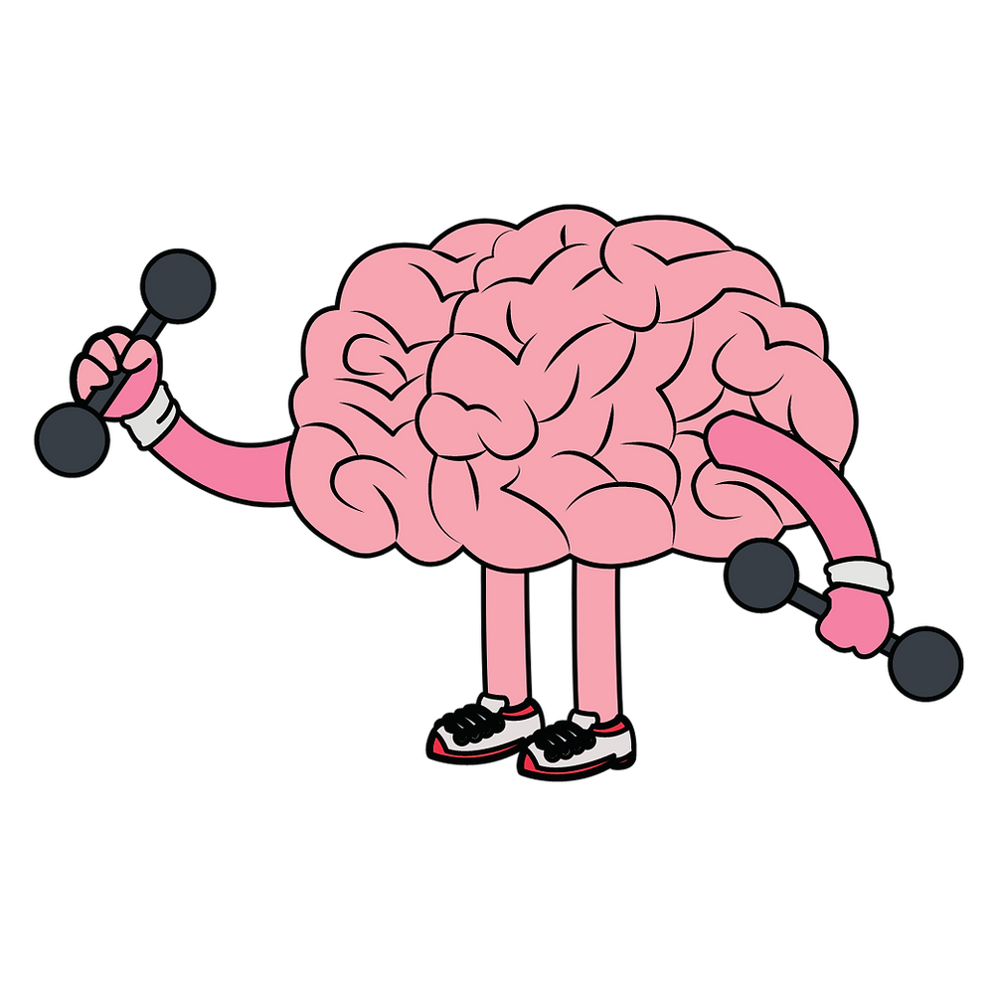

      - Post-reading Text
Chain game
Working in groups, you are required to present a summary of the text in the form of a chain game .
Example
Student 1 provides the first piece of information.
Student 2 repeats that information differently and adds another piece of information.
Student 3 repeats what was given by 1 and 2 differently and adds a third piece of information.
The process continues until the last student repeats all the pieces of information and adds another one.
Then, the process goes back (the last student recalls another piece of information and they do the same until student 1 who provided only one piece of information at the beginning retells all the pieces of information provided by his/ her classmates).
    - Self-evaluation
Which statement best describes how you feel about summary completion task ?
- I feel confident about doing Yes/No/Not Given task
- I did OK, but I still need to do more work on Yes/No/Not Given tasks
- I need more practice with Yes/No/Not Given tasks. I need to focus on ...

  - Text 2: Sugar and Society

Task Type 4: Multiple Choice Questions
Students have to locate the focus of each question and identify the writer's views and claims.
    - Introduction
Definition
The multiple choice task tests the students' ability to read a text carefully and understand detailed information and arguments. It is often used to test their understanding of a text in which the writer is presenting an argument or where different ideas are compared and analysed.
Method
You have a set of question stems with four possible answers. Your job is to read the passage and decide which of the four options correctly answers the question.

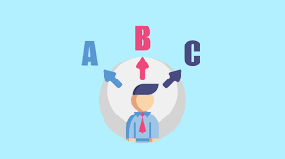

Extra
There are two types of question:
- A question which has four different answers (A, B, C, D)
- An incomplete sentence that has four possible endings (A, B, C, D)
    - The Basic Rules for the Multiple Choice Task
Fundamental
- The questions follow the order of information in the text.
- The wording of the options is not exactly the same as the wording in the passage.
- When you read the question stems, you see some words and names that are also used in the passage. These help you to find the relevant information.
- You read the section carefully and compare the information and ides with the four options.
- You have to decide which option correctly answers the question or completes the sentence.
    - Quiz
The question stems always end in a question mark.
The question stems probably include words from the passage
    - Practice
      - Pre-reading Text
Prediction
Read the title and the first sentence of each paragraph and try to guess what is the text about?
      - While-reading Text
Read the text and answer the questions

Sugar and society RC.docx

      - Post-reading Text
T.V report
Individually or in pairs, pretend to be TV reporters and sum up the highlights of the text entitled 'Sugar and Society".



    - Self-evaluation
Which statement best describes how you feel about multiple choice task ?
- I feel confident about doing Yes/No/Not Given task
- I did OK, but I still need to do more work on Yes/No/Not Given tasks
- I need more practice with Yes/No/Not Given tasks. I need to focus on ...

