


Reading
GROUND WATER

Origin of ground water
Much of the rain that falls on land seeps into soil and bedrock to become ground water. More than 90 percent of the liquid fresh water available on or near the earth's surface is groundwater. Hot groundwater can also be a source of energy.
Groundwater is derived from rain and melting snow that percolate downward from the surface. The process of percolation is called infiltration. Most ground water moves slowly, about 4 centimeters per day.

Characteristics of ground water
In the upper few kilometers of the Earth, bedrock and soil contain small cracks and voids that are filled with air or ground water. The proportional volume of these open spaces is called the porosity of rock or soil. The porosity of sand and gravel is typically high, 40 percent or higher.
Porosity indicates the amount of water that rock or soil can hold. In contrast, permeability is the ability of rock or soil to transmit water (or any other fluid).
Ground water saturates the upper few kilometers of soil and bedrock to a level called the water table. The rock and soil in which

all the open spaces are filled with water is called the saturated (or saturation) zone. The water table is the top of the zone of saturation (Fig. 12–1).
Above the water table lies the unsaturated zone, or zone of aeration (Fig. 2–1). In this layer, the rock or soil may be moist but not saturated. An aquifer is a body of rock that can provide economically significant quantities of water. An aquifer is both porous and permeable.
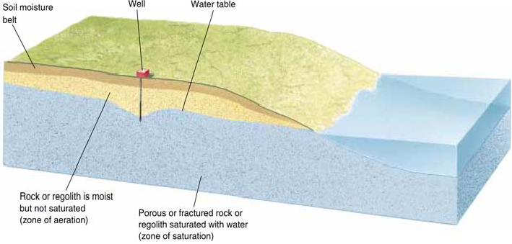
If you dig into the unsaturated zone, the hole does not fill with water. However, if you dig below the water table into the zone of saturation, you have dug a well, and the water level in a well is at the level of the water table (Fig. 12–1).
Figure 2-1. The water table is the top of the zone of saturation near the Earth’s surface. It intersects the land surface at lakes and streams and is the level of standing water in a well.

If water is withdrawn from a well faster than it can be replaced by the aquifer, a cone of depression forms. If rapid withdrawal continues, the water table falls.
Other effects of excessive removal of ground water include
subsidence of the land and salt-water intrusion near a seacoast.
- Subsidence: Excessive removal of ground water can cause subsidence, the sinking or settling of the Earth’s surface.
- Salt-water intrusion: Two types of ground water are found in coastal areas: fresh water and salty water that seeps in from the sea.

Fresh water floats on top of salty water because it is less dense. If too much fresh water is pumped to the surface, the salty water rises into the aquifer and contaminates wells.

Effects of groundwater flow
The dissolution of calcite from limestone by slightly acidic groundwater results in the gradual widening of joints that may develop into openings, or caves. Most caves develop below the water table.
The groundwater that percolates through the cracks in the cave contains calcium and bicarbonate from the dissolution of limestone.
As the water drops from the cave's ceiling, CO₂ gas is released and a small amount of calcite crystallizes where the drop is attached to the ceiling. More CO₂ is lost from the water when the drop hits the floor, causing more calcite to precipitate. By this process, stalactites and stalagmites form. Stalactites hang from cave ceilings; stalagmites are cone-shaped masses that build up on cave floors. A column results when stalactites and stalagmites grow long enough to join into one structure.
A sinkhole forms when the roof of a limestone cavern collapses (Fig. 2-2). Karst topography, with numerous caves, sinkholes, and underground streams, is characteristic of limestone regions.
Hot springs develop when hot ground water rises to the surface. Ground water can be heated by: (1) the geothermal gradient, (2) shallow magma or a cooling pluton, and (3) chemical reactions between ground water and sulfide minerals.
A geyser is a more explosive hot spring that periodically erupts extremely hot water and steam. Fumaroles are vents from which steam and other gases escape.
Hot ground water can be used to drive turbines and generate electricity, or it can be used directly to heat homes and other buildings. Energy extracted from the Earth’s heat is called geothermal energy.

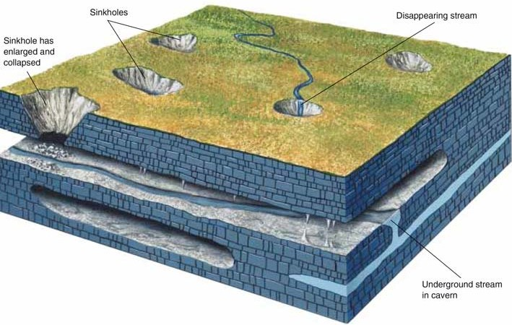
Figure 2-2. Sinkholes and caverns form in limestone. Streams commonly disappear into sinkholes and flow through the caverns to emerge elsewhere.

