Introduction
Fluid kinematics is a branch of fluid mechanics dedicated to the geometric description of fluid motion. It focuses on the trajectories of fluid particles, their velocity, and acceleration, without considering the causes of this motion. In other words, it describes how a fluid moves, but not why.
If a liquid flows in contact with the atmosphere, it is said to have a free surface flow. If the flow occurs in a closed pipe, occupying the entire cross-section of the pipe, generally at atmospheric pressure, it is said to be a pressurized flow. If the liquid flows through a porous medium, it is called a porous medium flow or a filtration flow.
There are two primary methods for studying fluid motion:
- Lagrangian method: In this approach, each fluid particle is studied individually. The coordinates x, y, z of a particle at time t, relative to a Cartesian coordinate system OX, OY, OZ, are called Lagrangian variables.
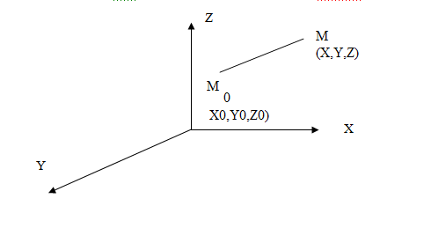
Particle Trajectory: The trajectory of an individual particle is defined as the geometric locus of the successive positions occupied by the particle over time.
Therefore, the motion of a particle is known if we can express its coordinates (x,y,z) as functions of time and its initial coordinates.
X :x (x₀, y₀ z₀, t )
Lagrangian variables
Y : y (x₀, y₀ z₀, t)
Z : z (x₀, y₀ z₀, t)
"Velocity vector V with components (u, v, w)"
Dx_{i}= u_{i} dt ou u_{i} = dx_{i}/dt

Note:
This method is only used when the starting point of the particle matters. For turbulent flows, it's impossible to calculate the exact path of a particle.
Eulerian Description
In the Eulerian framework, we examine the spatial and temporal variations of the velocity field. The velocity of the fluid at a fixed point in space is considered as a function of time. The Cartesian components u, v, w of the velocity vector v of the fluid particle passing through point M with coordinates (x, y, z) at time t
V
U (x,y,z,t)
V(x,y,z,t)
ω (x,y,z,t)

Flow line: A flow line is a curve that is tangent to the velocity vector at every point along the line
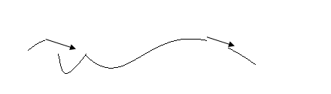
The vector equation can be expressed as dxi/ dui = constant, where xi and ui are the components of the position and velocity vectors, respectively.
Streamtube:
The ensemble of streamlines resting on a closed contour forms a streamtube. The volume of fluid located inside the streamtube is called a filament of fluid.
The differential equation of the streamline
The velocity is tangent to the streamline provided that the vector product:
= V Dl sin (V dL) = 0
V ∧ dL =0
V : Velocity vector
dL: dL: displacement vector

d L : vecteur déplacement
dx
dy
dz

V
dL
U
V
ω

(V, dL) = 0 V ∧ dL = V dL sin (V, dL) = 0

i j k
u v ω
dx dy dz
V ∧ dL
= i( v dz – ω dy)- j (u dz- dx ω) + k (udy-dxv) =0

So : v dz – ω dy =0 v/dy = ω /dz
u dz- dx ω =0 u/dx = ω /dz
udy-dxv = 0 u/dx = v/dy

So v/dy= u/dx = ω /dz
v/dy= u/dx = ω /dz
Differential equation

2.2.1 Concept of Flow Rate
Flow rate is a physical quantity that characterizes the volume or mass of a fluid passing through a given cross-sectional area per unit of time.
- Volumetric flow rate Q: This is the volume of fluid passing through a given cross-sectional area per unit of time. It is expressed in m³/s.
- Mass flow rate ṁ: This is the mass of fluid passing through a given cross-sectional area per unit of time. It is expressed in kg/s.
Relationship between volumetric flow rate and mass flow rate: ṁ = ρQ where:
- ρ is the density of the fluid.
- Continuity equation
- This equation expresses the fundamental principle of mass conservation. Consider a continuous liquid medium. Let dx, dy, dz be the sides of an elementary liquid parallelepiped. Let v(u,v,w) be the velocity of an infinitesimally small volume dw that enters through ABCD and exits through A'B'C'D'.
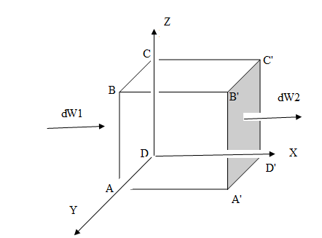
Dw1 = u dt dy dz dm1 = ρ u dt dy dz
The mass exiting through A'B'C'D', dm₂, is equal to ρw₂, where dm₂ dm2 = dm1+ ∂ dm₁. dx
∂x
dm_{x} = dm2-dm1 = (ρ u+ (∂ρudx)) dydzdt - ρudydzdt
∂x
dmx= ∂ρu dx dydzdt
∂x
Similarly, for the y and z directions:
In the y-direction: dmy = (∂ρv/∂y)dx dydzdt
In the z-direction: dmz = (∂ρw/∂z)dx dydzdt
The total mass increment, dm, is the sum of dmx, dmy, and dmz:
dm = dmx + dmy + dmz = [(∂ρu/∂x) + (∂ρv/∂y) + (∂ρw/∂z)] dx dy dz dt
dm = [∂ρu + ∂ρ v + ∂ρ ω ] dx .dy .dz .dt
∂x ∂y ∂z

Lost mass
Dm= ∂ρu + ∂ρ v + ∂ρ ω ] dx .dy .dz .dt = ∂ ρ dt. Dx.dy.dz
∂x ∂y ∂z ∂t

Dm= [∂ρu + ∂ρ v + ∂ρ ω ] = -∂ ρ
∂x ∂y ∂z ∂t
∂ρu + ∂ρ v + ∂ρ ω + ∂ ρ =0
∂x ∂y ∂z ∂t

∂ρu + ∂ρ v + ∂ρ ω = ρ div V
∂x ∂y ∂z
So : div(ρ V)+ ∂ρ =0
∂t
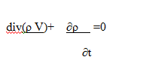

Types of Flows:
Fluid mechanics classifies flows based on various characteristics, allowing for a better understanding and modeling of physical phenomena. Here is a summary of the main types of flow:
Steady flow: The flow characteristics (velocity, pressure, and density) do not vary with time at a given point. The velocity at point m, V(m) = V(x,y,z)
U, u (x,y,z)
V,v(x,y,z)
ω : ω(x,y,z)
∂ρ = 0, ∂V = 0
∂t ∂t

Unsteady flow:
Flow characteristics evolve over time. ∂ρ/∂t ≠ 0, ∂V/∂t ≠ 0

Uniform flow:
A flow is said to be uniform if the velocity, cross-sectional area, and depth do not vary along the flow direction. ∂v/∂L = 0, ∂ρ/∂L = 0, ∂s/∂L = 0

Rotational flow:
A rotational flow is a type of flow where fluid particles not only move along rectilinear or curvilinear paths but also rotate about their own axis. Imagine a whirlpool in water: the water particles spin around themselves while moving.

Characteristics of Rotational Flow
Non-zero vorticity: Mathematically, a flow is rotational if the curl of the velocity vector is non-zero:
rot(v) ≠ 0 where v is the velocity vector.
Curved and closed streamlines: Streamlines in a rotational flow are often curved and may close on themselves, forming vortices.
Presence of vortices: Vortices are a typical characteristic of rotational flows. They correspond to regions where the fluid rotates intensely about its own axis.
rot(v) = ∇ × v
In Cartesian coordinates, this is written as:
rot(v) =
| i j k |
| ∂/∂x ∂/∂y ∂/∂z | ≠ 0
| u v ω |

Irrotational or Potential Flow
An irrotational flow is a type of flow where fluid particles do not undergo net rotation about their own axis. In other words, the curl of the velocity field is zero: rot(v) = 0 where:
- v is the velocity vector of the fluid.

