Chapter III: Dynamics of Perfect Incompressible Fluids (Lecture: 3 hours, Tutorial: 3 hours)
3.1. Euler's Equation and Bernoulli's Theorem
3.2. Applications of Bernoulli's Theorem: * Venturi tube * Tank draining * Pitot tube
3.3. Momentum Theorem in Steady Flow * Jet reaction * Impinging jet

Introduction This chapter is dedicated to the study of fluids in motion. Fluid dynamics is based on three fundamental principles:
- Conservation of mass, also known as the continuity principle
- Conservation of energy, also known as Bernoulli's theorem
- Conservation of momentum, also known as Euler's equation
3.1. Euler's Equation and Bernoulli's Theorem Continuity equation
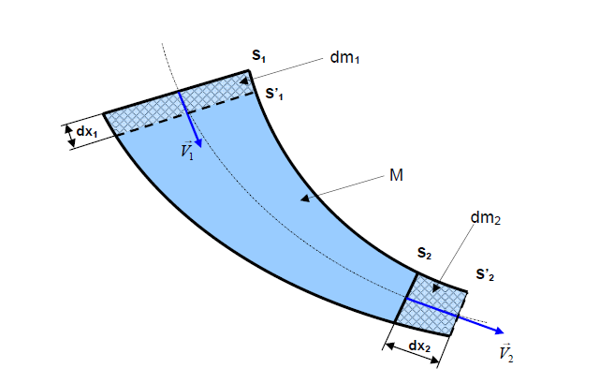
We denote by:
- S1 and S2, respectively, the inlet and outlet cross-sectional areas of the fluid at time t,
- S'1 and S'2, respectively, the inlet and outlet cross-sectional areas of the fluid at time t'=(t+dt),
- V1 and V2, respectively, the velocity vectors of the flow through sections S1 and S2 of the streamtube.
- dx1 and dx2, respectively, the displacements of sections S1 and S2 during the time interval dt,
- dm1: the elementary mass entering between sections S1 and S'1,
- dm2: the elementary mass exiting between sections S2 and S'2,
- M: the mass contained between S1 and S2,
- dV1: the elementary volume entering between sections S1 and S'1,
- dV2: the elementary volume exiting between sections S2 and S'2.
At time t: the fluid contained between S1 and S2 has a mass equal to (dm1+ M). At time t+dt: the fluid contained between S'1 and S'2 has a mass equal to (M+ dm2).
By conservation of mass: dm1+ M = M + dm2. Simplifying by M, we obtain: dm1= dm2. Therefore, ρ1 .dV1 = ρ2 .dV2 or ρ1 .S1.dx1 = ρ2 .S2.dx2.
Dividing by dt, we obtain:
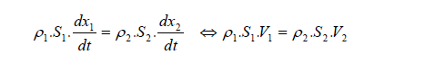
Since the fluid is incompressible: ρ = ρ1 = ρ2. We can simplify and obtain the following continuity equation:
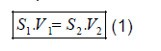
Euler's Equation This theorem allows us to determine the forces exerted by the moving fluid on the surrounding objects. Statement: The resultant of the external mechanical actions (∑ Fext) on an isolated fluid, a continuous fluid in an envelope bounded by S1, S2, is equal to the rate of change of momentum of the fluid entering through s1 with velocity v1 and exiting through s2 with velocity V2. ∑ Fex = d/dt ∫m (v2-v1)
Bernoulli's Theorem
Consider a streamtube of an incompressible fluid with a mass density ρ undergoing a steady flow. The flow is in a perfectly smooth conduit. We consider a vertical Z-axis directed upwards. 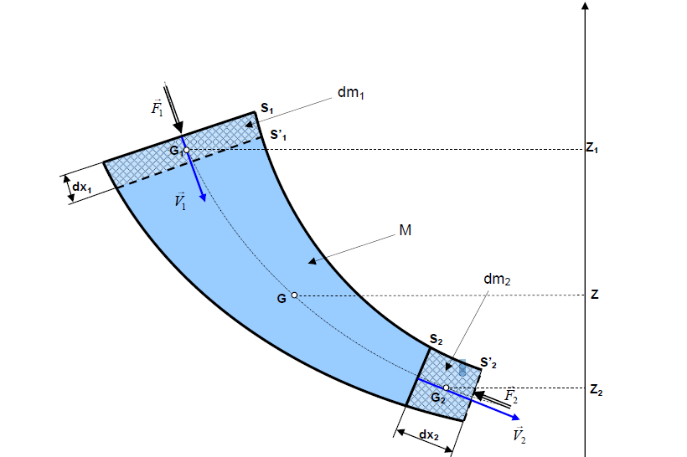
We denote by Z1, Z2, and Z respectively the altitudes of the centers of gravity of the masses dm1, dm2, and M. We denote by F1 and F2 respectively the magnitudes of the pressure forces of the fluid acting on sections S1 and S2.
At time t, the fluid of mass (dm1 + M) is contained between S1 and S2. Its mechanical energy is:
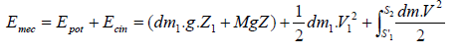
At time t’=(t+dt), the fluid of mass (M+dm2) is contained between S’1 and S’2. Its mechanical energy is:
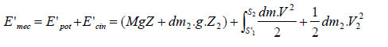
Applying the theorem of mechanical energy to the fluid between t and t’: “The variation of mechanical energy is equal to the sum of the work done by external forces.”
Simplifying, we obtain:
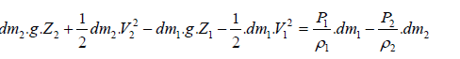
By conservation of mass: dm1 = dm2 = dm and since the fluid is incompressible: ρ1 = ρ2 = ρ, we arrive at Bernoulli's equation.
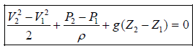
From equation (4), we can write:
P1 +v₁² +z1 = P₂ + v₂² +z2= constant
ρg 2g ρg 2g
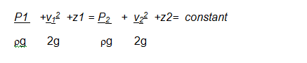
3.2. Applications of Bernoulli's Theorem: * Venturi tube
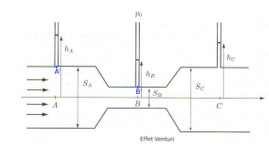
p_{A}/ρg+ V_{A}²/2g +ZA= p_{B}/ρg+ V_{B}²/2g +ZB
Calculating the velocity:
We have the continuity equation VA.SA = VB.SB
V_{A} = V_{B}.S_{B} /S_{A}
We have Bernoulli's equation between A and B
PA/ρg + VA 2 /2g + ZA = PB/ρg + VB 2 /2g + ZB
Since the Venturi tube is horizontal, ZA = ZB
P_{A}/ρg + V_{A} ² /2g = P_{B}/ρg + V_{B} ² /2g
P_{A}/ρg + (V_{B}.S_{B} /S_{A}) ² /2g = P_{B}/ρg + V_{B} ² /2g
P_{A}/ρg - P_{B}/ρg = + V_{B} ² /2g -(V_{B}.S_{B} /S_{A}) ² /2g
P_{A}/ρg - P_{B}/ρg = V_{B} ² /2g (1 -(S_{B} /S_{A}) ²
HA-HB= V_{B} ² /2g (1 -(S_{B} /S_{A}) ²
VB = √( HA-HB).2g
(1 -(S_{B} /S_{A}) ²
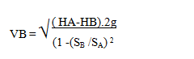

Draining a reservoir
Consider a large-section reservoir filled with a liquid that flows through an orifice with a small cross-sectional area compared to that of the reservoir, located at a height H below the free surface. Atmospheric pressure is exerted on both the free surface and the jet at the outlet.
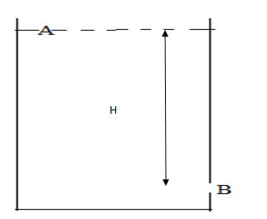
PA/ρg + VA 2 /2g + ZA = PB/ρg + VB 2 /2g + ZB
PA= PB =0, VA=0 alors on aura
ZA = VB 2 /2g + ZB
ZA- ZB = V_{B} 2 /2g , ZA- ZB = H
V_{B} = √2gh
Torricelli's formula
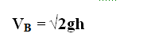
Pitot tube
A Pitot tube is an instrument used to measure the velocity of a moving fluid, such as air in a duct or wind. Its operation is based on the principle of Bernoulli's theorem.
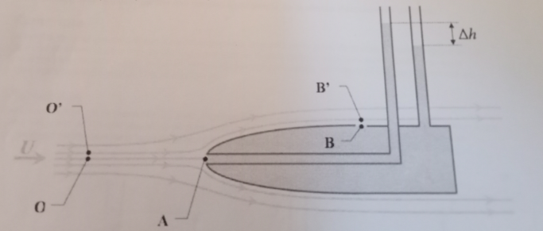
P_{o} /ρg+ Z_{o} + V_{o}²/2g = PA /ρg+ Z_{A} + V_{A}²/2g Z _{o =} Z_{A,} V_{o = U ,} V_{A=0}

PA /ρg = P_{o} /ρg+ U²/2g
P_{o’} /ρg+ Z_{o’} + V_{o’}²/2g = PB’ /ρg+ Z_{B’} + V_{B’}²/2g Z _{o =} Z_{B’,} V_{o = U ,} V_{A=0}
Po = po’
Vo= Vo’= U
V_{B = U}
PB= PB’ PB= Po
On a
PA /ρg = P_{o} /ρg+ U²/2g PA /ρg = P_{B} /ρg+ U²/2g
PA /ρg - P_{B} /ρg = U/2g

PA-PB= ρg ∆H U =√2g∆H
PA - P_{B} = U²/2g . ρg

