
ABOUBEKR BELKAID UNIVERSITY
Full Name
…………….…………………………………………….………………………….
FACULTY OF TECHNOLOGY
DEPARTMENT OF HYDRAULIC

First exam of Matter “Introduction of Hydraulic Computational”
Exercise N°1
To analyse the simple distribution network shown below by Epanet, what the input data to be entered for the Network Objects mentioned in the figure below? (Use words, not symbols or abbreviations)
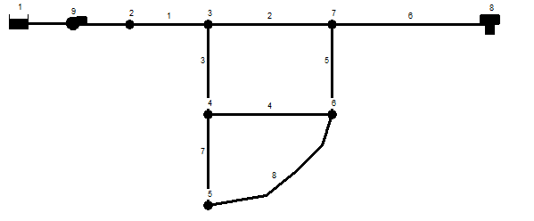
1 :…………………………………………………………………..……..……….
2 :……………………………………………………………………..………………
1 :…………………………………………………………………..……..……….
2 :……………………………………………………………………..………………
3 :………………………………………………………………..……………………
1 :…………………………………………………………………..……..……….
2 :……………………………………………………………………..………………
3 :………………………………………………………………..…………………….
4 :………………………………………………………………………………………

Exercise N° 2
To analyse the drainage network shown below by SWMM, what the input data to be entered for the Network Objects mentioned in the figure below? (Use words, not symbols or abbreviations)
1 :…………………………………………………………………..……..……….
2 :……………………………………………………………………..………………
3 :………………………………………………………………..…………………….
4 :………………………………………………………………………………………

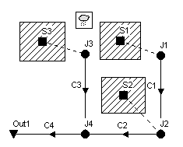
1 :…………………………………………………………………..……..……….
2 :……………………………………………………………………..………………
3 :………………………………………………………………..…………………….
4 :………………………………………………………………………………………

1 :…………………………………………………………………..…….
2 :……………………………………………………………………..

QCM questions (Cross out one box)
- Surface drainage systems are usually used :
In flat land and nearly steep land
In land with high rainfall intensity
- The soil has become waterlogged if
The water table reaches the root zone
The pools may form on the soil surface
- The dimensions of the open drains can be determined by using:
Bernoulli equation
Manning equation
- Hooghoudt used the equivalent depth ‘de’ to transform
The horizontal and radial flow into an equivalent horizontal flow
The radial flow into an equivalent horizontal flow
- The collectors used in subsurface drainage have a constant diameter
True
False
- The celerity equation of the negative wave moved downstream is:
$C_{t}\left(h\right)=U_{1}-3\sqrt{gh}+2\sqrt{gh_{1}}$
$C_{t}\left(h\right)=U_{1}+3\sqrt{gh}-2\sqrt{gh_{1}}$
- The combined sewer system is the system in which:
The sewers carry both sanitary and storm water
One pipe carries storm water and second pipe carries sanitary water
- Pipes in parallel have:
Same head losses
Same flow discharge
- Branched Networks is
Commonly used in rural water supply
Commonly used in urban water supply
- A small dam stores 9 m of water in the reservoir created by it. If a wide section of the dam collapse instantaneously, using the ideal dam break solution:
- The velocity at the axis of the dam is
7.26 m/s 5.26 m/s 6. 26 m/s
- The depth of flow at the axis of the dam is
4.12 m 4 m 5.13 m

- The equation of surface profile 2 second after the dam break is
$x\left(h\right)=-37,58+18,79\sqrt{h}$ $x\left(h\right)=-37,58+19,79\sqrt{h}$ $x\left(h\right)=37,58-18,79\sqrt{h}$
- By using the equation of surface profile, fills the below table
x (m) |  |  | 0
h (m) | 0 | 3 |  | 6 | 9

