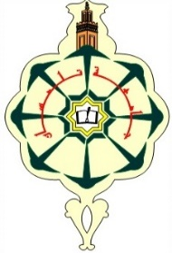 | UNIVERSITY ABOUBAKR BELKAID OF TLEMCEN  FACULTY OF TECHNOLOGY  DEPARTMENT Génie Civil
WEEKLY MAKE-UP EXAM SCHEDULE
ACADEMIC YEAR 2025_2026

Branch: Génie civil | Speciality: COMM | Level : L2 | Group: G11 | Semester: S1
 | DIMANCHE  31/05/2026 | LUNDI  01/06/2026 | MARDI  02/06/2026 | MERCREDI  03/06/2026 | JEUDI  04/06/2026
09h00-11h00 | Ondes et vibrations  A101 | Mathém 3  A101 | Méc rationnelle  A101
11h30-13h30 | Méc des fluides  A101 | Angl techni 1  A101
14h00-16h00 | Technol de base  A101 | Metrologie  A101
15h30-17h00

Date : 20-05-2026

