Civilisation of the Tartget Language

Lesson Plan:
Civilisation of the Tartget Language

Dr. Seyf Eddine GUETTAIA
Tlemcen University
Faculty of Foreign Languages
Department of English
June 2026

Civilisation of the Tartgeted Language

Table of Contents

- Course Information..............................................................................................1
- Course Presentation............................................................................................2
- Content...............................................................................................................3
- Prequisites...........................................................................................................5
- Learning Objectives............................................................................................6
- Assessements Methods......................................................................................7
- Teaching Learning Activities..........................................................................7
- Course Modalities.........................................................................................9
XI. Support Ressources.........................................................................................10
- Course Information

Faculty: Foreign Languages
Department: English
Level: 2nd Year LMD students
Course Title: Civilisation of the Tartgeted Language
Credit: 02
Coefficient: 02
Timing: Sunday 10h- 11h30
Room: 31
Teacher: Dr. Seyf Eddine GUETTAIA
Contact:
Email: sifoguettaya@gmail.com
Availability:
Office Hours: Monday and Wednesday from 11h30 to 12h30
By Email: Responses will be provided within 24 hours of receiving the message barring unforseen circumstances.

Civilisation of the Targeted Language

Concept Map

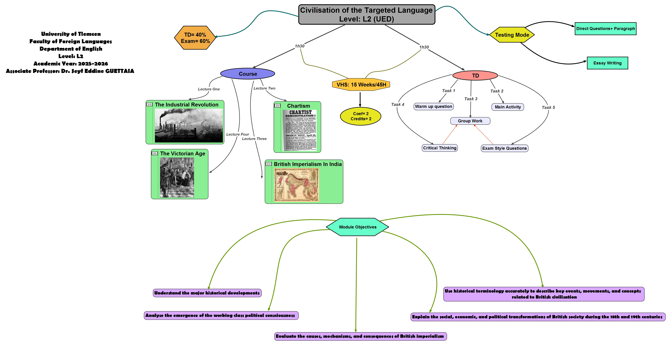

- Course Presentation

This course is designed for second year license students in the English section program to develop a strong knowledge in civilisation, culture and history. The first unit focuses over The nineteenth century, particularly during the reign of Queen Victoria, was a period of profound transformation for Great Britain, known as the Victorian Age. This era was marked by rapid industrial, scientific, and cultural progress, largely driven by the Industrial Revolution, which led to the expansion of factories, urbanization, and technological innovation. Britain became the world’s leading power, supported by population growth and economic prosperity, and showcased its achievements through events such as the Great Exhibition of 1851. However, this progress also brought serious social problems, including poverty, overcrowding, and child labor, revealing deep inequalities within society.
The second unit sheds the light on Britain expanded its influence abroad, particularly in India, where the British East India Company gradually established control after key events like the Battle of Plassey. India became a crucial source of raw materials and a market for British goods, creating economic dependency. Resistance to British rule, especially the Sepoy Mutiny, highlighted tensions between the colonizers and the colonized. Although British rule introduced infrastructure and modernization, it also led to exploitation and loss of independence. Thus, the Victorian Age can be understood as a period of both progress and contradiction, where Britain’s rise to power was closely linked to its imperial domination.

- Content

* The Victorian Age: Progress and Transformation
The Victorian Age refers to the reign of Queen Victoria from 1837 to 1901. It was a period characterized by rapid changes in almost every aspect of life, including industry, science, population, and culture. At the beginning of this era, Britain was filled with optimism and confidence, largely due to its economic growth and global influence. One of the most important features of this period was the expansion of the Industrial Revolution. Industrialization led to the development of factories, the growth of cities, and the rise of new social classes, particularly the middle class. Technological innovations, such as the telephone invented by Alexander Graham Bell, and advances in medicine, including anesthesia and antiseptics, significantly improved living conditions. Cultural life also flourished during the Victorian Age. The organization of the Great Exhibition of 1851 demonstrated Britain’s technological superiority and celebrated its achievements. Literature became a powerful tool for reflecting social realities, as writers such as Charles Dickens exposed the harsh conditions faced by the poor and criticisez social injusice. However, despite these advancements, the Victorian Age also had a darker side. Industrialization created significant social problems, including poverty, overcrowded cities, and child labor. Many workers lived in poor conditions, and the gap between the rich and the poor widened. Therefore, although the period is often described as a “Golden Age,” it was also marked by deep social inequalities.

* British Imperialism in India: Expansion and Control
While Britain was developing internally, it was also expanding its power abroad. One of the most important regions under British control was India, often referred to as the “jewel in the crown” of the British Empire. British involvement in India began with trade through the British East India Company, but it gradually evolved into political domination. A key turning point in British expansion was the Battle of Plassey, which marked the beginning of British political control. Over time, the company extended its authority across large parts of India, taking advantage of internal political divisions and the decline of the Mughal Empire.
The primary motivation behind British imperialism in India was economic. The Industrial Revolution created a high demand for raw materials such as cotton, tea, and indigo, as well as new markets for British manufactured goods. As a result, India was transformed into a supplier of raw materials and a consumer of British products. This economic system weakened local industries and made India dependent on Britain.
* Resistance and the Impact of Colonial Rule
British rule in India was not accepted without resistance. One of the most significant uprisings was the Sepoy Mutiny. This rebellion was caused by political, economic, and cultural tensions between the British and the Indian population. Although the revolt was eventually suppressed, it had important consequences. It led to the end of the East India Company’s rule and the establishment of direct control by the British government, known as the British Raj. The impact of British imperialism in India was complex and contradictory. On the one hand, the British introduced modern infrastructure, including railways, telegraph systems, and educational institutions, which contributed to modernization. On the other hand, colonial rule led to economic exploitation, social inequality, and the loss of political independence for Indians.
- Prequisites
Before studying the Victorian Age and British Imperialism in India, students are expected to possess a solid foundation of historical and literary knowledge that will help them better understand the complexity of the two lectures.
In addition to this, they will have to have:
- General historical background of Great Britain in the 18th–19th centuries
- Awareness of the historical context of India
- Ability to analyze cause-and-effect relationships
Moreover, From a literary perspective, students should be familiar with major literary movements such as Romanticism and Realism. Understanding these movements will allow them to better situate Victorian literature as a transitional phase that combines emotional expression with social criticism. Basic knowledge of key writers such as Charles Dickens will also be helpful in analyzing how literature reflects the social realities of the Victorian period.
- Learning Objectives
This lesson examines the Victorian Age and British Imperialism in India, two closely connected aspects of 19th-century history. During the reign of Queen Victoria, Great Britain experienced major industrial and economic growth, which contributed to its global power. At the same time, this expansion was closely linked to its control over India, making it essential to understand the relationship between progress and empire.
By the end of the course, students will be able to:
- Define the Victorian Age and identify its main characteristics.
· - Describe the impact of the Industrial Revolution on British society.
· - Explain the concept of imperialism and its main features.
· - Identify key events such as the Battle of Plassey and the Sepoy Mutiny.

- Assessement Method:
The learning assessement for this course consists of two complementary components.
- Continuous Assessement Through TD (40%)
*Formative Assessment:
Students are assessed during the lesson through participation in discussions, answering questions, and engagement in activities. This helps monitor their understanding of key concepts such as the Industrial Revolution and imperialism.
*Question and Answer (Oral Assessment):
The teacher asks questions throughout the lesson to check comprehension, for example about events like the Sepoy Mutiny or the characteristics of the Victorian Age.
*Short Written Tasks:
Students may write short paragraphs or summaries explaining the relationship between Great Britain and India, or discussing whether the Victorian Age was truly a “Golden Age.”
- Final Exam (60%)
students will complete a written essay in which they demonstrate their understanding of the Victorian Age and British Imperialism in India. The essay will require students to develop a structured argument, using relevant historical knowledge and examples.

- Teaching Learning Activities

1. Warm-up / Introduction Activities
- The teacher starts by asking guiding questions such as: “What makes a country powerful?” or “What do you know about Britain in the 19th century?”
- Students brainstorm ideas and share prior knowledge.
- The teacher introduces key concepts: Victorian Age, industrialization, and imperialism.

2. Presentation Activities (Teacher-led)
- The teacher presents the main characteristics of the Victorian Age, including industrial, social, and cultural changes.
- Visual aids (maps, timelines, images of factories or the Great Exhibition of 1851) are used to support understanding.
- The teacher explains British expansion in India and key historical events such as the Sepoy Mutiny.

3. Reading and Text Analysis
- Students read short extracts about Victorian society or British rule in India.
- They identify key ideas such as industrial progress, exploitation, or resistance.
- The teacher guides students in interpreting historical meaning from texts.

4. Group Work Activities
- Students are divided into groups to discuss topics such as:
  - Positive vs negative aspects of the Victorian Age
  - Causes of British imperialism
  - Effects of colonial rule on India
Each group presents its conclusions to the class.

- Course Modalities
The course is delivered in a hybrid format combining both face-to-face classroom instruction and online learning activities. This allows flexibility while maintaining direct teacher–student interaction.
· In-Person Sessions:
Classroom sessions are dedicated to explaining key concepts such as the Victorian Age, the Industrial Revolution, and British Imperialism in India. These sessions focus on teacher explanations, guided discussions, and group activities.
· Online Learning Platform:
Supplementary materials (PDF documents, lecture notes, readings, and videos) are shared through an online platform or classroom system (e.g., Google Classroom or Moodle). Students are expected to review these resources before or after class.
· Synchronous Online Activities:
Some sessions or parts of sessions may be conducted live online using video conferencing tools. These are used for discussions, Q&A, and review sessions.
· Asynchronous Activities:
Students complete independent tasks such as reading comprehension, short written assignments, and preparation for discussions at their own pace.
· Interactive Learning Tools:
Digital resources such as presentations, videos of historical events (e.g., the Great Exhibition of 1851), and quizzes are used to reinforce understanding.
· Student Autonomy:
Students are encouraged to take responsibility for their learning by reviewing materials regularly, participating in online discussions, and preparing questions for class.

XI. Support Resources
To assist students during the course, several resources are available in the example of:
· Course handouts and lecture notes:
Printed and digital summaries prepared by the teacher covering the Victorian Age and British Imperialism in India, including key definitions, dates, and explanations.
· Textbook references:
Chapters dealing with the Industrial Revolution, the Victorian Age, and colonial expansion in India.
· Historical documents and extracts:
Primary and secondary sources such as speeches, political writings, and excerpts from Victorian literature (e.g., Charles Dickens).
· Visual materials:
Maps of the British Empire, images of factories, cities, and the Great Exhibition of 1851 to support understanding of industrial and cultural development.
· Multimedia resources:
Educational videos and documentaries explaining Victorian society, industrialization, and British rule in India.
· Online learning platforms:
Use of platforms such as Google Classroom or Moodle to share documents, assignments, quizzes, and additional readings.
· Timelines and charts:
Chronological representations of key events such as the Battle of Plassey and the Sepoy Mutiny.
· Maps and geographical tools:
Historical maps showing the expansion of the British Empire and trade routes between Britain and India.
· Student notes and summaries:
Personal notebooks where students organize and synthesize information from lectures and readings.

