Lecture III
Numbers in English
- Introduction (purpose 3) Numbers are a very important part of language. Not only do they allow us to express quantities(how much we want to buy, how much some owes us, our age,etc.) but they’re also very useful for periods of time. For instance, how would you refer to the year 1945? Try the link below for more infos about the use of numbers; https://live-english.net/use-english-numbers/
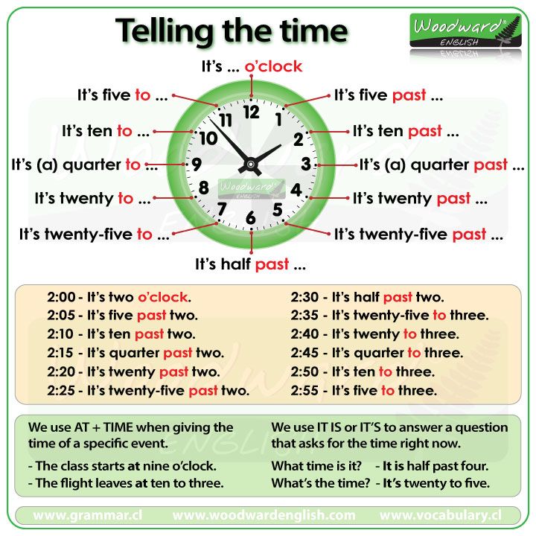
Pic 01
Numbers are also common in popular cultures, sciences and religions all over the world. For example, in most Arab Cultures, the number five is associated with a counter charm to an evil eye; for five is with them an unlucky number and it means their five fingers in your eyes (khamsa fi einek); as a proverb for cursing or defiance.
- Task 3: read the following text carefully and answer the questions below;
‘3’ is a special number. It is common in popular culture, science and religion. Some people say that in our minds we break concepts into three parts to understand them. People say that luck, especially bad luck, comes in groups of three. There are famous threes everywhere. A hat trick is three goals scored by the same player in the same game. Athos, Porthos and Aramis are the heroes of The Three Muskateers, while Melchior, Balthazar and Gaspar are the three Magi (also called the Three Wise Men). A trio is a group of three people or things that do things together, while triplets are three babies born at the same time from the same mother. Some people talk about the ‘three Rs’ in education: Reading, Writing and Arithmetic. We are supposed to eat breakfast, lunch and dinner, three meals a day. Many books or films come in trilogies, which is a series of three. Finally, we live on the third planet from the sun .

Questions:
• What is a hat trick?
• What is an example of a ‘three’ from literature?
• What is the difference between a trio and triplets?
• What are the ‘three Rs’?
• Can you think of any other famous threes?

