Teacher’s Name: Prof Faiza SENOUCI
Level: L1
Module: Phonetics
Course number: 02
Course title: Nasal consonants.

The definition of Nasals:
A nasal sound is a sound produced with a lowered velum which allows the passage of the air through the nasal cavity, at the same time the air is obstructed at some point in the oral cavity by the lips or the tongue so that the air is completely expelled through the nose.
There are three nasal consonants in English which are /m/, /n/, and /ŋ/ and all of them are voiced. In other words, they are produced with a narrow glottis and a vibration of the vocal cords.
- Description of /m/ sound:
/m/ is a bilabial consonant, articulated with the lips pressed against each other. This prevents the air to go through the mouth and it is released through the nose. /m/ is also a lenis voiced sound produced with a narrow glottis.

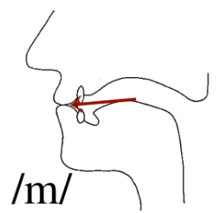
The bilabial lenis voiced nasal /m/

- Description of /n/ sound:
/n/ is an alveolar sound produced with the tongue raised against the alveolar ridge. This prevents the air to go through the mouth and it is released through the nose. /n/ is also a lenis voiced sound produced with a narrow glottis.
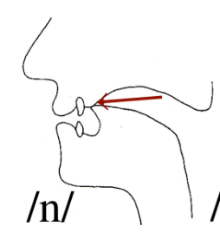
The Alveolar Lenis Voiced Nasal /n/

- Description of / ŋ / sound:
/ŋ/ is a velar sound articulated with the back of the tongue raised against the soft palate (velum). This prevents the air to go through the mouth and it is released through the nose. /ŋ/ is also a lenis voiced sound produced with a narrow glottis.
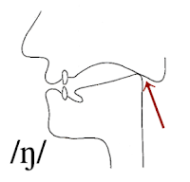

The Velar Lenis Voiced Nasal / ŋ/

Compare the words of column A with those of column B
Column A | Column B
-Finger /fɪŋɡə/  -Anger/ æŋɡə/ | -Singer / sɪŋə/  -Hanger /hæŋə/

What is noticeable is that in the words of column A the /ŋ/ sound is followed by /ɡ/ in the phonemic/phonetic transcription while the words of column B have no /ɡ/ following /ŋ/. The important difference is, in fact, related to the nature of those words and the way they are constructed (i.e., their morphology). The words of column B may be divided into two grammatical units: sing+ er and hang+ er. These units are called morphemes (a morpheme is the smallest meaningful unit in language), and we can say that words in column B are morphologically different from the words of column A which consist of one single morpheme and hence cannot be divided into units.
The rule:
The rule states that when we have words containing the combination of “n+g” in the spelling like finger and hanger, /ŋ/ occurs without a following /ɡ/ if it occurs at the end of the morpheme. Nonetheless, if it occurs in the middle of the morpheme it has a following /ɡ/. Thus, the word singer is transcribed as/ sɪŋə/ and not as / sɪŋɡə/* because the combination of “n+g” is at the end of the first morpheme. On the other hand, finger is transcribed as /fɪ ŋɡə/ and not as /fɪ ŋə/* because the combination of “n+g” is in the middle of the morpheme.

The exception(s):
There are some exceptions that contradict the rule and they are related to the comparative and superlative suffixes “er” and “est” respectively. According to the rule, the adjective “long” is transcribed as follows: long /lɒŋ/ which is correct. Similarly, if we add another morpheme like “ish” to the adjective long we would get the word “longish” which will be transcribed as /lɒŋɪʃ/ also according to the rule. Yet, “longer” (the comparative form) and “longest” (superlative form) are transcribed respectively as /lɒŋɡə/ and /lɒŋɡəst/ or /lɒŋɡɪst/ with /ɡ/ after /ŋ/ which is opposite to the rule as it is an exception to the rule.
Exercises:
- What are the characteristics of nasal sounds?
- Give the phonetic symbol of the underlined letters:
Mom- Win- Bringing- name- wings- strong- wringer- hungry.
- Write the words which correspond to these phonetic symbols:
/ˈneɪm/- /’æŋgl/- /’ʌŋkl- /ˈsentəns/- /ˈhəʊm/- /ˈlʌntʃ|- /ˈʃuːtɪŋ/
- Say the following sentences out loud to practice the English nasal sounds. The M sounds are green. The N sounds are red, and the /ŋ/ (ng) sounds are blue.
-My name is Mary.
-This pen is not mine.
-Bring me something from the supermarket.
-My mom is cooking.
-Sing me a song!
-Learning English is fun

