States of Matter

What is matter? – Everything on this earth that has mass and occupy space
(volume) such as: air, water, plants, soil, forest, rays etc.
• State of matter: Matter exist in three states: gas, liquid, and solid
• What is chemistry?
Chemistry is the study of matter in regards to its:
• Composition (what it is made of)
• Structure (shape or form)
• Properties (descriptive behavior)
• Reactions (how it responds to different conditions)
It is involved in everything we do in our daily activities (eating, washing clothes, etc)

Text. States of Matter
Read the text carefully then find meanings to the words written in bold.
There are four main states of matter: solids, liquids, gases and plasmas. Each of these states is also known as a phase. Elements and compounds can move from one phase to another phase when special physical forces are present. One example of those forces is temperature. The phase or state of matter can change when the temperature changes. Generally, as the temperature rises, matter moves to a more active state.
Phase describes a physical state of matter. The key word to notice is physical. Things only move from one phase to another by physical means. If energy is added (like increasing the temperature or increasing pressure) or if energy is taken away (like freezing something or decreasing pressure) you have created a physical change.
One compound or element can move from phase to phase, but still be the same substance. You can see water vapor over a boiling pot of water. That vapor (or gas) can condense and become a drop of water. If you put that drop in the freezer, it would become a solid. No matter what phase it was in, it was always water. It always had the same chemical properties. On the other hand, a chemical change would change the way the water acted, eventually making it not water, but something completely new.

- What is a ‘phase transition’? Insert the following terms into the phase transition scheme. Then find their scientific definitions.
melting condensation deposition vaporization
ionization deionization freezing sublimation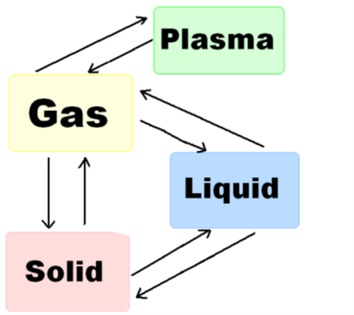
2. Choose the corrects answer
1. What is the term used to describe the phase change as a liquid becomes a solid?
evaporation condensation freezing
2. What term is used to describe the phase change of a solid to a liquid?
Freezing melting boiling
3. What is the term used to describe the phase change of a liquid to a gas?
boiling condensation melting
4. Of gases, liquids, and solids, what is the densest state of matter?
solids liquids gases plasmas
3. Find the synonyms of the following expressions in the article.
phase of matter rise of temperature drop of temperature
4. What is the meaning of the following words? Which changes of state do they correspond with?
melting point boiling point freezing point
5. What is the difference between:
melting point – melting pot boiling point – boiling pot
6. What is the difference between chemical and physical forces?

