Lecture II
My precious, favorite…place/Object
- Task 2: Prepare a short text of about 100 words, describing your favorite place or object and explain why this latter has a sentimental value for you (why it is worthwhile and precious to you?). You might include a digital photo (this is just optional), as you see down below.
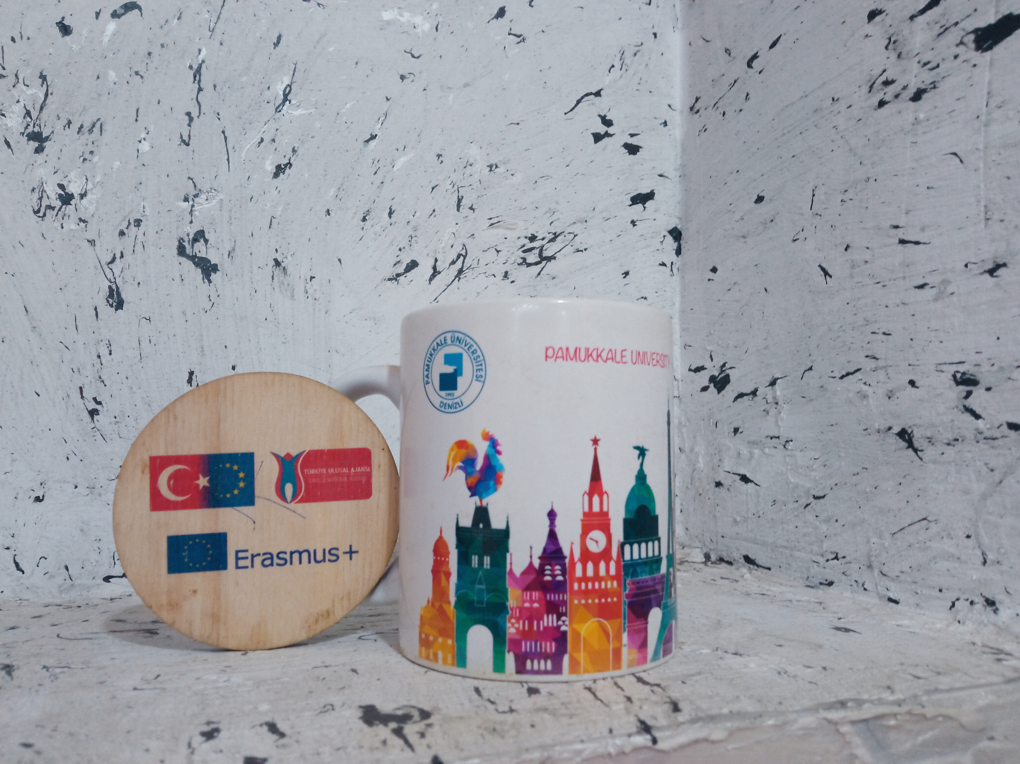
Pic 01
In the year 2021, I had the chance to be an exchange student for Erasmus+ scholarship in Turkey, I received this cup at the end of my mobility as a present/gift from my coordinator Mrs. Ayşe Tuncer at Pamukkale University, Turkey. I will never be able to express to anyone how much this cup means/ worth to me, with the wooden slogan of Erasmus+ on the left side of the picture. It made me feel so proud of myself and grateful for the European Union for providing me with such an opportunity to exchange my knowledge with other people from a different cultural background. Moreover, I was the only Algerian representative there; of both my beloved country Algeria and my home university (UABT). All in all, this latter will always bring me a lot of wonderful, marvellous, and extraordinary memories that I will never be able to forget.

- .
- Purpose 2: Integrating the use of photos of favorite places or objects into an online course help students or learners in general to be encouraged to contribute or speak about their own experiences in a given country they have already visited or been through. In adittion to that, students will be able to express their own ideas in English using the past tenses; check the picture down below.
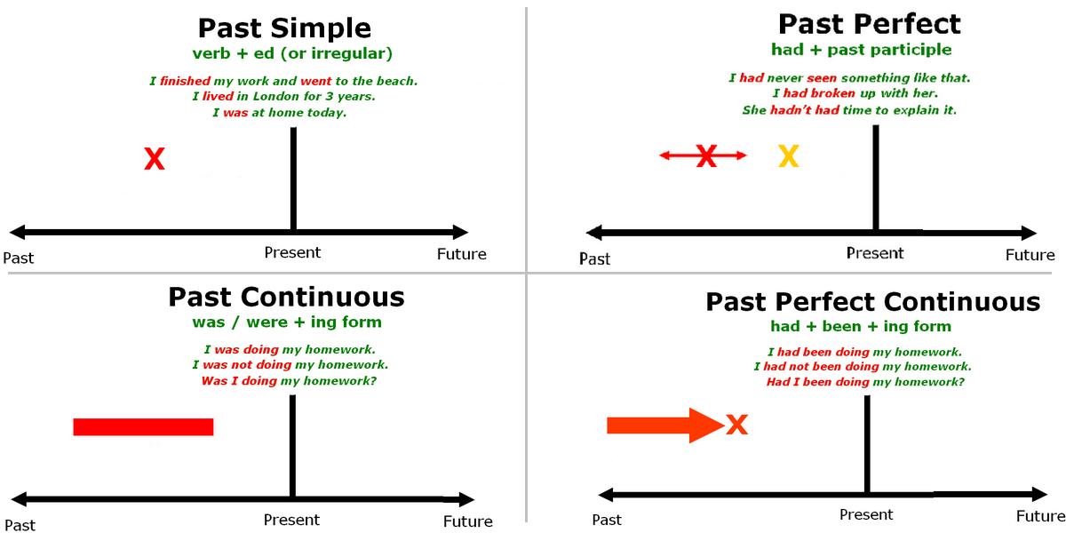
Pic 02

