TENSES IN ENGLISH:

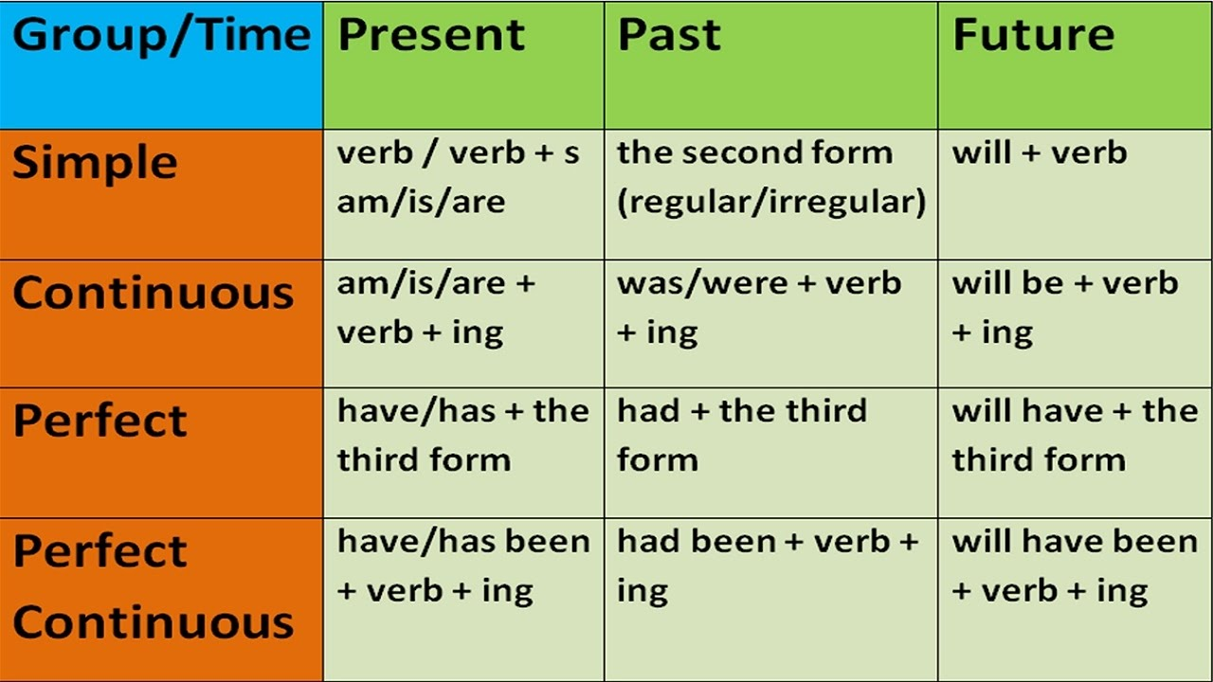
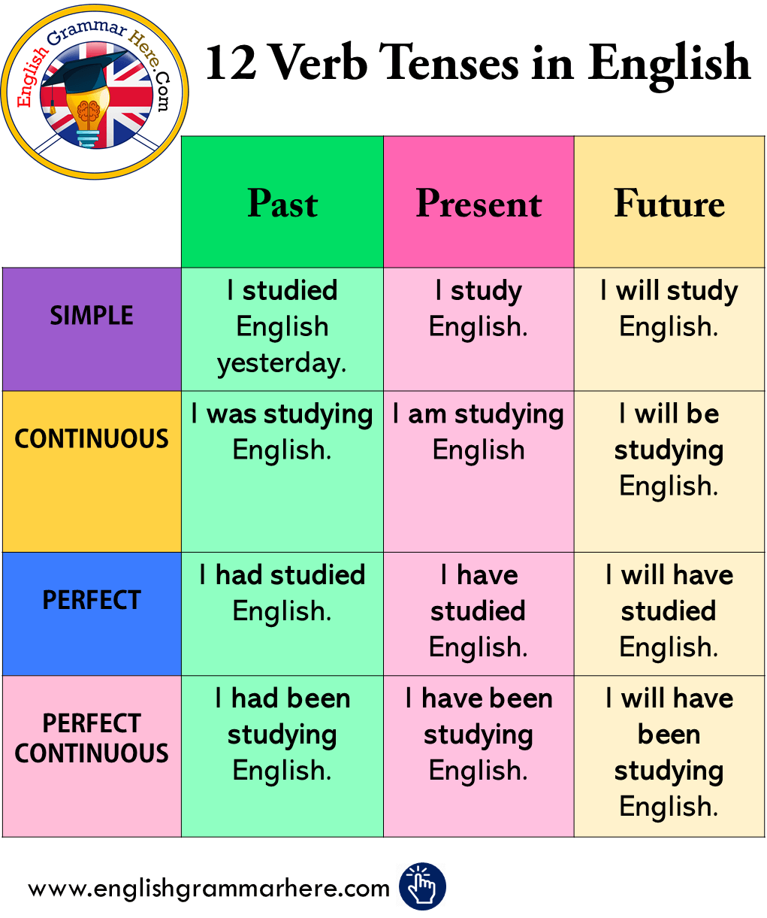
The following table illustrates the proper use of verb tenses:
Simple Present | Simple Past | Simple Future
I read nearly every day. | Last night, I read an entire novel. | I will read as much as I can this year.
Present Continuous | Past Continuous | Future Continuous
I am reading Shakespeare at the moment. | I was reading Edgar Allan Poe last night. | I will be reading Nathaniel Hawthorne soon.
Present Perfect | Past Perfect | Future Perfect
I have read so many books I can’t keep count. | I had read at least 100 books by the time I was twelve. | I will have read at least 500 books by the end of the year.
Present Perfect Continuous | Past Perfect Continuous | Future Perfect Continuous
I have been reading since I was four years old. | I had been reading for at least a year before my sister learned to read. | I will have been reading for at least two hours before dinner tonight.
Exercice 1
Fill in the blanks

1. I ................................ there for two hours and then I went home.
Waited / have waited /had waited

2. She ..................................... six novels so far.
Wrote /has written /had written

3. He ....................................... from Las Vegas yesterday.
Returned /has returned /had returned

4. See that you .................................... no harm.
Cause /have caused /caused

5. The hostess made sure that the guests .................................... enough to eat and drink.
Had /have /had had

6. You will get the job if you ................................................ in the interview.
Succeed /succeeded /had succeeded

7. The doctor concluded that the man ...................................... several hours ago.
Died /has died /had died

8. We ............................................ to hear from him for more than two weeks now.
are waiting /have been waiting /waited

9. The show ....................................... by the time we reached the theatre.
Began /has begun /had begun

10. He ..................................... for work at 8.30.
Leaves /is leaving /will leave

11. Father .................................... the newspaper every morning.
Reads /is reading /has read

12. When I visited him he ........................................ bed-ridden for months.
Was /had been /has been
Exercices 2 : Fill in the blanks

1. We reached the venue before the show .............................
Began /begun /begins

2. Her parents .................................. with her.
Live /are living /have lived

3. We ........................................ in Tlemcen for fifteen years by next January.
will be living /will have been living /are living

4. We ..................................... two tickets before rain interrupted the match.
have lost /had lost /were losing

5. I ..................................... him twice before he went abroad.
Saw /had seen /have seen

6. When I was young, I .................................... exercise every day.
Used /used to /was used to

7. She ...................................... for the US tonight.
Leaves /is leaving /left

8. Water .................................... at 100 degree Celsius.
Boils /is boiling /has boiled

9. We ....................................... in this house for ten years now.
Lived /are living /have lived

10. I ........................................ her if I wanted to.
could marry /could have married /can marry

11. Does she ................................... what she is doing?
Know /knew /know

12. He .................................. to be a scientist.
always wanted /is always wanting /has always wanted
Exercise 3 Fill in the blanks with an appropriate tense form.

1. My father ............................... for a brisk walk every evening.
is going /goes /has gone

2. We ……………………………. for Singapore tomorrow.
Leave /are leaving /will leave

3. I ……………………….. all of my problems.
Solved /have solved /had solved

4. I ………………………. to post the letter yesterday.
have forgotten /forgot /had forgotten

5. He ………………………. his breakfast when I visited him.
Had /has /was having

6. I …………………….. him before.
never saw /have never seen /had never seen

7. I ………………………… the problem with the minister last week.
have discussed /discussed /had discussed

8. He said that he ……………………….. the next day.
will come /would come /come

9. The letter ……………………….. yesterday.
Posted /was posted /had posted

10. The teacher ……………………….. the boy for misbehaving in the class.
Reprimanded /reprimands /had reprimanded

11. If you like this book, you ………………………. take it.
Could /can /will

12. He ………………………… president.
Elected /has elected /was elected

