Module: Phonetics
Level: L1- FILA
Time Allotted: 90 min
Instructor: Dr Fatma KHERBACHE
E-mail: socioling@gmail.com
Lecture 2: Production of Speech Sounds (Articulatory Phonetics)

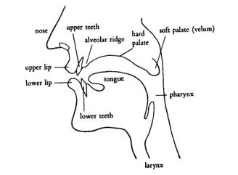
Figure 1 Speech Organs
Articulators above the larynx (see the diagram above)
The speech organs have other functions which are not connected with speech but they are biologically primary. The lungs are to supply Oxygen to the blood, the tongue and the teeth are for eating. However, speech sounds in all languages are produced as following: the air stream is expelled by the lungs, goes through the windpipe along the vocal tract which begins from the larynx to the lips (oral cavity) and nostrils (nasal cavity). Speech sounds are classified in terms of speech organs that produce them (the place of articulation) and the way in which they are produced (the manner of articulation).

Place: lips place: lips
Examples: /p/, /b/ /m/
Manner: plosive consonants manner: nasal consonant

- The pharynx: is a tube which begins just above the larynx. It is divided into two (2) parts at its top end: the back of mouth and the beginning of the way through the nasal cavity.
- The Soft palate (velum): the velum is seen in the diagram in a position that allows air to pass through the nose and the mouth , but it may be seen in three (3) positions:
*lowered: to allow the air pass through both nose and mouth.
*lowered with a complete closure of the oral cavity: so that the air passes only through the nasal cavity.
*raised: so that the air escapes only from the mouth.
3-The hard palate: it is often called the roof of the mouth.
4-The alveolar ridge: it is between the top front teeth and the hard palate.
5- The tongue: it can be moved into many different places and different shapes. It is usually divided into five (5) parts. The figure below shows these parts:

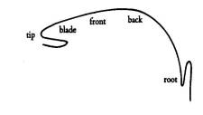
Figure 2. Subdivisions of the Tongue

6- Teeth: the diagram shows only the upper and lower front teeth. The tongue is in contact with the upper teeth for many speech sounds.
7- Lips: (upper and lower) are important in speech. They can be pressed together to get bilabial /p/, /b/, brought into contact with teeth to get labio-dental /f/, /v/, or rounded to produce vowels like [u:] or spread to produce [i:].
8- Nasal cavity: is used for nasal sounds like /m/, /n/ where the air goes into the nasal cavity when the velum is completely lowered.
9- Larynx: is situated at the end of the windpipe. It is a very complex articulator with the vocal cords inside.
10- Vocal cords: they are very important for making the difference between voiced and voiceless sounds: if they are kept close together and made to vibrate as the air passes through the glottis(space between the vocal cords), he sound produced is voiced. If the air passes through without vibration, the sound is voiceless. All English vowels are voiced; consonants may be voiced or voiceless. In whispered speech, voiced consonants and vowels are voiceless.

