Module: Phonetics

Level: L1- FILA

Time Allotted: 90 min

Instructor: Dr Fatma KHERBACHE

E-mail: socioling70@gmail.com

Lecture 4: English Vowels

**Introduction**

We use three (3) principles (tongue-height/frontness vs. backness/ lip-position) to describe the English vowels. There is a large number of vowel sounds with different degrees of the length (short or long) described in relation to the cardinal vowels.

**A-Short vowels:** the symbols for these short vowels are: **ɪ - e - æ - Ʌ - ɒ - ʊ - ə**

**1- ɪ** as in fish, rich, dish, give.

The diagram below (figure 5) shows that this vowel is in the *close front* area. The lips are *slightly spread*.

**2- e** as in yes, men, rest, beg, tell, sell. This is a *front* vowel between *half close and half open*. The lips are *slightly spread.*

**3-** **æ** as in cat, fat, bat, hat. This vowel is *front open*. The lips are *slightly spread*. **4**- **Ʌ** as in but, cut, dust, rush, some, sun, cup. This is a *central* vowel between *half open and open*. The lips are *neutral.*

**5-ɒ** as in not, hot, dog, rock, top, gone, cross, lot. The vowel is *back* between *half open and open*. The lips are *slightly rounded.*

**6- ʊ** as in put, push, should, could, book, look. It is near to the cardinal vowel [u] but it is more *open* . The lips are *rounded*.

**7- ə** as in **o**ppose, p**er**haps, teach**er**, It is a *central* vowel with *neutral* lips. It is called schwa.

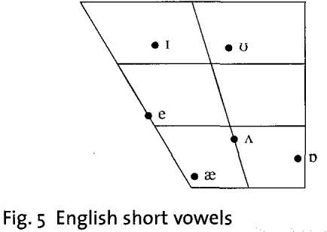

**B- Long vowels:** there arefive (5) long vowels. They tend to be longer than the short vowels. The symbols for these long vowels are: **i: - ɜ: - a: - ͻ: - u:**

1. **i:** as in see, free, peace, leave, speech. This vowel is near to the cardinal vowel [i]. It is *close front*. The lips are *slightly spread.*
2. **ɜ:** as in first, third, girl, earth, learns. This is a *central* vowel with *neutral* lips.
3. **a:** as in dark, arm, large, half, mark, car. This is an *open back* vowel near to the cardinal vowel [a]. The lip-position is *neutral.*
4. ͻ: as in daughter, more, short, for. This is a *back* vowel between *half close and half open*. The lips are rounded
5. **u:** as in food, tool, soon, wood, rule, blue, choose. This vowel is *back close* with *rounded* lips. It is near to the cardinal vowel [u].

The long vowels are different from the short vowels not only in *length* but also in *quality* (tongue shape and position and lip position). If we compare short **ɪ** with long **i:** or short **ʊ** with long **u:** or short **æ** with long **a:**, we can see differences in tongue *shape* and *position* and *lip-position*, as well as in *length.*

**

**C- Diphthongs**

R.P English has a large number of diphthongs. They are sounds which consist of a movement or a glide from one vowel to another vowel. They are like the long vowels in terms of *length.* The most important thing to remember about the diphthongs is that the first part is much longer and stronger than the second part. The total number of diphthongs is eight (8) as shown below:

Diphthongs

3 centring 5 closing

ending in **ə**  ending in **ɪ**  ending in **ʊ**

**ɪə eə ʊə eɪ aɪ ͻɪ əʊ aʊ**

**Figure 7. Diphthongs**

**Centring diphthongs**

The centring diphthongs glide towards the schwa vowel as it is indicated in the diagram below.

ɪə near, here, fear

eə fair, air, where, there

ʊə tour, moor



**Closing diphthongs**

The closing diphthongs have the characteristic that they all end with a glide towards a close vowel:

*Three of the diphthongs glide towards short **ɪ** as described below:

**eɪ** stay, play, main, face

**aɪ**  glide, ice, time, nice, five

**ͻɪ**  oil, boy, voice, join, coin

*Two diphthongs glide towards **ʊ**

**əʊ** show, go, most, window - bet

**aʊ** out, now, house

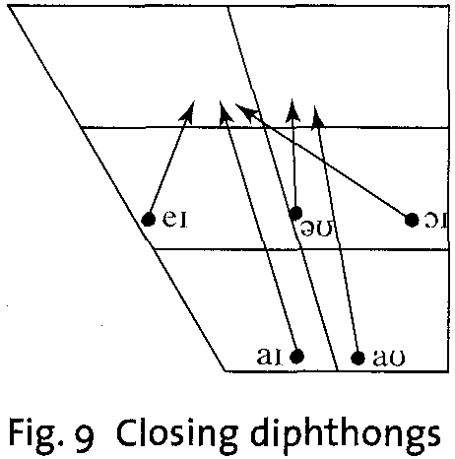

**D- Triphthongs**

They are the most complex English sounds of the vowel type, because they are difficult to pronounce and recognize. A triphthong is a glide from one vowel to another and then to a third, all produced rapidly and without interruption. The triphthongs are composed of five closing diphthongs plus (+) schwa added to the end. Thus, we got: **eɪə - aɪə - ͻɪə - əʊə - aʊə.**

**eɪə** player- layer

**aɪə** liar-fire- empire

**ͻɪə** loyal - royal

**əʊə** lower - mower

**aʊə** power- hour – flower