Module: Linguistics

Level: L1- FILA

Time Allotted: 90 min

Instructor: Dr Fatma KHERBACHE

E-mail: socioling70@gmail.com

Lecture 9: Levels of Language Analysis: Phonetics and Phonology

**Introduction**

Language is the basic means of human communication. Linguists have devoted significant attention to studying various aspects of human language. These differing aspects are generally referred to in linguistics as levels of analysis. Thus, to understand how language works we have to look at its structure from smaller units that form its phonological aspects (sounds) to larger units such as conversations, or written texts.. Only a comprehensive approach can lead understand language structure. The following diagram shows these levels of analysis from smaller to larger.

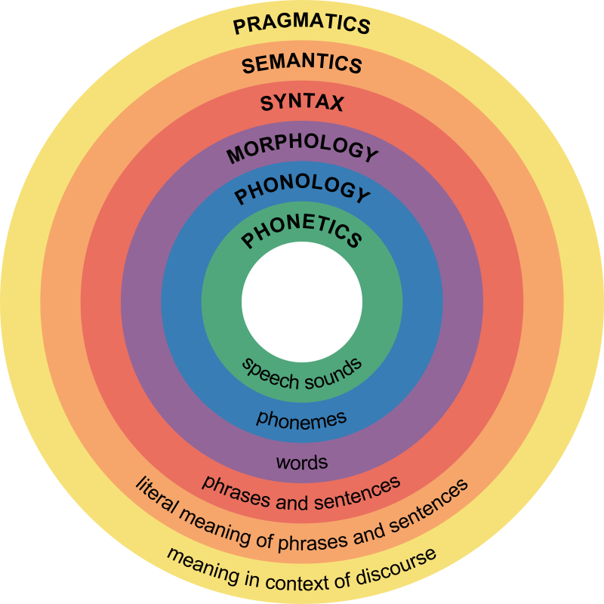

Levels of Language Analysis <https://en.m.wikipedia.org/wiki/File:Major_levels_of_linguistic_structure.svg>

Microlinguistics as an approach to study the inner structure of language deals with six levels: these are phonetics, phonology, morphology, syntax, semantics, and pragmatics.

**2. Phonetics and Phonology**

**-Phonetics**

Phonetics (pronounced [fə’netɪks] is a branch of linguistics concerned with the scientific study of how human speech sounds are articulated by the speaker and transferred to the hearer and how they are heard and perceived (Rogers, 2000). The sounds that human beings produce are studied in phonetics as physical objects (Zsiga, 2006). Phonetics covers all aspects of speech production, transmission, and perception, including:

1. *Articulatory phonetics (emission of sounds):* it studies the way speech sounds are produced by speech organs and articulators.
2. *Acoustic phonetics (transmission of sounds)*: it deals with the physical properties of sound waves created by the activity of speech organs.
3. *Auditory phonetics (perception of sounds):*it studies the perception of speech sounds by ear and brain.

Speech is a complex physical process (Gibbon, 2017). Generally, five main phases are recognized in this process and which are: speech planning, speech production, speech transmission, speech perception and speech comprehension (Gibbon, ibid). The following diagram illustrates how the three branches of phonetics are combined with each other creating a speech cycle.

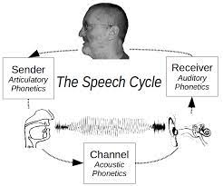

**The basic speech cycle (Gibbon, 2017)**

In order to represent speech sounds, there was a real need for a conventional (standardized) system of phonetic transcription called: **IPA** (International Phonetic Alphabets) which was established in 1888.



**-Phonology**

Phonetics may be defined as comparatively study of describing the sounds that we use in speaking. Phonology studies how *phonemes function in language* and the *relationship* between different phonemes. It is the study of the abstract side of sounds of a language. “Phonology has been defined as the study of sound systems. That is, the study of how speech sounds structure and function in languages” (L. Hyman, 1975: 2).

The set of sounds found in a given language is called the phonic medium that is composed of a range of phonemes specific to a given language. Each language has its specific set of phonemes. A phoneme is the smallest contrastive unit of sound in the sound system of a language. Phonemes are based on spoken language and may be recorded with special symbols, such as those of the IPA. In transcription, linguist conventionally place phonemic symbols between slashes: /f/, / a /, /k/. a phoneme may have more than one variant , these are called allophones; for example, the /l/of “play” and “milk” slightly differ phonetically. An allophone is one of a set of multiple possible pronunciations (realizations) of a single phoneme in a particular language.

Play [‘ple] vs milk [‘mk]: clear “l” [l] in play and dark “l” [] in milk are two allophones of the same phoneme /l/.

-**Phonetics vs. Phonology**

“A phonetic study tells how the sounds of a language are made and what their acoustic properties are. A phonological study tells how these sounds are used to convey meaning” (L. Hyman, 1975: 2).

We have to study both phonetics and phonology to acquire a full understanding of the use of sounds in a language.

