**Chapter 1: Silicon-based Photovoltaic Materials**

**Silicon-based photovoltaic materials are essential components of solar panels used for converting sunlight into electricity.**

**1-Introduction to Silicon Solar Cells:** A **photovoltaic cell** is an electronic component that, when exposed to light (photons), generates electricity. This is the photovoltaic effect that is at the origin of the phenomenon. The current obtained is a function of the incident light. The photovoltaic cell produces a continuous current.

The most common photovoltaic cells are made of semiconductors, mainly based on silicon (Si) and more rarely other semiconductors: copper indium selenide (Culn(Se)₂), cadmium telluride (CdTe), etc. They are generally in the form of thin plates a few centimeters on a side, sandwiched between two metal contacts, for a thickness of the order of a millimeter.

Cells are often grouped together in photovoltaic solar modules or solar panels, depending on the desired power.

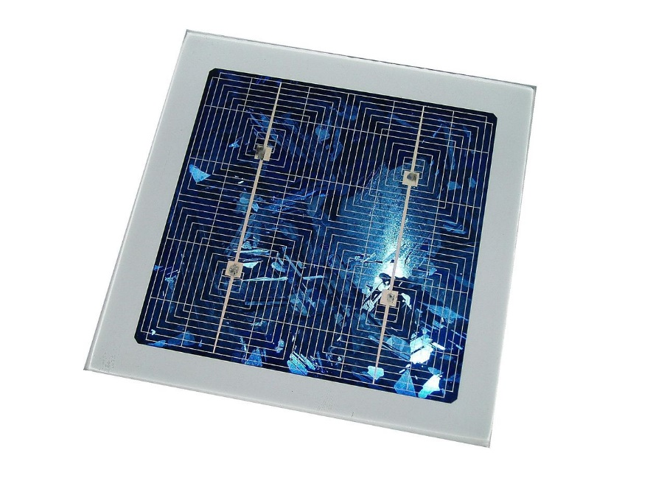

Figure 1. A photovoltaic cell

Silicon is currently the most widely used material for manufacturing photovoltaic cells. It is obtained by reduction from silica, the most abundant compound. in the earth's crust and especially in sand or quartz. The first step is the production of metallurgical silicon, only 98% pure, obtained from quartz pieces from pebbles or a vein deposit (the industrial production technique does not allow to start from sand). Photovoltaic grade silicon must be purified to more than 99.999%, which is obtained by transforming silicon into a chemical compound which will be distilled then retransformed into silicon.

**Amorphous silicon cell**

During its transformation, silicon produces a gas, which is projected onto a sheet of glass. The cell is very dark gray. It is the cell of calculators and watches called "solar".

**Monocrystalline silicon cell**

During cooling, the molten silicon solidifies into only one large crystal. The crystal is then cut into thin slices which will give the cells. These cells are generally of a uniform blue.

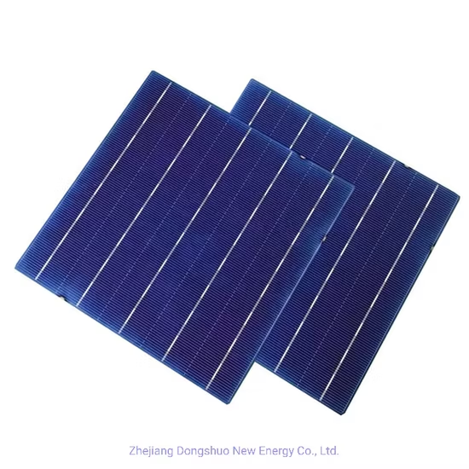

**Multicrystalline silicon cell**

During the cooling of silicon in an ingot mold, several crystals form. The photovoltaic cell has a bluish appearance, but it is not uniform, and patterns created by the different crystals can be distinguished.

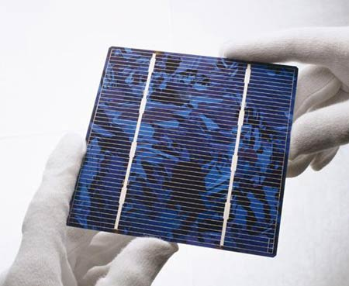

Figure 2. Multicrystalline silicon photovoltaic cell

**Polycrystalline or Multicrystalline?**

Here, we will talk about multicrystalline silicon (ref. IEC TS 61836, International Photovoltaic Vocabulary). The term polycrystalline is used for layers deposited on a substrate (small grains).

**Tandem Cell**

Monolithic stacking of two simple cells. By combining two cells (thin film of amorphous silicon on crystalline silicon for example) absorbing in overlapping spectral domains, the theoretical efficiency is improved compared to distinct simple cells, whether they are amorphous, crystalline or microcrystalline.

**Organic Photovoltaic Cell**

**5- Emerging Technologies:**

Emerging technologies for photovoltaic solar panels include the development of perovskite solar cells, which offer higher energy efficiency potential than traditional silicon solar cells. In addition, research is focused on integrating energy storage technologies to optimize the use of solar energy. Advances in materials and design aim to reduce production costs and improve the durability of solar panels. In addition, progress is being made in the integration of artificial intelligence and IoT (Internet of Things) to monitor and optimize the performance of photovoltaic installations. These advances contribute to the constant evolution of photovoltaic technologies towards more efficient and sustainable solutions.

Crystalline silicon technologies (multicrystalline and monocrystalline) are by far the most widely used today, but thin-film technologies, particularly CIS and CdTe, are increasingly developing on the market. Other technologies based on the use of dyes or organic materials, still in their infancy, promise a bright future for photovoltaic energy.

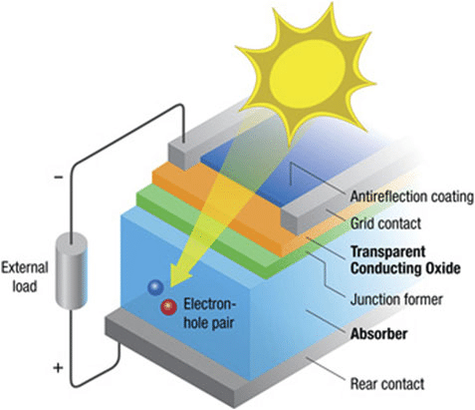

The solar cell, the unit element of a photovoltaic module, is also the active element in which the photovoltaic effect occurs. This allows the cell material to capture luminous energy (photons) and transform it into electrical energy characterized by a displacement of charges, positive and negative.

The characteristic common to all photovoltaic technologies is the presence in the cell material of an electron donor and an electron acceptor to allow this charge displacement. Once transferred to an external electrical circuit, it takes the form of a continuous electric current.

**THE MAIN SOLAR PHOTOVOLTAIC TECHNOLOGIES**

Three main families of solar cells can be distinguished:

* **Crystalline silicon cells:** For these cells, the active element is silicon doped in the mass. Although older, this technology still represents 90% of the market share due to its robustness and performance (module efficiency ranging from 12 to 20% for a lifetime of around 30 years) as well as the significant investments that have been made in it, whether for the transformation of silicon, the manufacture of cells or the assembly of modules.
* **Thin-film cells:** These cells share a common process of depositing the semiconductor material in a thin layer on various substrates, resulting in a uniform appearance, producing modules with slightly lower efficiency (from 7 to 13%). The market share for all these technologies is around 10% and remains relatively stable: these sectors have lost the advantage of their lower production cost with the massive investments made in silicon in the early 2000s.
* **Organic photovoltaic cells:** This segment is the subject of intensive research with the aim of producing very low-cost cells for new applications. Their operating principle is based on dye-sensitized solar cells with variations on the type of materials used. With efficiencies on the order of 3 to 5%, their weak point today remains their limited lifetime.

In general, photovoltaic cells can be seen as a stack of materials:

* **The active layer or absorber**, consisting of a first electron-accepting material and a second electron-donating material, forming a donor-acceptor junction;
* **The front and rear metal contacts** forming the positive (+) and negative (-) electrodes responsible for collecting the generated current;
* **Additional layers** such as an anti-reflective layer or a more heavily doped layer to **improve cell performance**: better light absorption, better charge carrier diffusion in the material, etc.

Thus, what differentiates one solar technology from another is mainly the nature of the absorber. Its physicochemical properties determine the deposition processes used, the nature and characteristics of the other cell components (anti-reflective, electrodes...), as well as its overall architecture: type of substrate, thickness, electrode positioning, etc.

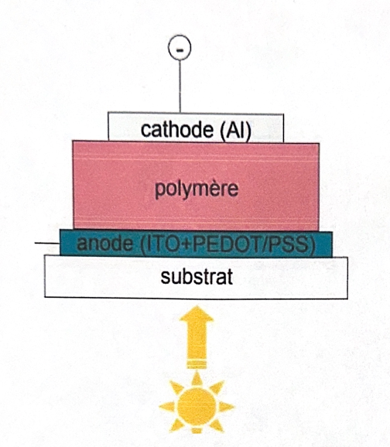

* Dissociation of excitons in the volume less important than at the electrodes
* Φa - Φc creates an electric field capable of separating charge carriers at the electrodes
* Electric field rarely sufficient to separate excitons
* Absorption covering the entire visible spectrum rare with a single molecule
* Hétérojonction : structure bicouche

**Heterojunction: bilayer structure**

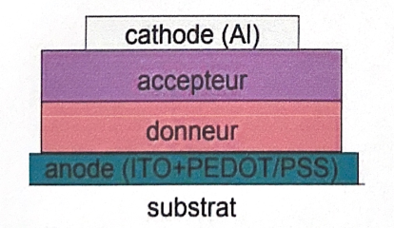

**6. Fill Factor (FF):** It measures how close the current-voltage curve of the cell is to an ideal rectangle. The FF is also related to the cell's efficiency.

**7. Spectral Response in Wavelength:** Evaluates the response of the solar cell to different wavelengths of solar light.

**8. Stability and Durability:** Evaluation of the long-term stability and durability of the solar cell's performance under various environmental conditions.

**9. Operating Temperature:** The influence of temperature on the performance of the solar cell is also an important aspect of its characterization.

Accurate characterization of solar cells is essential to understand their behavior under various conditions and to optimize their use in specific applications.

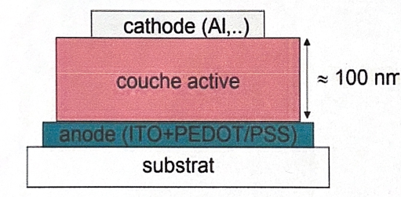

Figure 4. Structure of an organic PV cell

* Substrate: rigid (glass) or flexible (polymer, metal)
* Transparent anode: generally ITO but other possibilities (carbon nanotubes, conductive polymers)
* Active layer
* Cathode: deposited by vacuum evaporation (Al, LiF+Al, ...)
* "small molecules" deposited by vacuum evaporation
* polymers deposited by wet processes (spin-coating, doctor-blading, ink-jet ...)

**Different types of PV cells**

**Homojunction**

Thickness of about 250 µm. The operation is carried out in the presence of slurry, an organic solution containing abrasives in suspension. It should be noted that there is a significant loss of material during sawing (30 to 40% not recycled). In the diagrams, it is noted that the corners of the monocrystalline silicon are rounded because the plate is cut from a cylindrical ingot.

* Ribbon pulling to obtain **multicrystalline silicon** ribbon.

This last technological option combines the steps of crystallization and shaping of the silicon, and has the advantage of minimizing material loss. It is obtained by pulling a silicon ribbon on a flat or tubular support from a bath of molten silicon. This process was almost abandoned in the industry in 2019.

**4. Characterization of solar cells:**

Solar cells are characterized by several important parameters, including their efficiency, open-circuit voltage, short-circuit current, fill factor, and maximum power. Cell efficiency indicates the proportion of sunlight converted into electricity. Open-circuit voltage is the maximum voltage available across the cell when no current flows. The short-circuit current is the maximum current the cell can deliver when short-circuited. The fill factor measures how close the cell's power curve is to an ideal rectangle. Finally, efficiency represents the percentage of solar power converted into electricity. These characteristics are essential for evaluating the performance and suitability of solar cells for different applications.

The characterization of solar cells refers to the evaluation of the performance and properties of photovoltaic cells used to convert sunlight into electricity. Here are some important parameters for characterizing solar cells:

1. **Efficiency**: Measures the efficiency of converting sunlight into electricity by the cell. It is generally expressed as a percentage.
2. **Short-circuit current (Isc):** The maximum current produced by the cell when it is short-circuited.
3. **Open-circuit voltage (Voc):** The maximum voltage available across the cell when it is not connected to any load.
4. **Maximum power current (Imp):** The current at which the cell's output power is maximum.
5. **Maximum power voltage (Vmp):** The voltage at which the cell's output power is maximum.

techniques for producing solar silicon from new chemical but also metallurgical processes, the Elkem process in particular, are being explored.

**STEP 2: CRYSTALLIZATION OF SILICON AND SHAPING OF PLATES**

At this stage and until the manufacture of the module, know-how specific to the photovoltaic industry comes into play.

The silicon will be purified once again, doped uniformly and cut into plates once cooled. The crystallization technique consists of progressively solidifying the molten polycrystalline silicon in a controlled manner. It is in the molten silicon charge that the doping element will be added, generally boron, which gives a p-type doping. The material finally presents a crystalline network, which is an ordered arrangement of silicon atoms. Impurity removal is done by segregation. More soluble in the liquid phase than in the solid phase, impurities will migrate towards the zones solidifying last. In the case of bottom cooling, they will concentrate on the top of the ingot.

Three main ways are possible for crystallization, depending on the technological choice made by the manufacturer.

* The Czochralski process, to produce cylindrical ingots of monocrystalline silicon (sc-Si).

Monocrystalline silicon is obtained by growing or pulling a cylindrical ingot from a "seed" monocrystal according to the Czochralski or CZ process. The final cells of monocrystalline silicon have one of the best yields (15%), but with a higher energy expenditure at this stage.

* Directional solidification gives bricks of multicrystalline silicon (mc-Si).

Multicrystalline silicon is obtained by casting in an ingot mold where slow cooling takes place, on the order of several tens of hours. Its development is less energy-intensive, and the final yield of the cells is around 12%.

**Slicing the plates (mc-Si and sc-Si):** After the first step, the monocrystalline ingots and the multicrystalline bricks are cut into slices by a wire saw, to a thickness of about 250 µm.

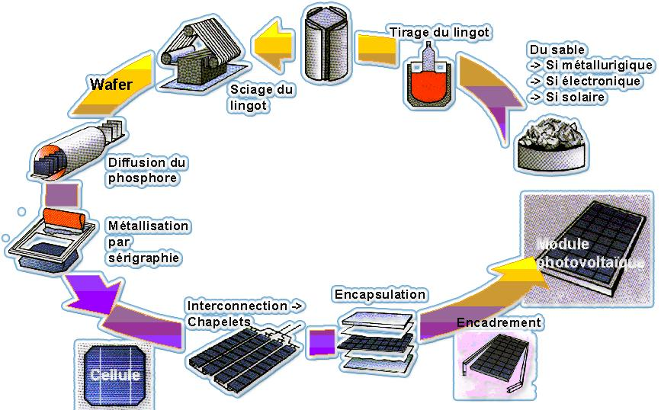

**STEP 1: SILICON REFINING**

In 2010, the production of polycrystalline silicon was 145,000 tons, of which 83% was for the solar industry (source: US Geological Survey). (Note: The term polycrystalline is often used incorrectly to refer to multicrystalline modules, whereas polycrystalline silicon is only used at the beginning and then transformed into monocrystalline or multicrystalline silicon). Based on a need of 15t/MWc, the photovoltaic industry produced 8 GWc of photovoltaic panels based on crystalline silicon. The obtaining of this material comes at the end of a refining process that can be divided into two major steps:

* + The transformation of quartz into metallurgical-grade silicon or MG-Si.

This is carried out in an arc furnace, a typical tool of the metallurgical industry. The purity of MG-Si is in the order of 98 to 99%.

* + The purification of metallurgical-grade silicon into solar-grade silicon or SoG-Si, with a purity of 99.9999%.

This is carried out by the Siemens process, inherited from electronics, and uses chemical reactors to synthesize polycrystalline silicon or poly-Si. Out of the entire production chain of photovoltaic modules, this is the most energy-consuming step. Due to the cost of this step and the fact that a lower purity can be tolerated,

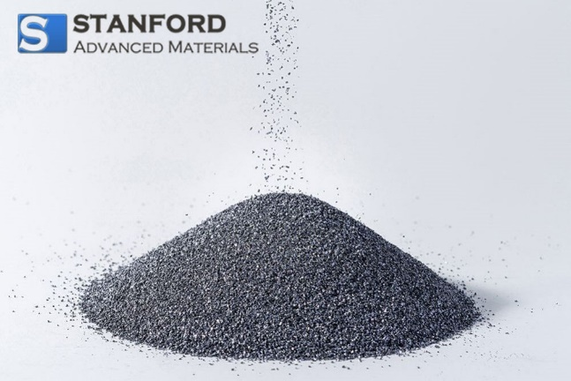

Figure. Silicon powder

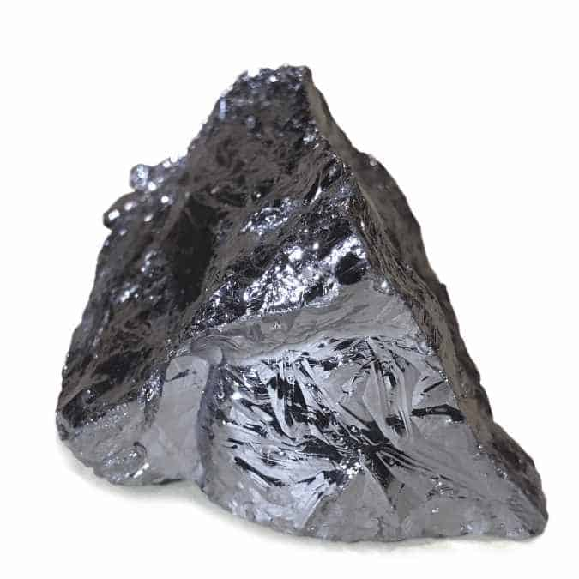

Figure. Monolithic Silicon sample

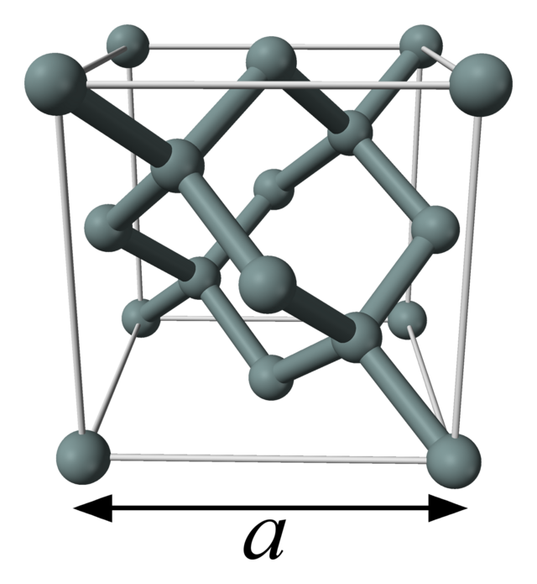

**Unit cell of diamond-type silicon.**

Silicon has a diamond-type structure (like germanium and the diamond form of carbon), with a lattice parameter of 0.543 071 0 nm.

**3-Manufacturing of silicon solar cells:**

Silicon solar cells are manufactured from pure silicon ingots. The manufacturing process involves several steps, including cutting the ingot into thin slices called wafers, doping the wafers with impurities to create N and P layers, creating metal contacts to allow the collection of electric current, and finally encapsulating the cells to protect them from external elements. Once assembled into solar panels, these cells convert sunlight into electricity through the photovoltaic effect. This manufacturing process is crucial for large-scale solar energy production and contributes to the transition to more sustainable energy sources.

**MANUFACTURING OF SILICON PLATES**

The standard manufacturing process of photovoltaic systems presents several steps. The explanations that follow apply to the crystalline silicon sector. In 2011, 88% of the photovoltaic market was still based on crystalline silicon technologies. Each of these steps is described in more detail in the document "Photovoltaic systems: manufacturing and environmental impact".

**Isotopes**

There are three natural isotopes of silicon, all stable: 28Si (92.18%), 29Si (4.71%) and 30Si (3.12%). There are also artificial, unstable isotopes: 25Si, 26Si and 27Si which are β+ emitters, as well as 31Si to 34Si which are β- emitters.

**Simple body**

Silicon is solid under normal temperature and pressure conditions, with a melting point of 1414 °C and a boiling point of 3265 °C under 1 atm. Like water, it is denser in the liquid state than in the solid state, unlike most other substances. It is also a fairly good heat conductor (thermal conductivity: 149 W m⁻¹ K⁻¹).

In crystalline form, pure silicon is gray with bluish metallic reflections. Like germanium, it is poorly deformable and very brittle. Like carbon and germanium, it crystallizes in the cubic system (diamond structure). Silicon crystals are gray to black, in the form of needles or hexahedra. Silicon is a semiconductor, its electrical conductivity is much lower than that of metals.

There are two other allotropes of silicon: silicene where silicon atoms are linked in chains, and silicene where they form planar layers.

Silicon also exists in the amorphous state, in the form of a dark brown powder.

Silicon oxidizes very quickly in air to form a layer of silica on the surface, which insulates the sample from oxygen and protects it from further oxidation (passivation); this oxide layer can be removed by hydrofluoric acid HF or by thermal abrasion. Insoluble in water except at high temperature, silicon is attacked by hydrofluoric acid HF or by a mixture of hydrofluoric acid/nitric acid (HNO3) depending on the phase.

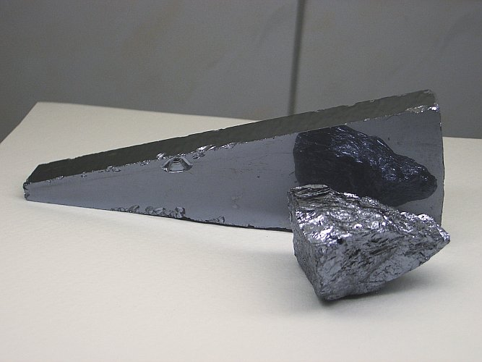

Le silicium est l'élément chimique de numéro atomique 14, de symbole Si. Membre du groupe 14 du tableau périodique, il est tétravalent et, comme le germanium, c'est un métalloïde. Le nom dérive du latin silex, silicĭs qui signifie « caillou » ou « silex ».

Le silicium est le deuxième élément le plus abondant dans la croûte terrestre après l'oxygène, et constitue 25,7 % de sa masse. En revanche il n'est présent qu'en relativement faible quantité dans la matière constituant le vivant. Il n'existe pas dans la nature à l'état de corps simple mais sous forme de composés, le dioxyde de silicium (SiO2) d'origine lithogénique (quartz du granite et des sables siliceux, cristobalite des roches ignées acides, etc.) ou biogénique (fabriqué par un organisme vivant comme les diatomées ou les radiolaires) et de nombreux silicates (feldspaths, kaolinite, etc.).

Sous sa forme amorphe, la silice (SiO2) provenant généralement de la terre de diatomées, est utilisée depuis très longtemps comme composant essentiel du verre. Il a depuis le milieu du XXe siècle de nouveaux usages en électronique (transistor), pour la production de matériaux tels que les silicones ou, pour fabriquer des panneaux solaires photovoltaïques et en tant que biominéral, la silice amorphe est actuellement étudiée pour ses utilités en nanotechnologie.

**Semiconductors in Silicon**

The first semiconductor components did not use silicon, but galena. The first silicon semiconductor device is a crystal radio detector in silicon, developed by the American engineer Greenleaf Whittier Pickard in 1906.

In 1940, Russell Ohl discovered the p-n junction and the photovoltaic effects of silicon. In 1941, techniques for producing high-purity germanium and silicon crystals were developed for radar detector crystals during World War II. In 1947, physicist William Shockley theorized a field-effect transistor made from germanium and ???

**Multi-junction cell**

Cells with high efficiency have been developed for space applications. Multi-junction cells are made up of several thin layers that use molecular beam epitaxy.

A triple junction cell, for example, is made up of GaAs, Ge and GaInP2 semiconductors. Each type of semiconductor is characterized by a maximum wavelength beyond which it is unable to convert the photon into electrical energy (cf. forbidden band). On the other hand, below this wavelength, the excess energy carried by the photon is lost. This is why it is interesting to choose materials with wavelengths as close to each other as possible (by multiplying their number as much as possible) so that a majority of the solar spectrum is absorbed, which generates maximum electricity from the solar flux. The cost of these cells is on the order of USD 40 $/cm².

**CIS semiconductor**

The technique consists of depositing a semiconductor material based on copper, gallium, indium and selenium on a substrate.

A concern, however: the resources in raw materials. These new technologies use rare metals such as indium whose world production is 25 tons per year and the price in April 2007 was 1000 dollars per kg; tellurium whose world production is 250 tons per year; gallium with a production of 55 tons per year; germanium with a production of 90 tons per year. Although the quantities of these raw materials necessary for the manufacture of solar cells are infinitesimal, a massive worldwide development of thin-film photovoltaic panels without silicon would inevitably run into this limited physical availability.

**2- Properties of silicon:**

Silicon is a chemical element with the symbol Si and atomic number 14. It is a grayish semiconductor with interesting physical and chemical properties. Physically, silicon is solid at room temperature, has a relatively low density and moderate electrical conductivity. It also has high thermal conductivity. Chemically, silicon reacts with halogens to form compounds such as silicon tetrachloride. It also forms covalent bonds with other elements, making it an important constituent of many minerals and materials. Silicon is widely used in the electronics industry to manufacture semiconductors, solar cells and other advanced electronic components.

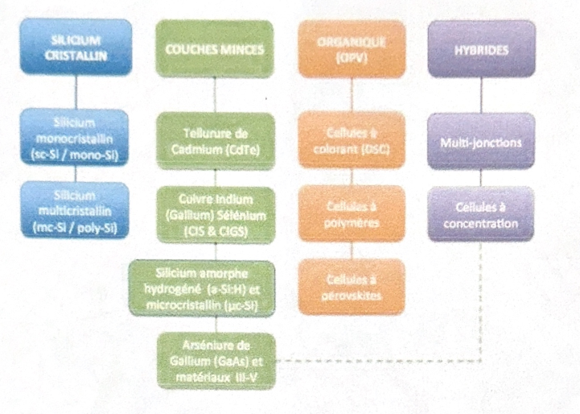Finally, the family of hybrids presented in the illustration below brings together cells combining technologies of different natures to achieve optimized yields.

**Reference:**

1. C. R. Mc Neill, M. J. Clifton-Smith, J. S. Quinton, B. V. King, S. Hotta, P. C. Dastoor. Current Applied Physics, 4, 335-338 (2004).
2. Z. El Jouad, L. Cattin, F. Martinez, G. Neculqueo, G. Louarn, M. Addou, P. Predeep, J. Manuvel, J.C. Bernède. The European Physical Journal Applied Physics, 74, 24603 (2016).
3. L. Cattin, J.C. Bernède, Y. Lare, S. Dabos-Seignon, N. Stephant, M. Morsli, P.P.Zamora, F.R. Diaz, M.A. del Valle. Physica Status Solidi A, 210, 802, (2013)
4. F.Z. Dahou, L. Cattin, J. Garnier, J. Ouerfelli, M. Morsli, G. Louarn, A. Bouteville, A. Khellil, J.C. Bernède. Thin Solid Films, 518, 6117-6122 (2010).
5. Journal of Photonics for Energy. Status report on emerging photovoltaics. 10.1117/1.JPE.13.042301