# Chapter 02: Energy Storage.

1. **Introduction:**

The balance supplies electricity demand, necessary for the operation of today is increasingly fragile. The grid is designed to resistance to a number of hazards: climate for example for consumption (in France, a 1°C drop in winter temperature leads to an increase of the power used of 2.3 GW), losses of works for production, etc.

The increasing use of intermittent electricity generation solutions, wind is a source of additional fragility. Fluctuations in production, dictated by weather conditions, are independent of the consumption. We must therefore manage new situations: overproduction of electricity in period of low consumption, means of production on which one cannot countduring peak periods.

Energy storage is a transversal and complementary solution. Certainly the The sector lacks maturity, but the benefits are manifold:

* An environmental gain related to the unlocking of large deployment scale of decarbonized energies, as well as in the case of thermal.
* The ability to provide centralized or decentralized responses for local or global constraints.
* Independence from fossil resources, economic advantage over the long-term because an increase in the prices of these resources and CO2 is predictable.

Electricity storage requires several stages of transformation. There are five forms of electricity storage:

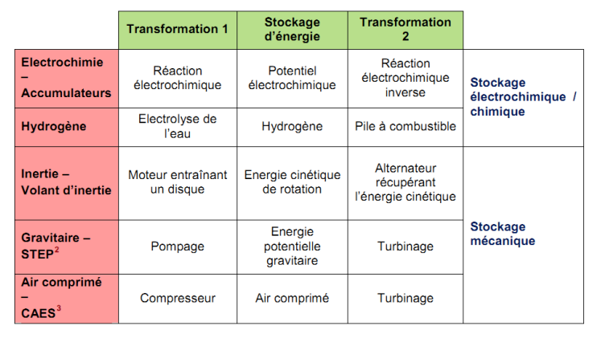

**Table 1. Forms of electricity storage**

The energy can also be stored in its thermal form and then returned under form of heat:

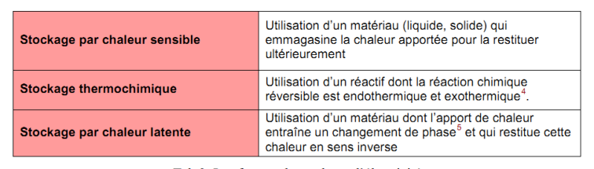

**Table 2. Forms of electricity storage.**

Finally, superconducting storage is a technology still in the demonstration stage semi-industrial, which consists of storing electricity in the form of magnetic energy through the use of superconducting coils. It is then directly in electrical form.

**2. Presentation of the different technologies available:**

The following pages provide a detailed presentation of each of the stationary storage available or under development.

The principle of operation, illustrated, is recalled as well that the technical data, the advantages and disadvantages of each.

**2.1. Pumping Energy Transfer Station –STEP:**

The principle consists of two water tanks located at different altitudes. During periods of low consumption (during which the demand - and therefore the cost – of energy are lower) the water is pumped to the highest reservoir. During periods of high demand, the water flows in the other direction and joins, by gravitation, the the lowest tank. It rotates when passing a turbine that feeds a generator and produces electricity. This is the most cost of investment is among the lowest. The constraint lies in the need to find suitable sites, which are becoming increasingly rare. New types of STEP are envisaged in particular at sea (marine STEP), the sea representing the lower tank and an upper tank being installed on the shore.

**Benefits:** Mature, good yield, life (+40 years) and cycling

**Disadvantages:** Location constraint, environmental impact and public acceptability

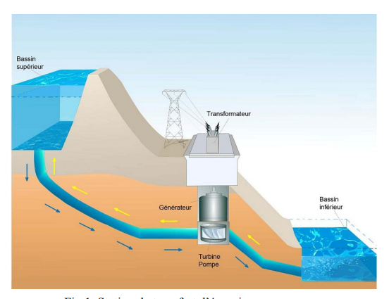

**Fig 1. Pumping power transfer station.**

**2.2. Compressed air storage CAES:**

In English Compressed Air Energy Storage. Powered by a During the off-peak hours of electricity demand, compressed air is produced and stored in a subterranean cavity.

During peak periods, compressed air passes through a combustion chamber where it is heated with natural gas before being relaxed in a turbine. Without this stage of warming, the temperature reached when relaxing the air would be much too low and the turbine would be damaged quickly. It is connected to a generator that produces electricity. If the performance is not very good, it remains better a conventional gas turbine.

One of the improvements being studied, the adiabatic CAES, aims to store heat produced during compression of the air to be returned when the gas is relaxed, which allows the use of air turbines to regenerate electricity without any emissions direct.

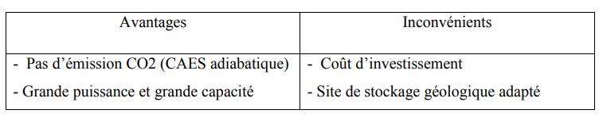

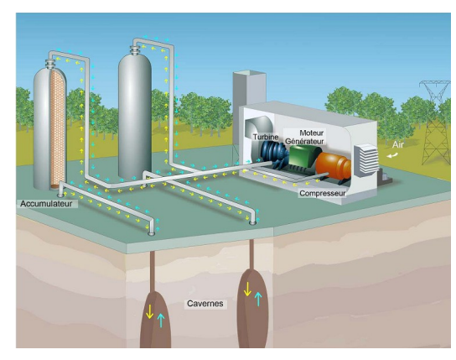

**Fig 2. Compressed air storage.**

**2.3. Inertial energy storage system (SISE):**

This storage system is based on the physical principle of storing the kinetic energy by rotating a mass at very high speed around an axis.

The flywheel is accelerated or braked by an electric motor-generator that allows to carry out the charging and discharging of the system. To avoid friction, the rotating parts are guided by often magnetic bearings. The entire system is housed in a low-pressure containment enclosure to limit self-discharge aerodynamic losses. SISE is used in many areas: frequency regulation, smoothing of wind and solar production, storage and restoration of the braking energy of vehicles.

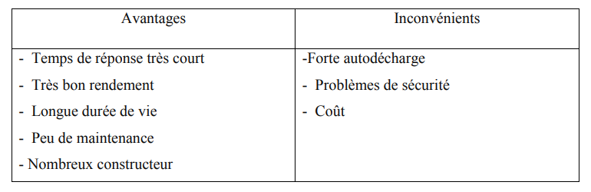

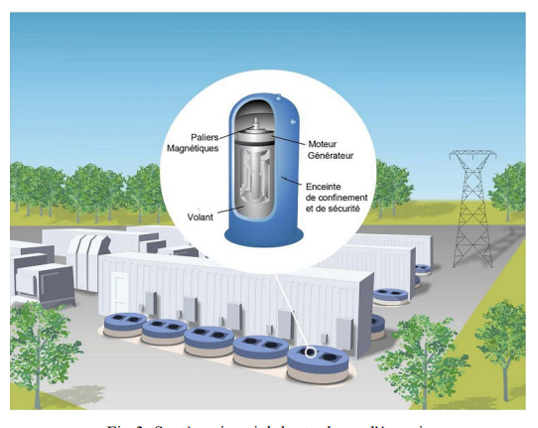

**Fig 3. Inertial energy storage system.**

**2.4. Storage as hydrogen:**

The three stages of the hydrogen storage process are: the electrolysis of water, hydrogen storage and fuel cell.

- First of all, the production of hydrogen during off-peak periods thanks to decomposition of water by electrolysis. The supply of electricity allows the electrolyser to break down H20 water into oxygen and hydrogen.

- Then the hydrogen is stored in a tank in gaseous, liquid or solid.

- It is finally reprocessed into a fuel cell. According to the inverse reaction from electrolysis, hydrogen combines with oxygen (the ions cross a membrane while the electrons circulate in a circuit creating a current electric), the reaction only releases water and heat.

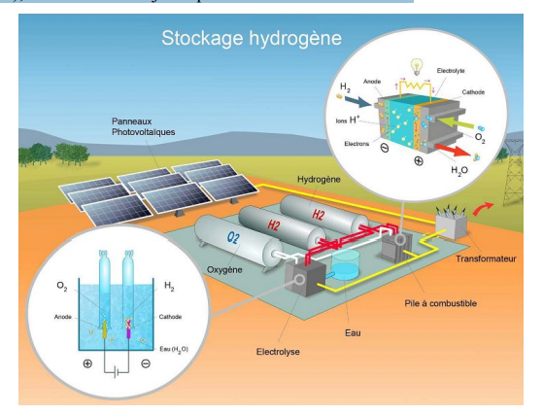

**Fig 4. Storage in the form of hydrogen.**

**2.5. Thermal storage by sensitive heat:**

Sensible heat storage has been proven for thousands of years. It For example, simply placing a stone near a fire, moving it and enjoy the warmth that it gives back in time. It is also the principle that we can be found in the use of a hot water tank or a simple.

In the case of a thermodynamic plant, it is necessary to store the heat stored in the during the day of sunshine. The heat transfer fluid (which carries the heat) circulates to a heat exchanger connected to two tanks of molten salts. The salts cold melts pass through the exchanger and store in turn the heat of the fluid, they are then stored in a hot salt tank.

At sunset, the circuit reverses and the hot salts circulate, through the heat exchanger, to the cold salt tank. The heat is thus transferred to the fluid heat carrier (around 500°) and can be used to power a turbine to produce electricity.

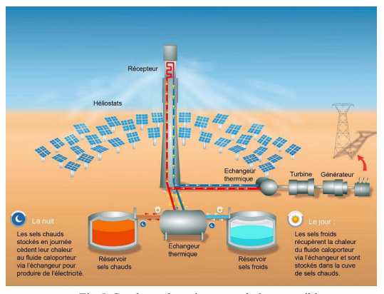

**Fig 5. Thermal storage by sensitive heat.**

**2.6. Thermochemical storage coupled to a solar thermal system:**

The principle is based on the use of a reagent (strontium bromide for installations in the habitat), stored in a tank. In summer, hot water brought by the combined solar system will give its heat to the air brought from outside via the water-air exchanger.

This hot air will then dry out the reagent. The reagent can be kept dry for several months. In winter, the circuit is reversed, the outside air is moist circulates through the reagent which, by re-humidifying itself, will release heat thanks to to an exothermic chemical reaction. The heated air (around 70°C) passes through the heat exchanger and gives its heat to the water that will flow to the balloon and allow a sanitary use.

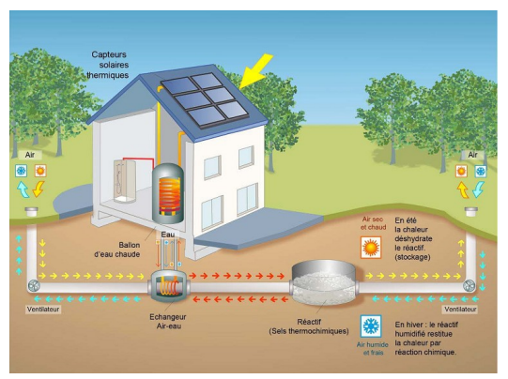

**Fig 6. Thermochemical storage coupled to a solar system.**

**2.7. Thermal phase change storage:**

The principle of storage via phase change materials (MCP) consists in use materials that change from a solid to liquid state during a heat supply. By example, paraffin. Placed in a storage tank in solid form at temperature ambient, it is crossed by copper pipes in which water circulates.

When the hot water arrives, the paraffin will warm up and change from solid to liquid.

Conversely, the paraffin will give off its heat by resolidifying itself if it is cold water (around 15°C) circulating in the tube.

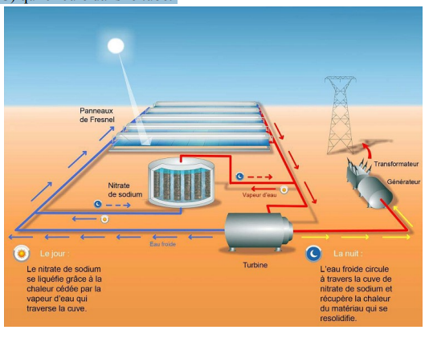

**Fig 7. Stockage thermique par changement de phase.**

A typical installation is to put the MCP in a large tank in the middle through which tubes pass to transport the heat transfer fluid. The MCP and the may be different depending on the heat production associated with it, and therefore the temperature or quantity of heat that is to be stored.

**2.8. Superconducting inductance storage – SMES:**

The energy is stored through an electric current sent in a coil made of a superconducting wire. Once the coil is short-circuited (closed), the current circulates without loss of energy because there is no friction (electrons circulate continuously). There is then production of a magnetic field in the coils. The energy is so stored in the coil in a magnetic and electrical form, and can be recovered in a very short time. Yields can be very high and main losses are located in the connections and in the converter power electronics. The instantaneous power efficiency can exceed 95%.

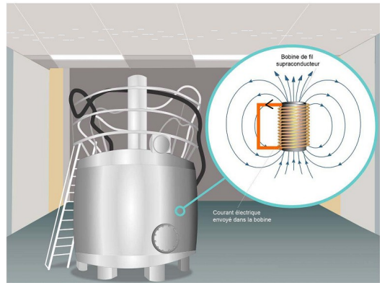

**Fig 8. Superconducting inductance storage.**

**2.9. Supercapacitors:**

The supercapacitor is a means of storing energy in electrostatic form. It is consisting of 2 porous electrodes, generally made of activated carbon, dipped in a liquid electrolyte and separated by a separator allowing the ions to circulate but not the electrons. The interaction of electrodes and electrolyte causes spontaneous of an accumulation of loads at the interfaces, we speak of formation of a double layer electrochemical: a positive charge layer and a negative charge layer, the whole being electrically neutral. The largest super capacitors were mainly developed for use in transport.

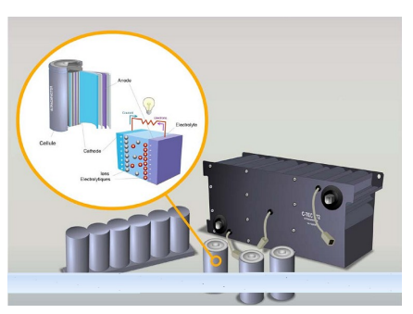

**Fig 9. Supercapacitors.**

**2.10. Batteries:**

The battery is an assembly of accumulators that stores electrical energy from the ion circulation between two electrodes through an electrolyte, and electrons that move through an external circuit.

**3. Storage technology selection criteria:**

There are different stationary storage technologies that can best adapt the energy production system, if necessary, investment...

All these technologies complement each other and should allow us to think in terms of storage grid. Each grid (thermal, electrical, hydrogen production) can be developed in parallel and thus cover all needs. The criteria for choice of storage technology depends on the need, to which a book of costs, regulatory constraints, cost and environmental...

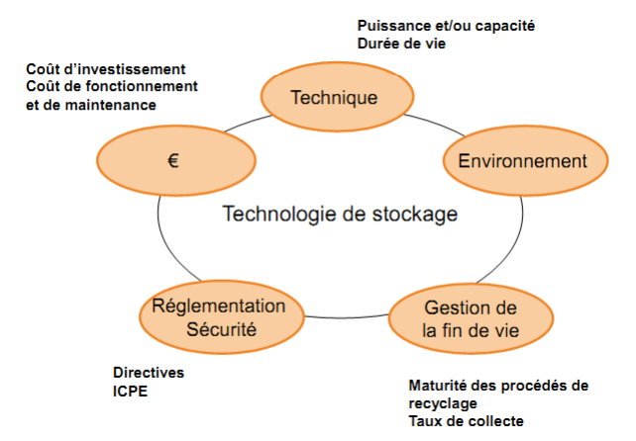

**Fig 10. Storage technology selection criteria.**

**Storage of electrical energy:**

The selection of a storage system on a given site depends on several criteria choice:

* Quantity and nature of available energy;
* Available powers;
* Density of energy and power storage, which conditions volume and weight of the system;
* Costs and maintenance related to the maturity of the technology;
* Number of cycles and depth of discharge;
* Safety.