** The Hammadids Scientific life**

The Hammadids were interested in science and scholars. Scientists appeared in Algeria, such as Abu Bakribn al-Hussein al-Maywarqi, Abu al-Qasim al-Biskari, and Abu Muhammad al-Ashiri, and **poets** such as IbnRashiq, IbnHamdis, and Abd al-Haqq al-Baja’i, and doctors such as Ibn Ali ibn al-Tabib and IbnAbi al-Malih. Bejaia was known as the “capital of mathematics,” thanks to It hosted the SidiTouati Institute, which served as a university, and females were not excluded from the opportunity to study there, and from it the Europeans took Arabic numerals, algebra, contrast, and the geometry of the Greek Euclid.

Sharia sciences had first place, followed by Arabic sciences, and the Arabic language was the official language of the state. Then the Hilal Arabs came and Arabized the countries of the Maghreb. Mosques and scientific institutes were full of science lessons and scientific councils, and the Sunni Maliki doctrine was the official doctrine of the Hammadid state, and Bejaia became a cultural center to which many scholars of the East or Maghreb took refuge, and MunimIbnHamdis al-Siqilli was among the writers, and Abu al-FadlIbn al-Nahwi al-Tawzari, and even the people of Pisa The Italians went to Bejaia and learned from them how to make wax. Their wax is still called Bougie, which is the French name for the city of Bejaia.

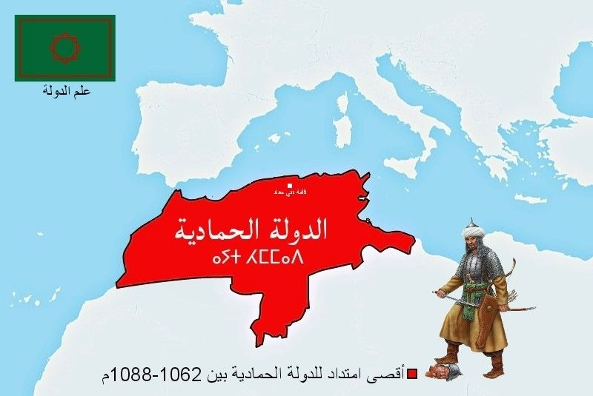

*Anno Domini*

*The term anno Domini is Medieval Latin and means "in the year of the Lord" but is often presented using "our Lord" instead of "the Lord", taken from the full original phrase "anno Domini nostriJesu Christi", which translates to "in the year of our Lord Jesus Christ"*