Dr Badra Menouer

LMD 1 LECTURES

**Lecture Four**

**Types of poetry**

1. **Types of poetry:**

When studying poetry, it is beneficial to begin by examining the main theme and its progression throughout the poem. The way in which the theme is developed depends largely on the type of poem being studied. It is helpful to categorize poems into two broad groups: lyric poetry and narrative poetry.

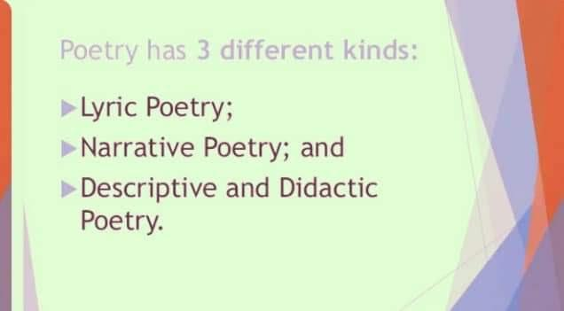

**4.1 Lyric poetry: (LEER-ick)**

The ancient Greek writers defined lyric as a song accompanied by the lyre. Lyric poetry is a type of poem that expresses the emotions, feelings, or thoughts of a particular person, distinguishing it from narrative poems. Typically, these poems are relatively short, usually ranging from twelve to sixty lines, and they employ vivid imagination and concise language to convey their message. Barbara Hardy, in her book The Advantage of Lyric, argues that lyric poetry captures intense feelings by isolating them within a small space. This definition suggests that lyric poems must be brief and capable of distilling and compressing momentary experiences to reveal the underlying emotions. Some subcategories of lyric poetry include elegy, ode, sonnet, dramatic monologue, and occasional poetry.

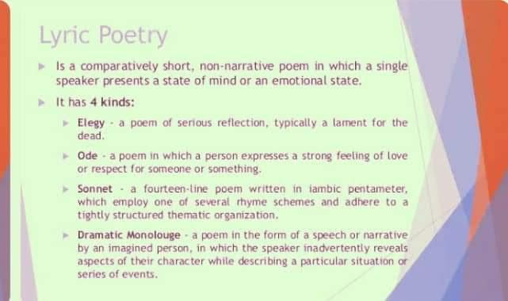

**4.1.1 *ELEGY (EL-e-je):***

The elegy is a type of poem that can be broadly defined as a solemn meditation on the subject of death, often expressed through mourning or lamentation. It originated from the Greek "**elegus**," which referred to a song accompanied by the flute that expressed grief or sorrow for the dead. An elegy in modern times can also serve as a formal expression of grief for the loss of a specific person, as illustrated in Tennyson's **In Memoriam** **A.H.H**. (Mackenzie, 2013). Gray's **Elegy Written in a Country Churchyard** is an example of an elegy that mourns the loss of a way of life rather than a person, with the poet expressing discontent for the tyranny and strife that was set upon England by Oliver Cromwell (Guthrie, 2016).

In American literature, Walt Whitman's When **Lilacs Last in the Dooryard Bloomed** is a well-known elegy inspired by the assassination of Abraham Lincoln, expressing sorrow for the loss of an individual (Guthrie, 2016). Elegies can take different forms and are not limited to mourning for the dead but can also be used to express sadness or grief for a broader range of subjects. For instance, John Clare's short poem "**I Am**" can be viewed as an elegy that laments the poet's mental anguish and despair (Clare, 2013).

Out of numerous examples of elegies that exist, we selected this short poem by John Clare as an illustration.

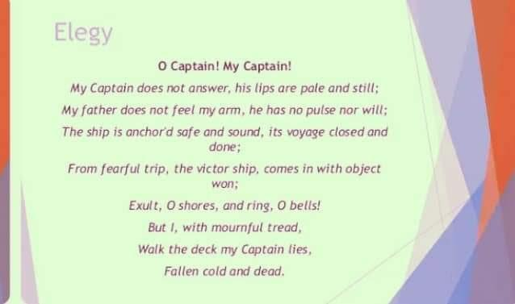

**The Secret**

I loved thee, though I told thee not,

Right earlily and long,

Thou wert my joy in every spot,

My theme in every song.

And when I saw a strange face

Where beauty held the claim,

I gave it like a secret grace

The being of thy name.

And all the charms of face or voice

Which I in others see

Are but the recollected choice

Of what I felt for thee.

* + 1. ***Ode*:**

A type of poem called an ode is a lengthy lyric poem that has a serious topic and is written in an elevated style. Examples of famous odes include Wordsworth's "**Hymn to Duty**" and Keats' "**Ode to a Grecian Urn**." Odes can be divided into two categories: public and private. Public odes are composed for formal occasions like funerals, state events, or birthdays, while private odes celebrate intensely personal and subjective experiences and are often reflective and meditative in nature.

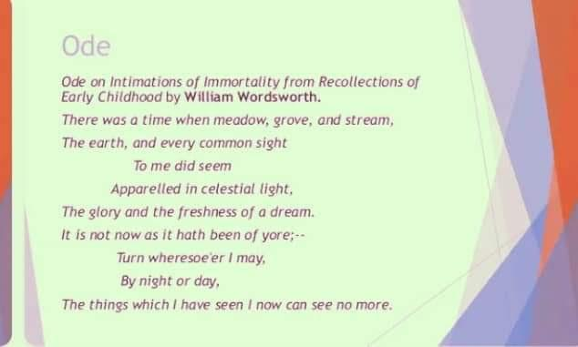

* + 1. ***Sonnet:***

The sonnet is a type of poem originally intended as a love poem, expressing the lover's sufferings and hopes through a system or pattern of metrical structure and verse composition. It typically consists of fourteen lines with a set rhyme scheme or pattern. There are two main styles of sonnets: **Italian and English**.

**The Italian or Petrarchan sonnet**, named after **Petrarch**, usually written in **iambic pentameter**, consists of an **octave of eight lines** posing a question or stating a problem, followed by **a sestet of six lines** offering an answer or resolution to the problem with the **rhyme scheme a-b-b-a, a-b-b-a.** **The English or Shakespearean sonnet** was named after **William Shakespeare** and is structured differently, with **three quatrains**, each with its own independent rhyme scheme typically rhyming every other line, followed by a **rhyming couplet**. In the English sonnet, the break occurs between the twelfth and thirteenth lines, and the concluding couplet delivers the primary idea shift of the poem, often with an epigrammatic ending, following the **rhyme scheme a-b-a-b, c-d-c-d, e-f-e-f, g-g.**

The sonnet was first introduced to England in the sixteenth century by Thomas Wyatt and Henry Howard, Earl of Surrey, and was later used to address other topics besides love, such as religious experience, reflections on art, and war experience. Many poets also wrote a series of sonnets linked by the same theme, known as sonnet cycles, which depict the various stages of a love relationship.

**EXAMPLE 1:**

When I consider how my light is spent**a**

Ere half my days, in this dark world and wide,**b**

And that one talent which is death to hide**b**

Lodged with me useless, though my soul more bent**a**

To serve therewith my Maker, and present**a**

My true account, lest he returning chide;**b**

“Doth God exact day-labor, light denied?”**b**

I fondly ask; but patience to prevent**a**

That murmur, soon replies, “God doth not need**c**

Either man’s work or his own gift; who best**d**

Bear his mild yoke, they serve him best. His state**e**

Is kingly. Thousands at his bidding speed**c**

And post o’er land and ocean without rest:**d**

They also serve who only stand and wait.”**e**

**EXAMPLE 2: W. Shakeapeare.**

Shall I compare thee to a summer’s day?

Thou art more lovely and more temperate:

Rough winds do shake the darling buds of May,

And summer’s lease hath all to short a date:

Sometime too hot the eye of heaven shines,

And often is his gold complexion dimm’d:

And every fair from fair sometime declines,

By chance, or nature’s changing course, untrimm’d.

By the eternal summer shall not fade

Nor lose possession of that fair thou owest;

Nor shall death brag thou wandered in his shade,

When in eternal line to time thou growest:

So long as men can breathe, or eyes can see,

So long lives this, and this gives life to thee.

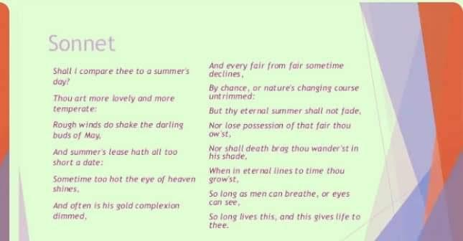

**4.1.4 Dramatic Monologue:**

A dramatic monologue is a type of poem in which a speaker, who is clearly distinct from the poet, addresses a silent listener, revealing a dramatic situation and often unintentionally providing insight into the character. The speaker may be a fictional or historical character or a persona created by the poet, and the poem is usually written in the first-person point of view. The dramatic monologue is characterized by its use of a specific, single perspective, as well as its exploration of complex psychological and emotional states.

**EXAMPLE 1:**  **Robert Browning's poem "My Last Duchess."**

"That’s my last Duchess painted on the wall,

Looking as if she were alive. I call

That piece a wonder, now: Frà Pandolf’s hands

Worked busily a day, and there she stands.

Will’t please you sit and look at her? I said

“Frà Pandolf” by design, for never read

Strangers like you that pictured countenance,

The depth and passion of its earnest glance,

But to myself they turned (since none puts by

The curtain I have drawn for you, but I)

And seemed as they would ask me, if they durst,

How such a glance came there; so, not the first

Are you to turn and ask thus."

**4.2 Narrative poetry:** Narrative poetry is a form of poetry that tells a story. It typically has a plot, characters, and a setting, and often follows a traditional storytelling structure with a beginning, middle, and end. Narrative poetry can be long or short and can be written in various poetic forms such as ballads, epics, or romances.

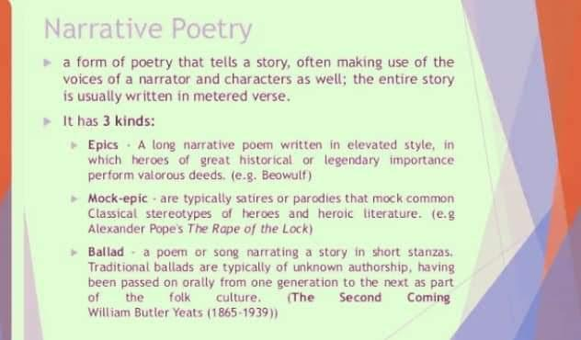

**EXAMPLE 1: "The Raven" by Edgar Allan Poe**

"And the Raven, never flitting, still is sitting, still is sitting

On the pallid bust of Pallas just above my chamber door;

And his eyes have all the seeming of a demon's that is dreaming,

And the lamp-light o'er him streaming throws his shadow on the floor;

And my soul from out that shadow that lies floating on the floor

Shall be lifted—nevermore!"