**Dr Badra Menouer**

**LMD1 LECTURES**

**Figurative Language**

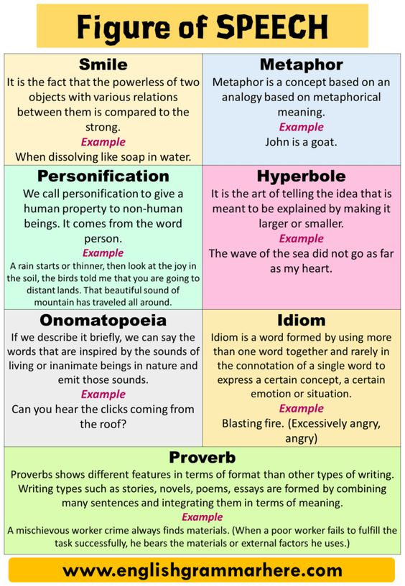

* **Metaphor:** Comparing two things directly, saying one thing is another, to reveal hidden similarities.
* **Simile:** Comparing two things indirectly, using words like "like" or "as," to highlight shared qualities.

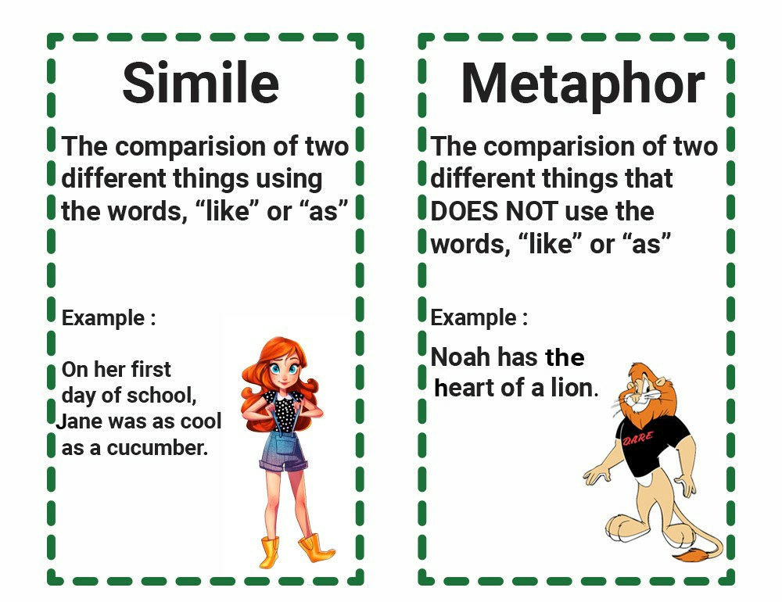

* **Symbolism:** Using objects, characters, or events to represent deeper meanings or ideas.
* **Personification:** Giving human qualities to non-human things, adding vividness and emotional connection.

**4.5.3 Other Techniques:**

* **Irony**: Saying the opposite of what is meant, creating humor, satire, or dramatic tension.
* **Tone:** The overall mood and attitude conveyed by the poem, influenced by word choice, rhythm, and figurative language.
* **Imagery:** Vivid descriptions that appeal to the reader's senses, evoking emotions and creating a mental picture.

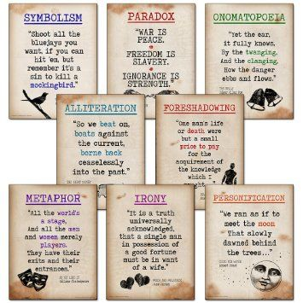

**Rhythm:**

* **Meter:** Patterns of stressed and unstressed syllables, creating a musical pulse. Common meters include iambic pentameter (five iambs per line) and trochaic tetrameter (four trochees per line).
* **Free verse:** Lacks a set meter, relying on natural speech rhythms and internal patterns.
* **Alliteration:** Repetition of consonant sounds at the beginning of words, like "whispering wind" or "crashing waves."
* **Assonance:** Repetition of vowel sounds within words, creating a lyrical quality, like "deeply dreaming" or "stars afar."
* **Onomatopoeia**: Words that mimic sounds, adding vividness and sensory experience, like "buzzing bee" or "roaring thunder."

**4.6.1 Other Sound Devices:**

* **Caésure:** A pause within a line, often marked by punctuation, offering emphasis and shaping rhythm.
* **Enjambment:** When a sentence or phrase runs over into the next line, creating a sense of momentum and anticipation.
* **Consonance**: Repetition of consonant sounds within a line, adding texture and richness, like "grim and gray" or "shimmering stars."

**4.6.2 Impact of Sound Patterns:**

* **Memorability**: Rhyme and rhythm make poems easier to remember and recite.
* **Emphasis:** Certain sounds can highlight key words or phrases, drawing attention to their meaning.
* **Emotional effect:** Different sound patterns can evoke specific emotions, from the playful lilt of assonance to the somber cadence of long vowels.
* **Musicality:** Poetry, through its sonic elements, can create an internal music, enhancing the aesthetic experience.

Sound patterns are not merely decorative add-ons; they are vital tools in the poet's toolkit, shaping the music and meaning of their work. By understanding and appreciating these sonic nuances, you can unlock a deeper layer of engagement with poetry, transforming it from words on a page into a vibrant symphony of sound and sense.