Dr Badra Menouer

LMD 1 LECTURES

**Lecture Three**

**Poetry**

1. **Introduction**

Poetry can be a great starting point for students who are new to literature because it is often shorter and more condensed than other forms of writing. This makes it easier to understand and analyze, as well as more accessible to readers who may not have a lot of experience with literature.

In addition, poetry is a unique form of writing that can evoke strong emotions and create vivid images in the reader's mind. It often employs figurative languages, such as metaphors and similes, which can help students develop their critical thinking and analytical skills. Reading poetry can also help students develop their own writing skills, as they learn about the use of language, sound, and imagery.

Finally, poetry can offer a glimpse into different cultures, perspectives, and experiences. Poems can be written about anything from nature and love to war and social justice. By reading poetry, students can explore different ideas and gain a deeper understanding of the world around them.

Overall, poetry is a valuable and rewarding form of literature that can help students develop their reading, writing, and critical thinking skills, while also providing insight into the human experience.

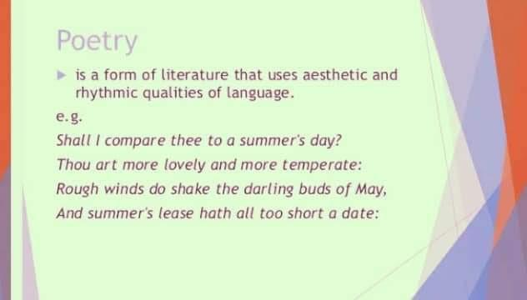

1. **The origins of the word**

Poetry derives from the Latin word Poetria, which is rooted in the Greek word poètès, meaning "doer" or "creator." Poems are compositions written in verse that combine sound and meaning. The genre is typically associated with specialized language and makes very concentrated use of such language due to its relative brevity. Poetry employs formal elements such as sound patterns, verse and meter, rhetorical devices, style, stanza form, or imagery more frequently than other types of text, which is known as structural and phonological over structuring. Poetry is often associated with subjectivity and intensely personal experience, though this does not apply to all poems. Even lyrical poems cannot be treated as subjective expressions of the author since the author and speaker are two separate entities. While it is challenging to define poetry conclusively, most people can recognize it when they see it. According to one recent critic (Müller-Zettelmann 2000: 73-156), poetic texts tend to be relatively brief, express subjectivity more than other texts, and display a musical or songlike quality. Poetry tends to display over structuring in terms of its phonology and structure, often deviating from everyday language. Additionally, it often has aesthetic self-referentiality, drawing attention to itself as an art form through its unique form and explicit references to the act of poetry writing.

Poems are made up of lines, sentences, and stanzas, and each line is like a garment that wraps and gives shape to the idea it contains. There are two major types of poetry: epic (a long narrative poem that tells the story of a national hero) and lyric (a short poem that expresses strong feelings).

1. **Definition of Poetry According to Different Writers**

"Poetry is the art of uniting pleasure with truth, by calling imagination to the help of reason." - Samuel Johnson (source: "The Rambler," 1750)

"Poetry is the spontaneous overflow of powerful feelings: it takes its origin from emotion recollected in tranquillity." - William Wordsworth (source: "Lyrical Ballads," 1800)

"Poetry is the rhythmical creation of beauty in words." - Edgar Allan Poe (source: "The Poetic Principle," 1850)

"Poetry is not a turning loose of emotion, but an escape from emotion; it is not the expression of personality, but an escape from personality." - T.S. Eliot (source: "Tradition and the Individual Talent," 1919)

These definitions offer different perspectives on what poetry is and what it aims to achieve, from the idea of uniting pleasure and truth to the creation of beauty in words. They can be useful for students to consider as they begin to explore and analyze poetry.

1. **Types of poetry:**

When studying poetry, it is beneficial to begin by examining the main theme and its progression throughout the poem. The way in which the theme is developed depends largely on the type of poem being studied. It is helpful to categorize poems into two broad groups: lyric poetry and narrative poetry.

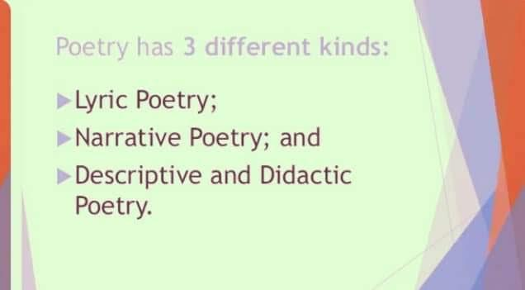

**4.1 Lyric poetry: (LEER-ick)**

The ancient Greek writers defined lyric as a song accompanied by the lyre. Lyric poetry is a type of poem that expresses the emotions, feelings, or thoughts of a particular person, distinguishing it from narrative poems. Typically, these poems are relatively short, usually ranging from twelve to sixty lines, and they employ vivid imagination and concise language to convey their message. Barbara Hardy, in her book The Advantage of Lyric, argues that lyric poetry captures intense feelings by isolating them within a small space. This definition suggests that lyric poems must be brief and capable of distilling and compressing momentary experiences to reveal the underlying emotions. Some subcategories of lyric poetry include elegy, ode, sonnet, dramatic monologue, and occasional poetry.

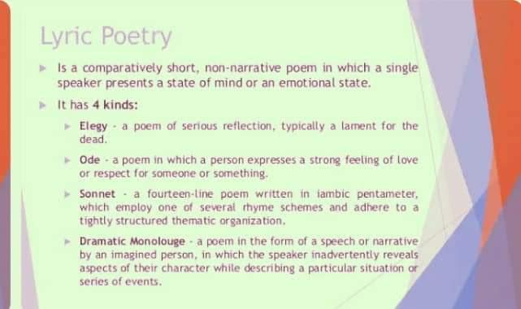

**4.1.1 *ELEGY (EL-e-je):***

The elegy is a type of poem that can be broadly defined as a solemn meditation on the subject of death, often expressed through mourning or lamentation. It originated from the Greek "**elegus**," which referred to a song accompanied by the flute that expressed grief or sorrow for the dead. An elegy in modern times can also serve as a formal expression of grief for the loss of a specific person, as illustrated in Tennyson's **In Memoriam** **A.H.H**. (Mackenzie, 2013). Gray's **Elegy Written in a Country Churchyard** is an example of an elegy that mourns the loss of a way of life rather than a person, with the poet expressing discontent for the tyranny and strife that was set upon England by Oliver Cromwell (Guthrie, 2016).

In American literature, Walt Whitman's When **Lilacs Last in the Dooryard Bloomed** is a well-known elegy inspired by the assassination of Abraham Lincoln, expressing sorrow for the loss of an individual (Guthrie, 2016). Elegies can take different forms and are not limited to mourning for the dead but can also be used to express sadness or grief for a broader range of subjects. For instance, John Clare's short poem "**I Am**" can be viewed as an elegy that laments the poet's mental anguish and despair (Clare, 2013).

Out of numerous examples of elegies that exist, we selected this short poem by John Clare as an illustration.

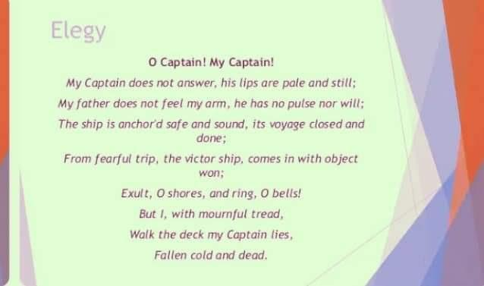

**The Secret**

I loved thee, though I told thee not,

Right earlily and long,

Thou wert my joy in every spot,

My theme in every song.

And when I saw a strange face

Where beauty held the claim,

I gave it like a secret grace

The being of thy name.

And all the charms of face or voice

Which I in others see

Are but the recollected choice

Of what I felt for thee.

* + 1. ***Ode*:**

A type of poem called an ode is a lengthy lyric poem that has a serious topic and is written in an elevated style. Examples of famous odes include Wordsworth's "**Hymn to Duty**" and Keats' "**Ode to a Grecian Urn**." Odes can be divided into two categories: public and private. Public odes are composed for formal occasions like funerals, state events, or birthdays, while private odes celebrate intensely personal and subjective experiences and are often reflective and meditative in nature.

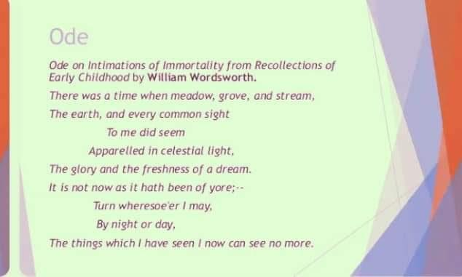

* + 1. ***Sonnet:***

The sonnet is a type of poem originally intended as a love poem, expressing the lover's sufferings and hopes through a system or pattern of metrical structure and verse composition. It typically consists of fourteen lines with a set rhyme scheme or pattern. There are two main styles of sonnets: **Italian and English**.

**The Italian or Petrarchan sonnet**, named after **Petrarch**, usually written in **iambic pentameter**, consists of an **octave of eight lines** posing a question or stating a problem, followed by **a sestet of six lines** offering an answer or resolution to the problem with the **rhyme scheme a-b-b-a, a-b-b-a.** **The English or Shakespearean sonnet** was named after **William Shakespeare** and is structured differently, with **three quatrains**, each with its own independent rhyme scheme typically rhyming every other line, followed by a **rhyming couplet**. In the English sonnet, the break occurs between the twelfth and thirteenth lines, and the concluding couplet delivers the primary idea shift of the poem, often with an epigrammatic ending, following the **rhyme scheme a-b-a-b, c-d-c-d, e-f-e-f, g-g.**

The sonnet was first introduced to England in the sixteenth century by Thomas Wyatt and Henry Howard, Earl of Surrey, and was later used to address other topics besides love, such as religious experience, reflections on art, and war experience. Many poets also wrote a series of sonnets linked by the same theme, known as sonnet cycles, which depict the various stages of a love relationship.

**EXAMPLE 1:**

When I consider how my light is spent**a**

Ere half my days, in this dark world and wide,**b**

And that one talent which is death to hide**b**

Lodged with me useless, though my soul more bent**a**

To serve therewith my Maker, and present**a**

My true account, lest he returning chide;**b**

“Doth God exact day-labor, light denied?”**b**

I fondly ask; but patience to prevent**a**

That murmur, soon replies, “God doth not need**c**

Either man’s work or his own gift; who best**d**

Bear his mild yoke, they serve him best. His state**e**

Is kingly. Thousands at his bidding speed**c**

And post o’er land and ocean without rest:**d**

They also serve who only stand and wait.”**e**

**EXAMPLE 2: W. Shakeapeare.**

Shall I compare thee to a summer’s day?

Thou art more lovely and more temperate:

Rough winds do shake the darling buds of May,

And summer’s lease hath all to short a date:

Sometime too hot the eye of heaven shines,

And often is his gold complexion dimm’d:

And every fair from fair sometime declines,

By chance, or nature’s changing course, untrimm’d.

By the eternal summer shall not fade

Nor lose possession of that fair thou owest;

Nor shall death brag thou wandered in his shade,

When in eternal line to time thou growest:

So long as men can breathe, or eyes can see,

So long lives this, and this gives life to thee.

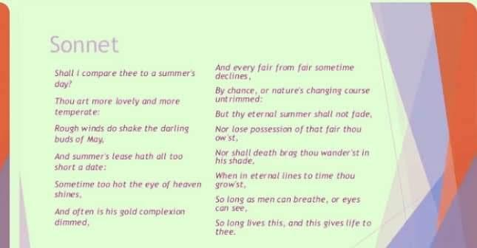

**4.1.4 Dramatic Monologue:**

A dramatic monologue is a type of poem in which a speaker, who is clearly distinct from the poet, addresses a silent listener, revealing a dramatic situation and often unintentionally providing insight into the character. The speaker may be a fictional or historical character or a persona created by the poet, and the poem is usually written in the first-person point of view. The dramatic monologue is characterized by its use of a specific, single perspective, as well as its exploration of complex psychological and emotional states.

**EXAMPLE 1:**  **Robert Browning's poem "My Last Duchess."**

"That’s my last Duchess painted on the wall,

Looking as if she were alive. I call

That piece a wonder, now: Frà Pandolf’s hands

Worked busily a day, and there she stands.

Will’t please you sit and look at her? I said

“Frà Pandolf” by design, for never read

Strangers like you that pictured countenance,

The depth and passion of its earnest glance,

But to myself they turned (since none puts by

The curtain I have drawn for you, but I)

And seemed as they would ask me, if they durst,

How such a glance came there; so, not the first

Are you to turn and ask thus."

**4.2 Narrative poetry:** Narrative poetry is a form of poetry that tells a story. It typically has a plot, characters, and a setting, and often follows a traditional storytelling structure with a beginning, middle, and end. Narrative poetry can be long or short and can be written in various poetic forms such as ballads, epics, or romances.

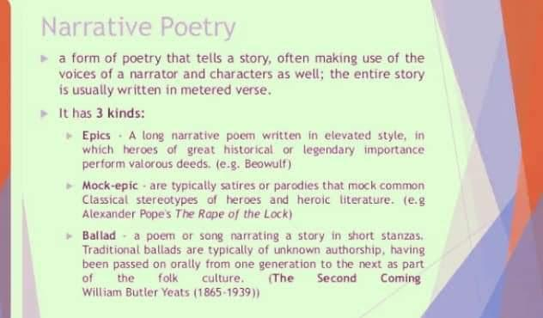

**EXAMPLE 1: "The Raven" by Edgar Allan Poe**

"And the Raven, never flitting, still is sitting, still is sitting

On the pallid bust of Pallas just above my chamber door;

And his eyes have all the seeming of a demon's that is dreaming,

And the lamp-light o'er him streaming throws his shadow on the floor;

And my soul from out that shadow that lies floating on the floor

Shall be lifted—nevermore!"

1. **Elements of Poetry**

The main elements of poetry include:

* 1. **Form**: The structure or pattern of a poem, including its rhyme scheme, meter, and stanzas.
* **Rhyme scheme** refers to the pattern of rhymes in a poem, typically indicated by letters representing the rhyming words. For example, in the rhyme scheme ABAB, the first and third lines rhyme with each other, and the second and fourth lines rhyme with each other.
* **Meter** refers to the rhythm of a poem, created by the pattern of stressed and unstressed syllables in a line. Common meters include iambic pentameter, where each line has ten syllables with alternating stressed and unstressed syllables, and trochaic tetrameter, where each line has eight syllables with a stressed syllable followed by an unstressed syllable.
* **Stanzas** are the groupings of lines in a poem, similar to paragraphs in prose. Stanzas can vary in length and structure and may have a consistent rhyme scheme and/or meter throughout. A poem may have several stanzas or just one. Stanzas can help to organize a poem and emphasize certain ideas or themes.
* two lines are called a couplet
* three lines are called a tercet
* four lines are called a quatrain
* five lines are called a cinquain
* six lines are called a sestet, or occasionally a sexain
* seven lines are called a septet
* eight lines are called an octave
  1. **Figurative language**: The use of language to create figures of speech, such as similes, metaphors, and personification.
  2. **Imagery**: Imagery refers to the use of descriptive language to create mental pictures and sensory experiences for the reader. This can include descriptions of sights, sounds, smells, tastes, and textures. Effective use of imagery can help to enhance the overall mood and tone of a poem.
  3. **Tone**: Tone refers to the author's attitude toward the subject matter or audience of the poem. Tone can be conveyed through word choice, imagery, and other poetic devices, and can range from playful and lighthearted to serious and somber. While
  4. **The mood**: The mood of a poem refers to the feeling it evokes in the reader.
  5. **Theme**: Theme is the underlying message or meaning of a poem. It is the central idea or concept that the author is trying to convey. Themes can be universal or specific to the author's own experiences or worldview.
  6. **Symbolism**: Symbolism is the use of objects, colors, or other concrete details to represent abstract ideas or concepts. For example, a rose might be used as a symbol of love or beauty, while a skull might represent death or mortality.
  7. **Sound**: Sound refers to the use of rhythm, rhyme, alliteration, and other sonic elements in poetry. These elements can help to create a musical quality to the poem and enhance its emotional impact on the reader.
  8. **Diction**: The choice and use of words and phrases in a poem, including their connotations and denotations.

By understanding these elements of poetry and how they work together, readers can gain a deeper appreciation for the craft and meaning of a poem. Similarly, by incorporating these elements into their own writing, poets can create more powerful and impactful works.

* **A metaphor**: A metaphor is an implied comparison between two objects or ideas, while
* **Personification**: involves giving human qualities to animals or inanimate objects.
* **A simile**: is a direct comparison using the words "like"or "as."
* **A symbol**: A symbol is a word or object that represents another word, object, or idea, carrying its own meaning.
* **Alliteration**: Alliteration involves the repetition of initial consonant sounds in a series  
  of words. It is used to create rhythm and musicality in a text.  
  Example: "She sells seashells by the seashore."
* **Assonance**: Assonance is the repetition of vowel sounds within words in close  
  proximity. It can create a sense of harmony or musicality.  
  Example: "The rain in Spain falls mainly on the plain."
* **Consonance**: Consonance involves the repetition of consonant sounds, especially at  
  the end of words, to create a pleasing or musical effect.  
  Example: "The little boat floated on the peaceful sea."