# Chapter 03: Consumption reserves and developments

**Introduction:**

The world’s final energy consumption in 2009 was almost 8.4 billion tonnes of oil equivalent (Key World Energy Statistics 2011, IEA). More than 40% between 1990 and 2008. Other estimates place global consumption of energy at 12.2 billion toe.

Global energy consumption is set to skyrocket: it is estimated that global energy will represent 570 to 600 exajoules per year in 2020.

According to a study by the IEA (International Energy Agency) from renewables will account for 25% of the total electricity mix in 2018. The production growth will reach 4% between 2012 and 2018 at 685 TW/h or +6% per year. It has already increased by 8.5% in 2012.

Renewable energies, hydropower at the top of the list, account for 8% of the electricity mix (from 2% to 4% between 2006 and 2011). The IEA study predicts an increase in to 11% in 2018.

Experts have developed 3 forecasts to estimate the growth of consumption global energy. The needs will at least double and could even quadruple In 2100 from 830 to 1750 exajoules per year.

he reagent can be kept dry for several months. In winter, the circuit is reversed, the outside air is moist circulates through the reagent which, by re-humidifying itself, will release heat thanks to to an exothermic chemical reaction. The heated air (around 70°C) passes through the heat exchanger and gives its heat to the water that will flow to the balloon and allow a sanitary use.

One of the difficulties encountered when doing such an analysis is the multiplicity of energy units used (tonnes oil equivalent, TW.h, exajoule EJ...).

Some useful equivalents when analyzing large data available in different sectors:

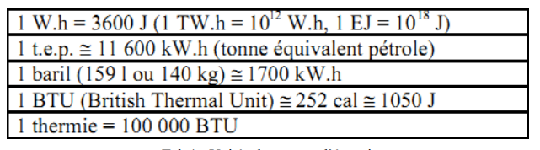

**Tab 1: Energy Units.**

The average energy values of the main fuels are given in Table 2:

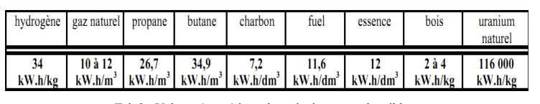

**Tab 2: Energy values of the main fuels.**

**1. Resources and energy consumption:**

**1.1. The oil:**

Oil reserves are difficult to estimate and are the subject of many controversies. There are about 30,000 profitable deposits, ranging from a few a few hundred km2. Among them, there are 450 to 500 so-called "giant" deposits (with reserves of more than 70 million tonnes) , of which about 60 "supergiants" (with reserves exceeding 700 million tonnes). 60% of the "super-giants" are in the middle east.

The Middle East will remain the main production area, but other regions have a high potential: Russia, West Africa, Brazil and the Gulf of Mexico.

central (Kazakhstan, Turkmenistan) is also, but transport problems towards the sea hinder its development.

**1.2. Natural gas:**

According to the International Gas Industry Union, conventional reserves of natural gas is 65 years of production at the current rate. Approximately 40% of reserves are concentrated in the world’s 25 or so giant deposits, two of which found in Europe (Groningen in the Netherlands and Troll in the Norwegian North Sea). Improved exploration techniques should increase reserves accessible.

Known reserves of natural gas are mainly in the Middle East (40.1%) and Russia (32.4%).

**1.3. Coal:**

Coal reserves, abundant and geographically well distributed, are estimated to 471 billion toe. Coal is, in general, mainly consumed in the country producer.

**1.4. Uranium:**

The uranium ore reserves currently exploited are dispersed in many countries (26% in the former Soviet Union, 27% in Australia, 17% in America in the North and 20% in Africa). At current consumption rates (about 450 reactors are in service worldwide) and without taking into account abundant storage, reserves of uranium should cover at least the next 50 years.

**1.5. Solar energy:**

The earth’s surface receives 1.6 1018 kW. h (equivalent to one power continuous 180 106 GW, 30% are directly reflected in space, 45% are absorbed, converted into heat and radiated in the infrared.

The remaining 25% feed hydrological cycles (24%) and photosynthesis (0.06%) is equivalent to an average of 45 106 GW.

The energy radiated to the ground is worth about 720.1015 kW. Depending on the regions, the energy received the surface of the earth varies, per m2, from 1100 kW h. to 2300 kW h/year, or power average (spread over the year, taking into account day-night alternation and periods clouds) from 120 to 260 W per m2 and a peak power of more than 1 kW/m2.

This energy can be directly converted into heat with excellent efficiency or, again, in electricity but under considerably less good conditions.

Part of this energy is used for photosynthesis: 950.1012 kW. h, which leads to the slow production of combustible materials such as wood or fossil fuels (coal, oil, natural gas). Fossil fuels unlike wood are the result of a long accumulation and cannot be considered as renewable.

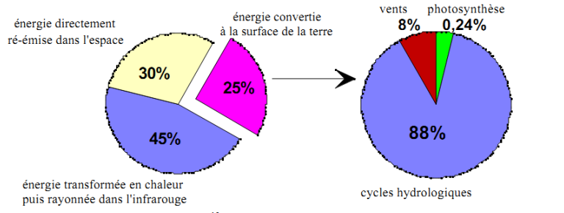

**Fig.1 Distribution of the 1600 1015 kW. h received annually from the sun by the earth.**

**1.6. Water power:**

Today, hydropower is the main renewable energy used for the production of electricity. Technically exploitable hydropower, is 25.1012 kWh (15.1012 kW h, or about 5 to 8 times what is already being exploited. The potential is already well used in OECD countries but it can still develop in many developing countries.

**1.7. Wind energy:**

The world’s exploitable resources are enormous and estimated at 1.1015 kW h/year. In France, on the coasts, the reserve is 4000 to 6000 kW. h/m2, in the lowlands, 300 to 1000 kW is obtained. h/m2 (the area counted is that of the propeller facing the wind, horizontal axis). Thus a propeller of 40 m diameter brews 1200 m2 and will produce on a site at 1000 kW. h/m2, about 1.2.106 kW. h per year. The wind field French is estimated at 60.109 kWh. or 13% of current production of electricity.

**1.8. Geothermal energy:**

The Earth’s melting core emits an energy corresponding to a power estimated at 35,000 GW or an annual energy of 300.1012 kWh. Depending on the location, the flow Geothermal ranges from 0.05 to 1 W/m, which is very low in relation to radiation solar. The usable reserves are about 26.1012 kW. h in high energy (150 to 350°C, used for electricity generation) and 280.109 kWh in low energy (50 to 90°C for heating).

**2. Some figures on energy consumption:**

In 1960, developing countries consumed 23% of energy world share in 1995 has risen to 30% and it is estimated that by 2020 it will be of 42%. One of the most optimistic estimates is that world consumption of energy should increase by 50% by 2020:



**Tab 3: Increase in energy consumption from 1995 to 2005.**

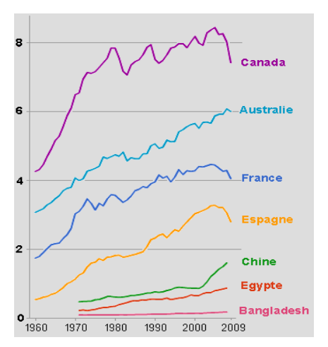

**Fig.2 Energy consumption per capita from 1960 to 2009 in Toe.**

1. **Some figures concerning Algeria:**

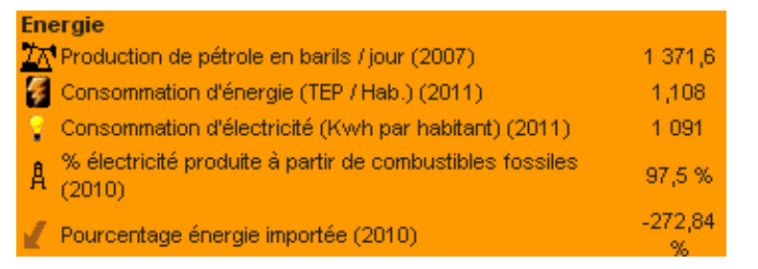

**Fig.3 Energy consumption in Algeria.**