[**Chapter N01: Energy**](https://transportgeography.org/contents/chapter4/transportation-and-energy/#1_Energy)

**Introduction:**

Human activities depend on using several [forms and sources of energy](https://transportgeography.org/?page_id=5832) to perform work. The more available and affordable energy sources are, the more capabilities and opportunities can be mobilized. The [energy content](https://transportgeography.org/?page_id=5837) (or energy density) of an energy source is the available energy per unit of weight or volume. Still, the challenge is to extract and use this energy effectively. Thus, the more energy consumed, the greater the amount of work realized, with [economic development](https://transportgeography.org/contents/chapter4/transportation-and-energy/primary-energy-consumption-countries-1965-2020/) correlated with higher energy consumption levels. There are four [types of physical work](https://transportgeography.org/contents/chapter4/transportation-and-energy/energy-and-work/) related to human activities:

* **Modification of the environment**. Activities involved in modifying the landscape to make it suitable for human activities, such as clearing land for agriculture, modifying the hydrography (irrigation), constructing infrastructures such as roads, and building and conditioning (temperature and light) enclosed structures.
* **Appropriation of resources**. Involves the extraction of agricultural resources from the biomass and raw materials (minerals, oil, lumber, etc.) for human needs. It also includes waste disposal, which is, in advanced economies, very work-intensive to dispose of safely (e.g. collection, treatment, and disposal).
* **Processing resources**. Concerns the modification of products from biomass, raw materials, and goods to manufacture according to economic needs. Since the Industrial Revolution, work related to processing resources was considerably mechanized, initially with simple machines, then assembly lines, and currently with automation.
* **Transportation**. The mobility of passengers and freight aims to attenuate the spatial inequalities in the location of resources and markets by overcoming distance. The lower the energy costs per ton or passenger-kilometer, the less transportation is an economic burden. Overcoming space in a global economy requires a substantial amount of energy and has consequently been subject to economies of scale. Vehicles and terminal equipment consume energy, while cargo needs to be bundled, sorted, and unbundled.

Lower energy prices in terms of efforts to extract and ease of application involve more opportunities to perform physical work. There are enormous reserves of energy able to meet the future needs of humanity. However, one of the leading contemporary issues is that many of these reserves are not necessarily widely available at competitive costs or are unevenly distributed worldwide. Oil reserves, solar energy, and wind energy are distributed according to well-defined criteria. The geography of energy reveals complex differences in the availability of energy sources and supply and demand patterns. Still, the availability or the competitiveness of an energy source can improve with technological development, implying dynamics in the geography of energy. Even if some energy sources are extracted far from where they are consumed, the massification of transportation enables their mobility, particularly for petroleum and coal.

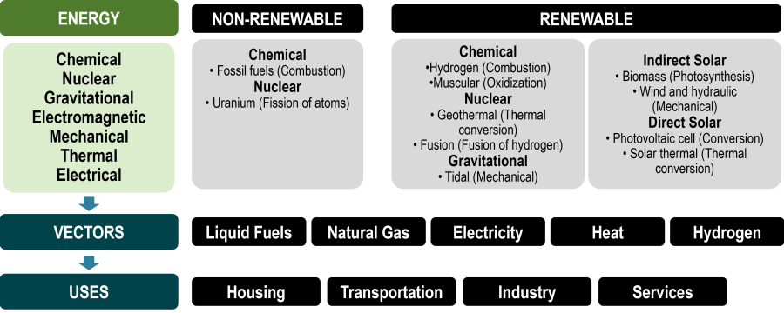

**Fig 01. Sources of Energy.**

[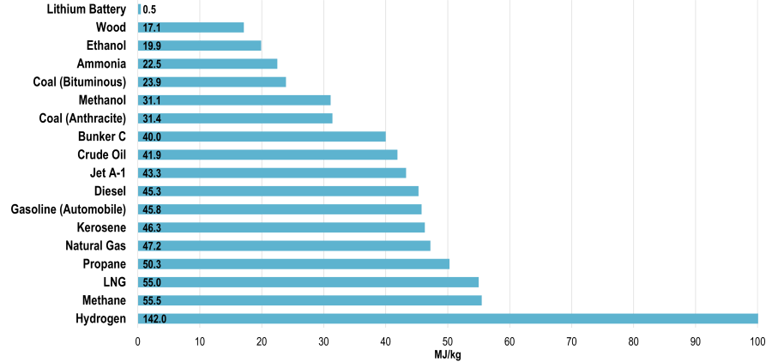](https://transportgeography.org/?page_id=5837)

**Fig 02: Chemical Energy Content of some Fuels in MJkg.**

[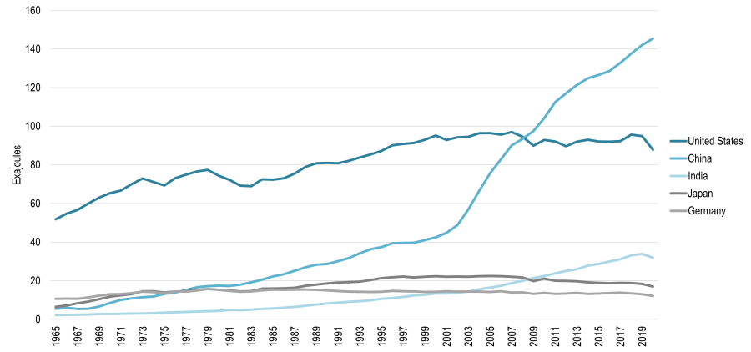](https://transportgeography.org/contents/chapter4/transportation-and-energy/primary-energy-consumption-countries-1965-2020/)

**Fig 03: Primary Energy Consumption Selected Countries.**

[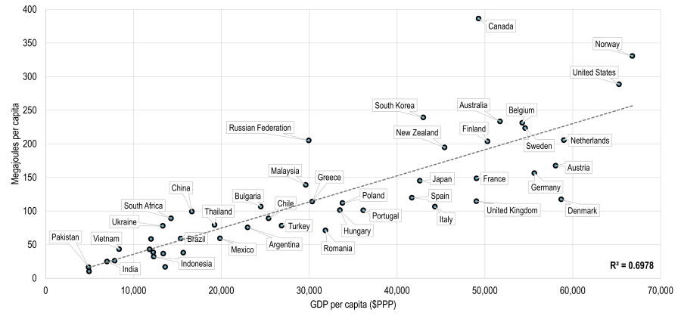](https://transportgeography.org/contents/chapter4/transportation-and-energy/primary-energy-consumption-gpd-per-capita/)

**Fig 04: Primary Energy Consumption and GPD Per Capita 2019.**

[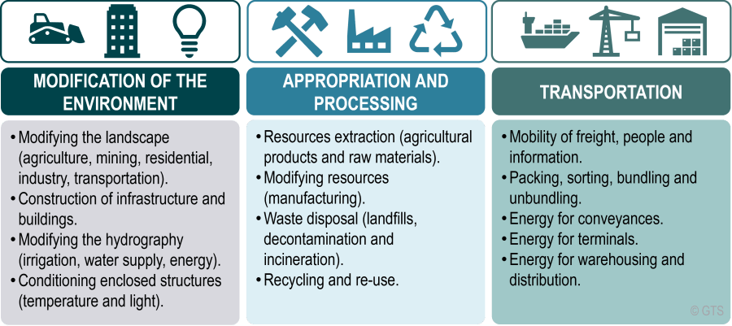](https://transportgeography.org/contents/chapter4/transportation-and-energy/energy-and-work/)

**Fig 05: Energy and Work.**

Throughout the [history of energy use](https://transportgeography.org/?page_id=5844), the choice of an energy source depended on several **utility factors** that involved a [transition in energy systems](https://transportgeography.org/?page_id=5849) from solid, liquid, and eventually to gas sources. Since the industrial revolution, efforts have been made for work to be [performed by machines](https://transportgeography.org/?page_id=5860), which considerably improved industrial productivity. The energy sources used for this mechanization substantially impacted energy demand patterns. The development of the steam engine and the generation and distribution of electric energy over considerable distances have also altered the spatial pattern of manufacturing industries by liberating production from a direct connection to a fixed power system. While in the earlier stages of the industrial revolution, factories located close to sources of energy (a waterfall or a coalfield) or raw materials, mass conveyances, and new energy sources (petroleum and electricity) enabled much greater locational flexibility.

Industrialization placed considerable demands on fossil fuels through its processes and outcomes. At the turn of the 20th century, the invention and commercial development of the internal combustion engine, notably in transport equipment, expanded the mobility of passengers and freight and incited the development of a global trade network. The setting of **industrial and energy systems** is interrelated. With globalization, transportation accounts for a growing share of the total energy spent on implementing, operating, and maintaining the international range and scope of economic and social activities.

Energy consumption strongly [correlates with the level of development](https://transportgeography.org/contents/chapter4/transportation-and-energy/primary-energy-consumption-gpd-per-capita/), with transportation accounting for between 20 and 25% of consumed energy among developed economies. The benefits conferred by additional mobility, notably in terms of better comparative advantages and resource access, have required a growing amount of energy to support this expanded spatial system. At the beginning of the 21st century, the transition reached a stage where [fossil fuels](https://transportgeography.org/?page_id=5865), such as petroleum, dominate. Of the [world’s total power production](https://transportgeography.org/?page_id=5855), 80% is derived from fossil fuels, a share that has been steadily declining as an **energy transition unfolds.**

[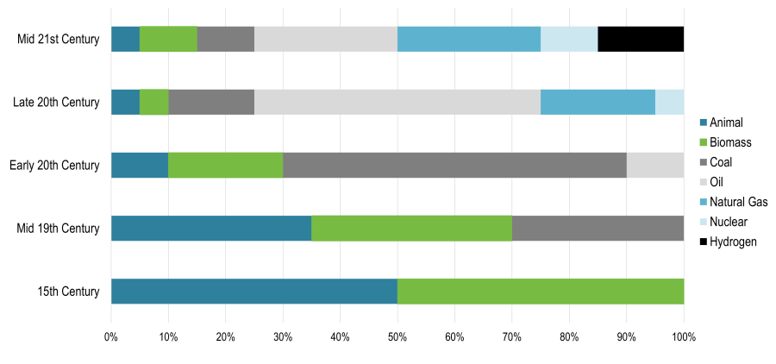](https://transportgeography.org/?page_id=5844)

**Fig 06: Evolution of Energy Sources.**

[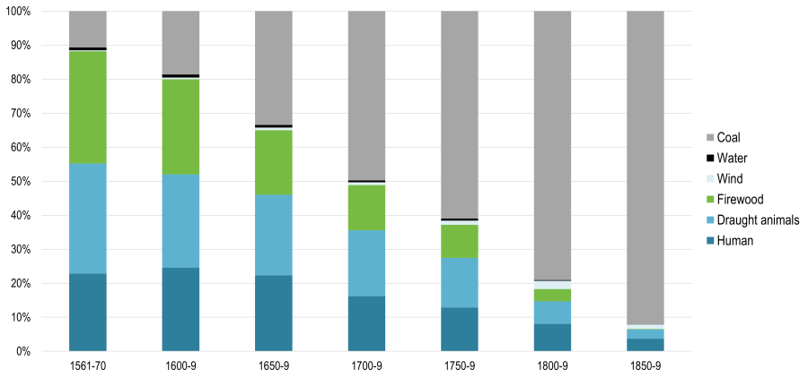](https://transportgeography.org/?page_id=9183)

**Fig 07: Annual Energy Consumption in England and Wales 1560s to 1850s.**

[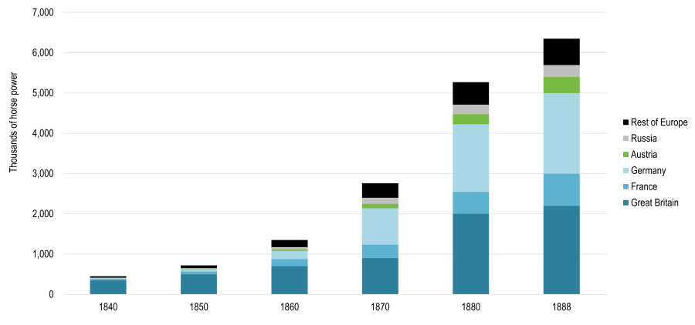](https://transportgeography.org/?page_id=5860)

**Fig 08: Power Generated by Steam Machines Europe 1840 1888.**

[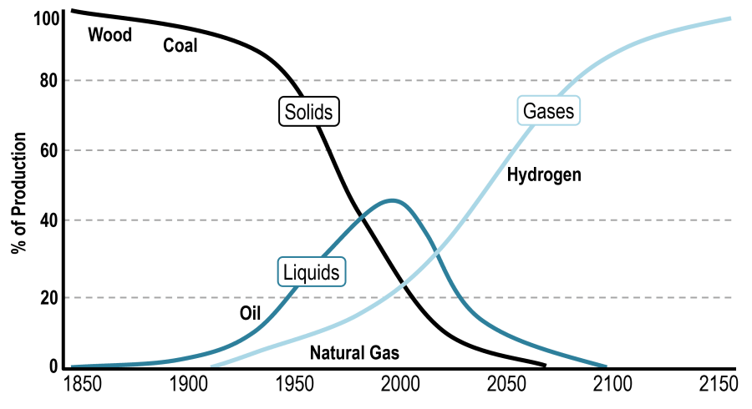](https://transportgeography.org/?page_id=5849)

**Fig 09: Global Energy Systems Transition.**

[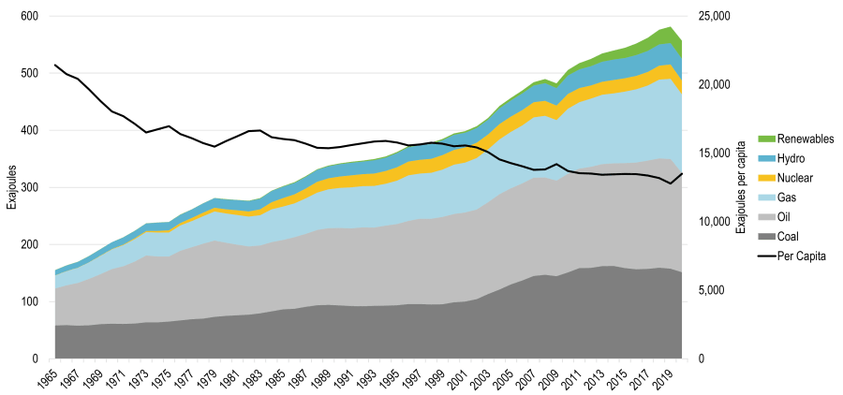](https://transportgeography.org/?page_id=5865)

**Fig 10:** **World Energy Consumption.**

[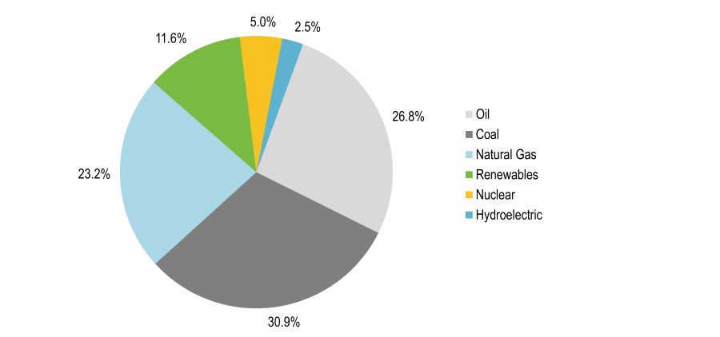](https://transportgeography.org/?page_id=5855)

**Fig 10:** **World Energy Production 2019.**