General Course Objectives
The present lecture as the title suggests, strives to introduce our students to key components of effective communication in contemporary organizational life, which are required in any communicative situation so that a message is properly conveyed; this includes skills such as active listening, non-verbal communication (i.e. body language) and more. Educating students on these kinds of skills is of critical importance not only for efficient cross-cultural communication but also for effective communication strategies after.
Attempting to introduce this lecture to our students helps them attain the following objectives listed as follows:
- Explain the concept of communication.
- Identify and describe the essential components of communication.
- Describe different types of communication.
- Examine the various models of communication.
- Identify various barriers which exist in the process of communication.
- Suggest strategies for effective communication.
Expected Outcomes:
By the end of this lecture, the students are expected to be able to
- Understand the meaning and concept of Communication
- Understand the Process of Communication.
- Understand the importance of Communication.
- Understand the functions of Communication
- Distinguish between interpersonal and intrapersonal communication types of communication)
- Analyse barriers to effective communication.
  - Introduction
“Where language is a tool, communication is an experience”.
On the basis of this expression, which actually demonstrates how language and communication go hand in hand, one can really confirm that nothing can be successfully accomplished unless communication is available. That is, all that ever has been accomplished by humans and all that ever will be accomplished involves communication with others. It is a main linguistic tool for communicating, exchanging ideas, and building interpersonal relationship with people. As a matter of fact, many social and organizational problems derive from unsatisfactory relationships brought about by inadequate communication between people. Success on and off the job often stems from one’s ability to transfer information and express ideas to others. Effective communication is therefore frequently the results in friendships that are more meaningful, smoother and more rewarding on and off the job, and increased ability to meet personal needs. Psychologist Abraham Maslow (1970) suggests that the capability to satisfy personal needs arises mainly from the ability to communicate.

  - Communication Defined: Meaning and Concept
The word communication has been derived from the Latin word 'communicare’ meaning 'common' which consequently implies common understanding. Basically, this term is commonly defined in various ways. Generally it is understood as a process of exchange of ideas, views, facts, feelings etc between or among people to create common understanding, information with others, which includes thinking, dreaming, speaking, arguing and so on. Thus, the scope of communication is very wide.
According to Crane, et. al. (1981:3—4), communication is a process in which information is transmitted from a source—the sender—to a goal—the receiver.

Communication is part skill, part art and part science. As a skill, it involves certain fundamental techniques, it is an art as it involves creative challenges, and it is science because certain verifiable principles are involved in making communication more effective. All this makes communication a complex process. (Pamela Chester, 2019).
As an art and science, Communication is requisite for life for it enables us to share and exchange ideas and information. It sustains businesses, schools, governments, hospitals. Therefore, communication tends to represent a mirror as it defines us, reveals our personality, our connections, and our ability to reason. If it were unavailable, then we could not survive and we would not even exist. If communication were only science, then art would not exist. There would not be a way to describe how an individual feels. If communication were only art, then science would not exist. There would not be a way to describe science because pure scientific writing is void of art. Science and scientific writing is reproducible. It is not formed by deliberating arranging words to cause emotion. (Chester, 2019).

To well understand the concept of communication as a linguistic phenomenon, it seems indeed wiser to examine its various definitions put forward by different scholars.

Communication is described as, “an act of interchanging ideas, information, or messages from one person or place to another, via words or signs which are understood to both parties.” It’s a crucial activity for any group of beings, because it is the means by which members of the group cooperate together.
Communication is not a static act but a dynamic process, which is continuous in nature and vital for teaching and learning. It involves the usage of a channel. This channel could be signs, symbols or verbal or written language. For communication to be complete and effective it has to achieve the desired objectives as intended by the communicator.

  - The Process of Communication Behaviour

Communication is necessary for any group to function effectively. It is, at its core, a two-way activity, consisting of seven major elements: sender, message, encoding, channel, receiver, decoding, and feedback which are required and needed in any communicative situation:
- A source or sender
The source initiates a message. This is the origin of the communication and can be an individual, group or inanimate object. The effectiveness of a communication depends to a considerable degree on the characteristics of the source. Three conditions are necessary for successful encoding the message.
- Skill: Successful communicating depends on the skill you posses. Without the requisite skills, the message of the communicator will not reach the requisite skills; the message of the communicator will not reach the receiver in the desired form.
- Attitudes:
Our attitudes influence our behaviour. We hold predisposed ideas on a number of topics and our communications are affected by these attitudes.
- Knowledge:
We cannot communicate what we don't know. The amount of knowledge the source holds about his or her subject will affect the message he or she seeks to transfer. ( Koontz & O'Donnell, 2018).

- An addressee or receiver
Once the source has decided what message to communicate, the content of the message must be put in a form the receiver can understand. As the background for encoding information, the sender uses his or her own frame of reference. It includes the individual's view of the organization or situation as a function of personal education, interpersonal relationships, attitudes, knowledge and experience.
Like the sender, the receiver is subject to many influences that can affect the understanding of the message. Most important, the receiver will perceive a communication in a manner that is consistent with previous experiences. Communications that are not consistent with expectations is likely to be rejected.
- Channel
The actual means by which the message is transmitted to the receiver (Visual, auditory, written or some combination of these three) is called the channel. The channel is the medium through which the message travels.
- Message
Is usually in a recognizable form of text or utterance made up from the inventory of, a code. The message is the actual physical product from the source encoding. The message contains the thoughts and feelings that the communicator intends to evoke in the receiver. The message has two primary components:
- The Content:
The thought or conceptual component of the message is contained in the words, ideas, symbols and concepts chosen to relay the message.
- The Affect:
The feeling or emotional component of the message is contained in the intensity, force, demeanour (conduct or behaviour), and sometimes the gestures of the communicator.
According to D.K Berlo - "when we speak, the speech is the message. When we write, the writing is the message. When we paint, the picture is the message. When we gesture, the movements of our arms, the expressions on our faces are the message". (2018)
- Code
Code is the form in which the message is sent. It might be in the form of language, text, video, etc
- Topic
Communication is usually about a particular topic, within a physical and social context common to the participants in the communication situation. The context of the communication interaction involves the setting, scene, and expectations of the individuals involved.

- Feedback
When you respond to the source, intentionally or unintentionally, you are giving feedback. Basically, it is a composed of messages the receiver sends back to the source. Verbal or nonverbal, all of these feedback signals allow the source to see how well, how accurately (or how poorly and inaccurately) the message was received. Feedback also provides an opportunity for the receiver or audience to ask for clarification, to agree or disagree, or to indicate that the source could make the message more interesting. As the amount of feedback increases, the accuracy of communication also increases.
All in all, to recapitulate what has been previously stated, it might seem wiser to consider the following figure that describes components of the communication process.

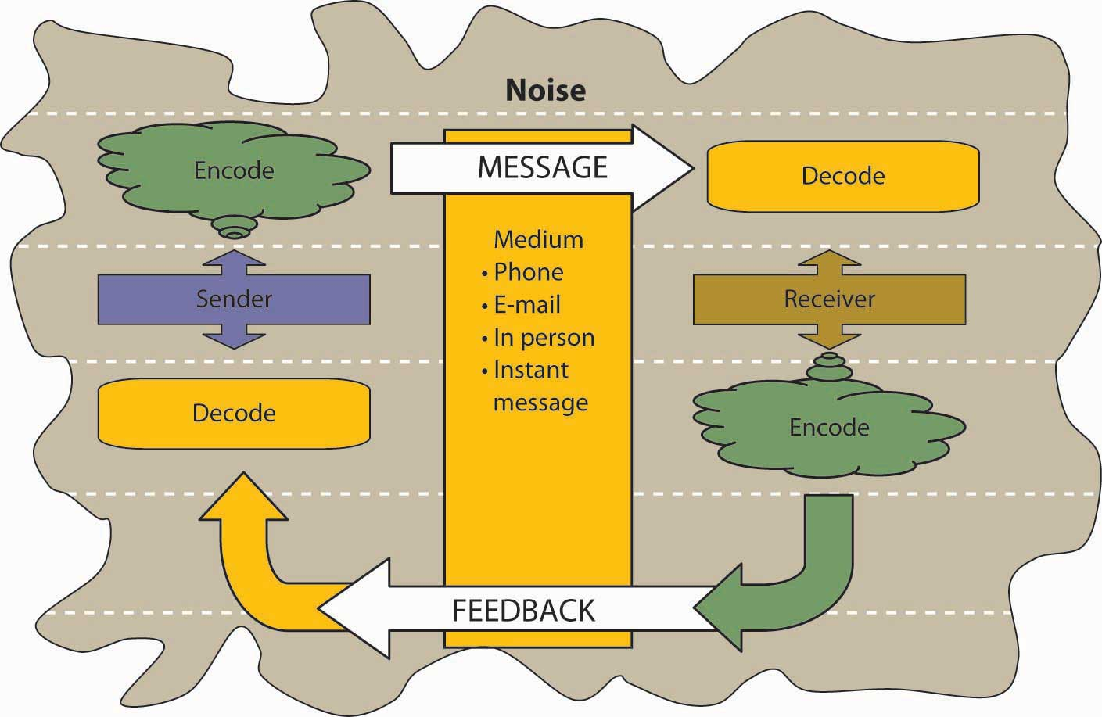
The communication Process Model

  - Examples of communication situations

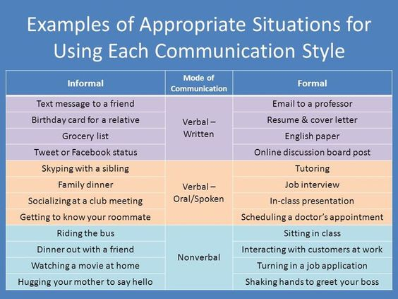
Retrieved from:yourarticlelibrary.com

Situation1 | Situation 2
1-sender: doctor | 1-sender: teacher
2-receiver: patient | 2-receiver: students
3-channel: face to face | 3-channel: face to face
4-message:spoken when the doctor explains the pathology to the patient/ and written when he prescribes the medical drugs relevant to the patient's disease | 4-message:spoken when the teacher explains the lesson and written for the dictation
5-code: French , Arabic, English | 5-code:French , Arabic, English
6-topic: topic discussion | 6-topic: topic discussion
7-Social/physical context: private cabinet or hospital | 7- Social/physical context:school or university

  - Lecture Summary
In gross, communication is a matter of passing or exchange of information distinguishes what is living and what is non-living in nature. It is found even in the apparently passive world of plants; trees, for example, which evidently have been found to pass on information about advancing predators by means of chemical signals.

Related to the human communication system, we should note that there are three systems of human communication. The three systems are in the form of speech, writing, and gesture. For most people, speech is the basic system of communication. Writing, however, allows the preservation of communications over space and through time, and its great importance in human history and in complex societies would be hard to overestimate. The role of gesture is less obvious. Among the deaf, of course, it may replace speech as the principle form of communication; but for most people it is an important supplement to speech. Together these systems allow us to communicate in a variety of situations with subtle shades of meaning (Crane et. al., 1981:14).

References

Jufrizal, M.Hum. Language and Linguistics.
https://www.wisdomjobs.com/
Adler, R, & Towne, N. (1978). Looking out/ looking in (2ne edition). New York: Holt, Rinehart and Winston.
Maslow, A. (1970). Motivation and Personality. New York : Harper & Ro

