Prof.Radia Benyelles
Linguistics /L1
Course number 1

Levels of language
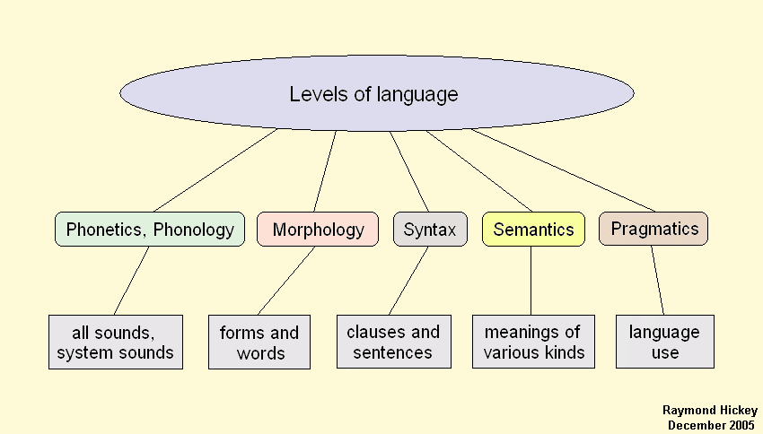

levels of language refer to the way language itself is organised and hence analysed by linguists
Phonetics, Phonology
- Definition
This is the level of sounds. One must distinguish here between the set of possible human sounds, which constitutes the area of phonetics proper
Phonology is concerned with classifying the sounds of language and with saying how the subset used in a particular language is utilised, for instance what distinctions in meaning can be made on the basis of what sounds.
- Some useful concepts
A phoneme is the smallest contrastive unit in the sound system of a language. In many phonological theories the phoneme is the smallest contrastive unit in the sound system of a particular language or dialect. It is the minimal unit that distinguishes between meanings of words
Phonetics is divided into three types:

- Articulatory phonetics : production of sounds
- Acoustic phonetics : transmission of sounds
- Auditory phonetics : perception of sounds.

- Sounds can be divided into consonants and vowels. The former can be characterised according to 1) place, 2) manner of articulation and 3) voice (voiceless or voiced).
- For vowels one uses a coordinate system called a vowel quandrangle( A vowel diagram or vowel chart is a schematic arrangement of the vowels) within which actual vowel values are located.

