Module: Linguistics
Level: L2
Teacher's Name: Dr. HAKEM Hadia

Lecture One: An Introduction to Pragmatics

“Pragmatics” is one of the fields of macrolinguistics. It is concerned with the notion of implicature, i.e., implied meaning as opposed to the mere lexical meaning expressed. (Grice, 1968)
Definitions and Background
Pragmatics is:
- The study of contextual meaning communicated by a speaker or a writer, and interpreted by a listener or a reader. (G. Yule)
- “The study of the relation of signs to their interpreters”.(Charles Morris,1938, p.6)
- “The study of the relations between linguistic forms and its users (…) Only pragmatics allows humans into the analysis: their assumptions, purposes, goals and actions they perform while speaking”. (G. Yule)
- “The study of language from the point of view of users, especially of the choices they make, the constraints they encounter in using language in social interaction and the effect their use of language has on other participants in the act of communication”. (Crystal, 1997, p.301)

Pragmatics is also …
- The study of speakers’ meaning. This refers to what people mean by their utterances rather than what the words or phrases might mean by themselves.
- The study of contextual meaning. This refers to the importance of the context, i.e. the circumstances and the audience or public.
- The study of how more gets communicated than said.
- The INFERENCES made by listeners or readers in order to arrive at an interpretation of the intended meaning.
- A great deal of what is UNSAID is recognized as part of what is communicated.
- The study of the “invisible meaning”.
- The study of the expression of relative distance. It means that the CLOSENESS or DISTANCE of the listener or reader determines how much needs to be said.
e.g.: A: There is a store over there. (Let’s go inside.)
B: No. (I don’t want to go inside.)
A: Why not? (Why don’t you want to go inside?)
B: I’m tired. (I don‘t want to because I’m tired.)
In other words, pragmatics studies how people make sense of each other linguistically. Look at the following example.
e.g.: A: So, did you?
B: Hey, who wouldn’t?
Two friends in a conversation may imply some things and infer some others without providing any clear linguistic evidence. So, pragmatics requires us to make sense of what people have in mind.
More explanation to what is stated above is provided below.
- Pragmatics is the study of speakers’ meaning.
It is concerned with the study of meaning as communicated by a speaker (or writer) and interpreted by a listener (or a reader). It has, consequently, more to do with the analysis of what people mean by their utterances than what the words or phrases in those utterances might mean by themselves. It should be recalled at this level that pragmatics is different from semantics even though both of t
Pragmatics vs Semantics
Pragmatics is concerned with four areas:
- Pragmatics is the study of speaker meaning.
- Pragmatics is the study of contextual meaning.
- Pragmatics is the study of how more gets communicated than is said.
- Pragmatics is the study of the expression of relative distance.
Semantics is concerned with:
- The meaning of the words and language.
- It also refers to the multiple meanings of words as well and sense relations existing between words.

- The study of contextual meaning
This type of study necessarily involves the interpretation of what people mean in a particular context and how the context influences what is said. It requires consideration of how speakers organize what they want to say in accordance with who they are talking to, where, when and what circumstances.
- The study of how more gets communicated than said.
This approach also necessarily explores how listeners can make inferences about what is said in order to arrive at an interpretation of the speaker’s intended meaning. This type of study explores how a great deal of what is unsaid is recognized as part of what is communicated. We might say that it is the investigation of the invisible meaning.
- The study of the expression of relative distance.
This perspective, then, raises the question of what determines the choice between the said and unsaid. The basic answer is tied to the notion of distance. Closeness, whether it is physical, social, or conceptual, implies shared experience. On the assumption of how close or distant the listener is, speakers determine how much needs to be said.
It can be summarized that …
- Pragmatics is the study of the relationships between linguistic forms and the users of those forms.
- The advantage of studying language via pragmatics is that one can talk about people’s intended meanings, their assumptions, their purposes or goals, and the kind of actions (for example, request) that they are performing when they speak.
- The big disadvantage is that all these very human concepts are extremely difficult to analyze in a consistent and objective way.
There are some elements which make the pragmatic competence. They are depicted in the following diagram:
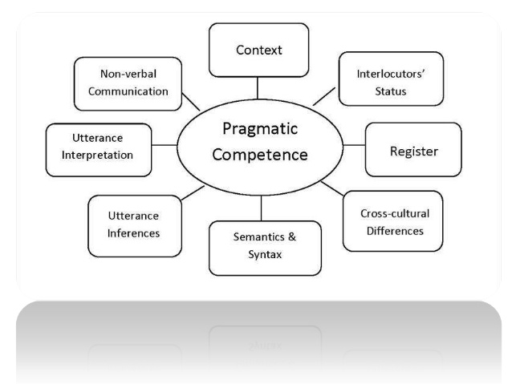

The notion of pragmatic competence was defined by Chomsky (1980) as the "knowledge of conditions and manner of appropriate use (of the language), in conformity with various purposes" (p.224).
Culture-Specific Pragmatic Features
Many culture-specific pragmatic features are implicit, but they are nonetheless central in communicative encounters. The following are just some examples:
- Mental sets: a frame of mind involving an existing disposition to think of a problem or a situation in a particular way (Sternberg, 1995, cited in Zegarac & Pennington 2000, p. 166); e.g.: what is the meaning of an offer of coffee after a meal? Is it an invitation by the host to stay a little longer or a polite hint to guests that it is time to leave?
- Schemata: a pre-existing knowledge structure in memory involving a certain pattern of things (Yule, 1996); e.g.: what constitutes an apartment, a holiday, a school, a restaurant, etc.
- Scripts: a pre-existing knowledge structure for interpreting event sequences (Yule, 1996, p. 87); e.g.: a visit to the doctor, shopping at a supermarket, phoning to make an appointment at a hairdressing salon, etc.
- Speech events: a set of circumstances in which people interact in some conventional way to arrive at some outcome (Yule, 1996, p. 57); e.g.: how does one make a request, a compliment, express disagreement or a complaint, etc.?
- Sociocultural norms determine culturally appropriate paralinguistic, phatic utterances, openings/closings, turn-taking, the use of silence etc. (Barraja-Rohan, 2000, p. 65)
- Linguistic etiquette determined by factors such as relative social distance between interlocutors, social power or authority, the degree of imposition associated with a given request or other face-threatening acts, etc. (Kasper, 1997, p. 381).
- Pragmatic accent aspects of a person's talk which indicate what s/he assumes is communicated without being said (Yule, 1996, p. 88).
Inter-cultural Pragmatic Failure
Pragmatic errors are the result of an interaction imposing the social rules of one culture on someone’s communicative behaviour in a situation where the social rules of another culture would be more appropriate (Riley 1989: 234). The following table included some example showing the cross-cultural pragmatics.
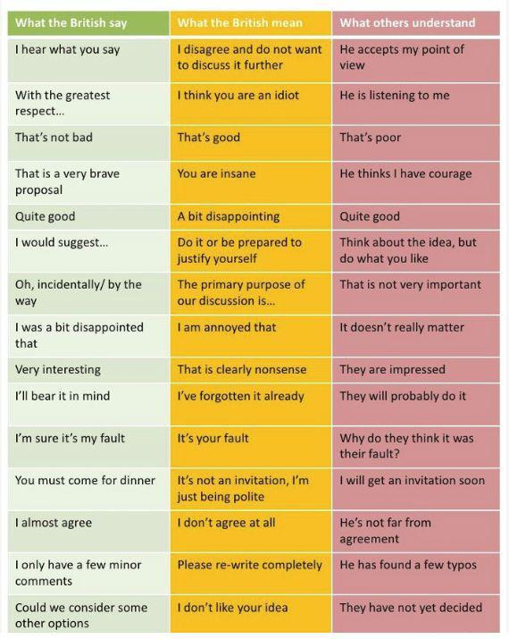
Further Reading:
- George Yule (2006, 2010). Pragmatics. In The Study of Language. 3th or 4th edition. Cambridge: Cambridge University Press.
Retrieved from: https://fac.ksu.edu.sa/sites/default/files/cambridge.the_.study_.of_.language.4th.edition.apr_.2010.ebook-elohim.pdf

