Exercise n: 1

Complete the sentences with the verb in brackets in past simple or present
perfect.

1. She loves Paris. She has been.... (be) there many times.
2. Bill has worked (work) in that company for 3 years. (He still works there).
3. They ..went .... (go) to London on holiday last summer.
4. I ..... have read ..... (read) that book. It´s good.
5. His parents . were... (be) here yesterday.
6. They ........went (go) to Germany when he .....was ...... (be) only 4.
7. did ... you ..watch .. (watch) a film last night?
8. I .. had ... (have) some toast when I got up.
9. He has lived .. (live) in Rome since he was a teenager.
11. I didn’t see . (not see) you in class last Friday.
12. Shakespeare...wrote ...... (Write) a lot of plays.
13. My brother has written ….(write) several plays. He has ..just finished (finish) his latest.

Exercise n:2

Say if the following sentences are right or wrong. Correct them if necessary.

1. Have you ever been to Thailand?.................................................C...................................

2. I can't go out because I haven’t finished my homework yet. Wrong …….

3. She enjoyed herself at the party last night. ...................wrong................................

4. I´ve read that book but I didn´t like it much. ...........right…………….

5. Tom left school one year ago. Wrong ……………

6. My cousins have lived in Dubai since they were children. Wrong ………….

7. We have worked here for a year and a half............................Right..................................

8. My parents lived in Britain for a couple of years. ............Right

9. James made a cake yesterday. ....Wrong..............................................................

10. I´ve washed the car. It looks great now. ..............Right ..................................

11.who discovered America?……………………wrong …………………………..

12. She arrived in London three days ago. She has been there for three days. Wrong

Exercise n:3

Complete the sentences with a verb from the box in present perfect or past simple: ( be- finish- stop - watch- not smoke- enjoy – win – live )

1. He stopped.. smoking two months ago.
2. He ...hasn’t smoked for two months.
3. .have .. you ever ..been........ to Turkey?
4. .did .. you. Watch .. that TV show last night?
5. They still live in that town. They ..lived...... there for ages.
6. A friend of mine .....won..... the lottery three years ago.
7. When....did.. you....do...... your homework?
8. They ..enjoyed............. themselves at the party last.

Exercise n:4 choose the correct answer!
- I have lost my keys. I can't find it anywhere.
- I haven't sold my car. I decided to keep it.
- haven't you finished your work yet ?
- I was born in Algeria but I have lived in Tlemcen.
- We have bought a new house. It has got a very large garden .
- She was a teacher when she was 21.
- If I had/ was alot of money, I would build a hospital.

Exercise n:5 1. Write the past simple and the past participle of these verbs
Write wrote written…. Drink…drank drunk……………
Forget forgot forgotten Lose lost …lost …
Teach taught taught ….. eat ate eaten ….
Know…knew known … run…ran run ………………
Speak spoke spoken …………… wear…wore worn ………
Give gave given …. choose chose chosen ………………
Feel… felt felt ….
2. Choose the correct pronunciation of "ed" in the following words: Accepted- helped- finished- lasted- started- happened- needed- played- stopped- listened- reported- laughed- visited-promised-lived- hiked- brushed- asked.

Solve the crossword below by completing with the correct verb form:

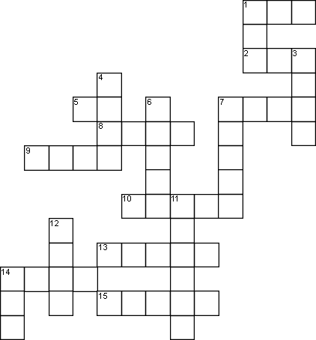

ACROSS
- Carol's the same old car for 10 years (have)
- Karen a good job defending you last year (do)
5 What did you at the weekend? (do)
- We've never to Tokio (be)
- I haven't you this month yet (see)
- I my mind last night (lose)
- I've him since 2014 (know)
- She's in Jundiai for 30 years (live)

- Neil Armstrong
- The Queen has just
DOWN
to the moon in 1930, I think (go) a speech (give)

1 She lots of good ideas at the meeting (have)
- Oh, my! What Have you ? (do)
- I've my keys (lose)
- Life has just (begin)
- He asking the boss about his plans (begin)
- The new restaurant 2 days ago (open)
- Mr. Sandman has just out (go)
14 I born in Brazil(be)

