3.6 Cognitive Development
Jean Piaget, a Swiss psychologist, developed one of the most widely known theories which gave insights about cognitive development which he called the cognitive stage theory. He observed children and created an account of how they gradually could think logically. Since his theory is very famous among all the other ones who have studied cognitive development, it is considered enough to focus on him rather on others in this part of the chapter.
3.6.1 Piaget’s Theory of Cognitive Development
Jean Piaget did a lifelong research on children where he tried to study their cognitive development (1954,1964, 1969). His longitudinal research consisted in observing individuals from their early childhood until they became adolescents. He observed them in natural situations and asked them specific questions as they were taking cognitive tasks. This enabled him to describe how children’s thinking processes developed over time. Here is a sample of a conversation that took place between Piaget and a 9-year-old child.

What is your nationality?—I am Swiss.—
How come?—
Because I live in Switzerland.—
Are you also a Genevan?—
No, that’s not possible . . . I’m already Swiss, I can’t also be Genevan.
(Piaget, 1965/1995, p. 252 cited in Moreno. R, 2010)
Jean Piaget (1896 – 1980) spent his whole life trying to answer questions about the way human beings acquire knowledge. He assumed that by studying developmental changes in the process of knowing and in the organization of knowledge, he could draw conclusions about his queries.
3.6.1.1 Stages as structures of logic
Piaget’s cognitive development theory is explained through a series of stages. During each stage the child’s thinking and behaviour while learning through different experiences and situations clarifies a particular kind of mental logical structure, which allows the interaction of the child with his environment. Thus, each stage reflects a different view of the world.
Piaget characterised these stages as being stable for all children and follow the same universal sequence. Each stage is a related and prepares the child to the next one.
Piaget developed his model of infancy mainly through observing babies as they perform their daily tasks of playing and learning about the world. His most remarkable conclusion related to infants’ observation was object permanence concept. He explained that for children understand that objects exist even when they cannot see, feel, or hear them.
For example, a young infant who sees a toy placed under a blanket so that it is no longer visible acts as though it no longer exists.
Piaget’s most famous task was conservation (of number, weight, length, etc.). For
example, he showed children two rows of eight objects, one right above the other. After
they agreed that they had the same number he spread out one row and then asked whether
they still had the same number. An 8 - year - old says they do, whereas a 4 - year - old says that the longer row has more. According to Piaget, preoperational children fail this task because they lack reversible mental operations, which characterize concrete operations. Finally, formal operational children perform operations on operations, such as generating possible outcomes and evaluating them in light of evidence.
Table 4 : Stages in Piaget’s theory (adopted from Patricia H. Miller, 2011)
Stages in Piaget’s Theory | Characteristics
Sensorimotor period  (roughly birth to 2 years) | Infants understand the world in terms of their overt, physical actions on the world. Simple reflexes gradually become more complex, intentional, and organized. Each action – based concept is a pattern of perceptual - motor interactions, for example, “ things you can suck on. ” Piaget refers to a “ logic of action. ”
Preoperational period  (roughly 2 – 7 years) | Children use symbols (mental images, words, gestures) to represent objects and events. That is, they reconstruct the Sensorimotor concepts of objects, relations, causality, space, and time in a new medium (mental representation) and a more highly organized structure. Despite the limitations of egocentrism, rigid thought, and limited role - taking and communication abilities, these symbols become increasingly organized and logical, so that children can think about causes.
Concrete operational period (roughly 7 – 11 years) | Logical structures permit children to perform various mental operations, which are internalized actions that can be reversed. Thinking now is more flexible and abstract. Actions are still the main source of knowledge, but the actions now are mental. Logic dominates over perceptions, such that children understand that quantities stay the same even though they change their appearance.
Formal operational period  (roughly 11 – 15 years) | Mental operations now can be applied not only to concrete objects but also to purely verbal or logical statements, to the possible as well as the real, to the future as well as the present. Children take the results of concrete operations and generate hypotheses (propositions, statements) about their logical relations. Thus, they have operations on operations; thought has become truly logical, abstract, and hypothetical. The essence of formal operational thought is the scientifi c method . Children formulate a hypothesis and test it. They can imagine all possible outcomes and generate all possible combinations to test.

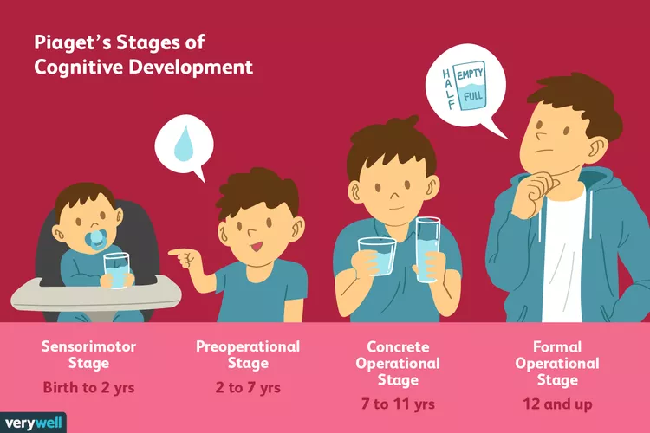
Illustration by Joshua Seong, Very well (retrieved from https://www.verywellmind.com/piagets-stages-of-cognitive-development-2795457

3.6.1.2 Assimilation and Accommodation cycles
Jean Piaget defines intelligence as the adaptation with the environment. In the same way that people adapt physically to the environment, so they do with to adapt mentally to the environment.
He further explained that the adaptation involves two complementary processes: assimilation and accommodation.
Assimilation is the interpretation of new information in terms of pre-existing concepts, information or ideas. A child who already understands the concept of ‘bird’ might initially identify any flying thing, such as butterflies or mosquitoes, with the term ‘bird’. Assimilation is in a way identical to the concept of generalization in operant conditioning. In the theory of Piaget, however, a mental representation for an object or an experience is being transferred rather than just a behaviour (Skinner's “operant” in operant conditioning). Assimilation works in parallel with accommodation, which is the modification of pre-existing concepts in terms of new experiences or new information .The little child who generalizes any flying object to be a bird, will later on revise the concept to consider only some types of flying objects such as swallows or a canaries and not others, like drones or butterflies. Up to Piaget, these two concepts (assimilation and accommodation) work hand in hand to develop the child’s thinking and to generate what Piaget named cognitive equilibrium, which is a kind of balance between relying on the prerequisite and openness to the unknown or what Piaget called new information. This ever-growing repertoire of mental representations for objects and experiences is further explained by Piaget and he considers that every mental representation as a schema. He explained that a schema is a mixture of vocabulary, actions, and experience related to the concept. A child’s schema for bird, for example, embodies not only the appropriate verbal knowledge (defining the word “bird”), but also the child’s experiences with birds, pictures of birds, and conversations about birds. As assimilation and accommodation about birds and other flying objects operate together over time, the child adds and remembers relevant new experiences and actions. From these collective revisions and additions the child gradually constructs general new schemata about birds, butterflies, and other flying objects. In general terms, Piaget might then consider that “the child has learned more about birds”.
Piaget assumes that the two processes, assimilation and accommodation, are motivated by the requirement to establish equilibrium, the natural tendency to find rationalism in one’s thinking. Disequilibrium, however, is the state of cognitive conflict that shows up when one’s thinking is not constant or when our present schemas are not validated by our experiences the world. Piaget explained that disequilibrium is the reason behind cognitive growth. For this reason, teachers are invited to find classroom situations where cognitive conflict is sustained to foster meaninglul learning among their pupils. For instance, in the case of a child who uses a dog schema for understanding what a cat is, a teacher can help the child focus on defining characteristics of dogs that are absent in cats (e.g., barking) to promote cognitive conflict, accommodation, and equilibrium. Limón (2001) identified the following steps to produce students’ cognitive conflict:
1. Assess students’ current state of knowledge or beliefs.
2. Confront students with contradictory information.
3. Evaluate the degree of change from students’ prior knowledge or beliefs.
Table 5: Cognitive Conflict Examples for three Grade Levels (adopted from Moreno 2010)
Grade Level | Classroom Examples
Elementary school | Ms. Allen’s first-grade art class is studying colours. She puts dabs of yellow, red, and blue tempera in front of her students and asks them how many colours they will be able to use in their paintings. Most students hold up three fingers. She asks if there is any way to paint green grass. Alex answers, “Only if you get green tempera.” Ms. Allen then asks the students to start mixing their paint to see if they can make green from the three colours on the table.
Elementary school | Ms. Perez asks her science class what makes plants grow strong and healthy. Tommy responds, “I know! Just like us, plants get stronger and healthy when they have good food. My mom always puts in plant food when she waters the plants.” To help Tommy understand the importance of light, Ms. Perez decides to have her students do an experiment where two plants are given the same amount of nutrients during a month yet one plant is left in the shade. She then engages the class in a discussion by revisiting her initial question.
Middle school | Mr. Jenson asks his social studies class if Christopher Columbus should be considered an American hero. Jenny is quick to respond, “Sure! He was the guy who discovered America!” Most of the class agrees with  her. Mr. Jenson then asks his class to read two articles about Columbus, one describing the implications of the discovery for Western society and another piece describing the effects on Native American societies. He then revisits his initial question.
Middle schoo | Ms. Dustin is starting her unit on dividing fractions. After reviewing adding and subtracting fractions, she asks the students what they think will happen when you divide two fractions. Karen answers, “When you divide numbers together you get a smaller number, so you should get a smaller fraction.” Most of the class agrees. Ms. Dustin then divides the groups into pairs and gives them paper pizzas to divide into pieces to show that fractions increase with division
High school | After studying data on global temperature and atmospheric changes, Mr. Olsen asks his environmental science class what the social and political implications of the data are. Many students say that there should be stricter laws on pollution, cars should be made more fuel-efficient, and people should drive less. So his students can gain greater perspective of this issue, he assigns each student a country to research and represent in a mock United Nations meeting. Most students are asked to represent developing or third world countries.
High school | Mr. Jenkins asks his literature class what role a government should play in people’s lives. Jackson answers, “Man, all the government does is keep you down. It’s just a bunch of people telling you what you can and can’t do. We need to lose it.” Mary Lou responds, “Yeah, it doesn’t do nothing to help me but take money.” He then has the class read George Orwell’s Animal Farm and then revisits his original question.

