- De Saussurean structuralism

1.1 Definition of structuralism

It is a linguistic approach to study and describe language structure, which was introduced by the Swiss linguist De Saussure in his book entitled Course of General Linguistics. This most cited and
influential book was based on lecture notes taken by Saussure's students at Geneva university and
published in 1916. Structuralism provided the foundation for modern linguistics, starting first in
Europe and then spread across mainly in America. The basic tenet in structural linguistics is that
languages have certain structures, wherein linguistic items or elements form a working unit. This
means that these elements exist in relation to one another.

1.2 Saussure's dichotomies

1.2.1 Signifier vs signified

According to De Saussure, language is a system of signs, i.e., words in a language are signs which carry meaning. So, a linguistic sign is an indicator of something or an idea and has two sides: a signifier ( the form of the sign which can be touched, heard or seen), a signified ( the mental concept or meaning of the signifier). The relationship between the signifier and signified is Arbitrary.

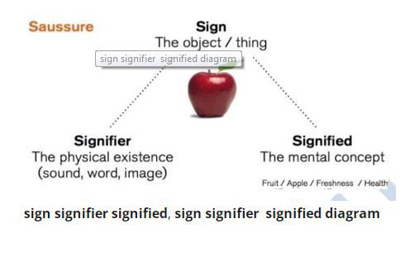

1.2.2 Langue vs Parole

Langue refers to the collective linguistic system shared by a particular speech community, e.g., all the rules of English language used by native speakers in England. Hence, langue is held to be a social
product. On the other hand, Parole is an individual product that is unique to a given speaker, who
applies to the rules of langue in everyday speech.

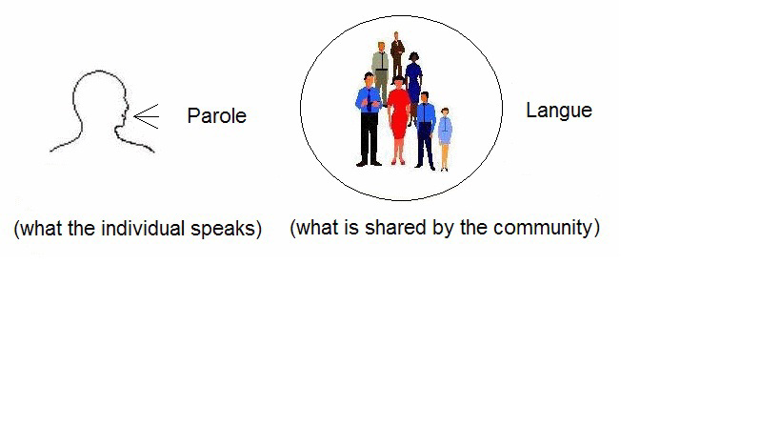

1.2.3 Synchronic vs diachronic

The concept of the study of language in synchrony, which is opposed to diachronic studies of language, was introduced by Saussure in the early twentieth century. It aims to study a language at a given period of time as if the language was not evolving. In fact, this approach proposes to clearly and systematically state all the rules that govern the subject language at a certain time. Hence, diachronic is the approach of analysis and investigation of a particular language in its entire history.

1.2.4 Paradigmatic vs syntagmatic

Syntagmatic relations are ”and” relations ( combination) . Paradigmatic relations are ”or” relations (substitution).

The sentence I work consists of two linguistic entities, a personal pronoun filling the role of subject and a verb filling the role of predicate. Sentence=Subject + Predicate. You do not have a sentence in English if you do not have a subject AND a predicate. Thus, the subject and the predicate are in a syntagmatic relation.

In the sentence The dog sleeps here. the phrase the dog can be replaced by the cat, the parrot, my pet, my uncle or many other noun phrases designating a singular entity that can sleep. In this particular sentence they are all equivalent: we can have the first OR the second OR the third…etc. In this particular pattern any noun phrase, but only one, designating an entity that can sleep in the place designated is syntactically equivalent. Thus, the noun phrases in question are equivalent but mutually exclusive and in a paradigmatic relation.

- Prague school

This school of thought was highly inspired by De Saussure's work. It considers language not only as a system of signs but also as functional system. In other words, it is a medium of expression allowing the speakers to attain their communicative purposes. It focuses on the relationship between the structure of the language and its communicative function it holds.

  - Main scholars and contributions of the Prague school

- It was established by Vilém Mathesius and Sergeyevich Trubetzkoy in the 1920s.
- It was best known for its work on phonology and phonetics, Trubetzkoy distinguished between these two levels of language and put forward phonology as a separate discipline.
- Trubetzkoy was the first linguist to introduce the concept of phoneme as the smallest distinctive unit in a given language that can amend the meaning.

- Copenhagen school

Copenhagen school, officially called linguistic circle of Copenhagen introduced a new theory called
glossmatics to study language structure. Glossmatics was proposed to account for the idea of
linguistic signs in a novel manner.

3.1 Main scholars and contributions

- It was led by Louis Hjelmslev (1899-1965) and Viggo Brøndal (1887-1942).
- Hjelmslev was interested in Semiotics and developed the theory of glossmatics; the word is
- taken from glossa (a greek term) meaning language. Glossmatics is the study of Glosseme which Hjelmslev defines as the most basic unit or component of language.

- Hjelmslev suggests that linguistic signs (signifier and signified) are glossemes and are to be referred to as expression and content, respectively.
- Hjelmslev claimed that linguistics is Algebra of language.

- American structuralism

As a opposed to European structuralism, Amercian structuralism involves theories and studies of
language structure in America from the 1920s until 1950s. The leading figure is Edward Sapir (1884-
1933) who focused the relationship between language and culture. According to Sapir, language is a
system of signs used by speakers to co-operate, interact and identify. Culture is reflected through
linguistic elements used for different communication purposes,i.e., language is a cultural product.
Sapir and hi student Whorf developed the Sapir-Whorf hypothesis to account for the relationship
between language; thought and culture. This hypothesis has two versions:

- A strong version known as linguistic determinism; which postulates that language not only
influences but determines how a person thinks. For example, the case of Inuit people with their
different uses of the word snow ( See video below).
- A weak version known as linguistic relativity; which states that language merely influences
thought as it does not determine it.

