Behaviorism

1.What is behaviorism

Behaviorism or behavioral psychology was a dominant school of thought from 1920s through the mid 1950s. It is based on the tenet that the environment shapes animal and human behavior. It is defined as the study of the observable behavior in a given environment, free from any intervention of the internal mental processes. The main behaviorists are: Pavlov, Skinner and Watson.

2. Classical conditioning (learning through association)

A behavioral learning process by which the behavior of an animal or human becomes dependent on an event occurring in an environment. It is a basic way of learning and referred to as learning through association. In Pavlov s' experiment with his dog, this latter learned to associate the sound of a bell with food. (See below).

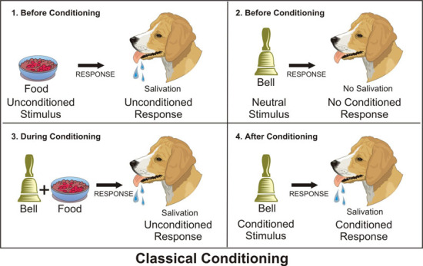

Pavlov showed food to the dog that starts salivating at the sight and smell of food. He then rings a bell (without showing food) but there was no response. Pavlov then rings the bell and gives food to the dog which starts salivating. The dog associated the sound of the bell with food such that when it heard the bell without food, it salivated.

3. Operant conditioning (learning by consequence)

It is a type of learning in which an animal or human being learns through the consequences of their
behavior. A good example would be that of Skinner's box. The consequence can be either a
reinforcement, which aims at increasing the desirable behavior or punishment, which seeks to
decrease undesirable behavior.

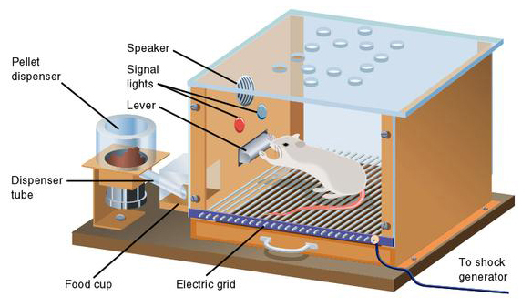

In Skinner’s box experiment, the rat started exploring around, and suddenly discovered a lever and pressed it accidentally. After the pressing, food was released inside the box. After a few more accidents, the rat notices that hitting the lever meant getting food out of a dispenser.
Hence, the consequence (food) made the rat press the bar many times.

4. Behaviorism and language learning

For behaviorists, language learning is the result of five crucial factors: reinforcement, repetition,
association, imitation and habit formation. For example, the child will acquire new words by
listening to and imitating his parents and caregivers. When the word candy is repeated many times: he will memorise it and associate it with the sweet food made from sugar. Likewise, in an EFL or ESL
classroom, the pupils or students will listen to the teacher and imitate him until they form the habit of the new language.

