INTRODUCTION TO MARKETING
PREPARED BY:
BENGHALEM abdelhadi

(1)
Definitions
of marketing
(5)
Trends in
marketing
(4)
Marketing
process
Differences
(3)
between sales &
market orientation
Marketing
(2)
management
philosophies
INTRODUCTION
TO MARKETING
INTRODUCTION
TO MARKETING
Production Concept
Selling Concept
Marketing Concept
Societal Marketing
Concept
What is
Marketing?
What Is Marketing?
A Philosophy
An Attitude
A Perspective
A Management
Orientation
A Set of Activities,
including:
Products
Pricing
Promotion
Distribution / Place

Definition Of Marketing
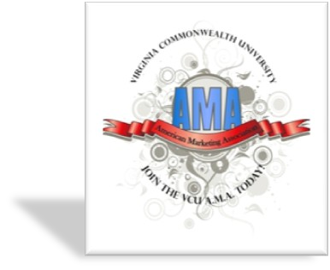
American Marketing
Dr. Philip Kotler Association

AMA : Marketing is an organizational function and a set of processes for creating, communicating, and delivering value to customers and for managing customer relationships in ways that benefit the organization and its stakeholders.
Kotler : A social and managerial process whereby individuals and groups obtain what they need and want through creating and exchanging products and value with others.

Simply put
Marketing is the delivery of customer satisfaction at a profit.
Goals
Attract new customers by promising superior value and keep and grow current customers by delivering satisfaction.

Other Definitions Of Marketing
- Marketing consists of the performance of business activities that direct the flow of goods and services from producer to user.
(American Marketing Association)
- Marketing is the process of planning and executing the conception, pricing, promotion, & distribution of ideas, goods and services to create exchanges that satisfy individual and organizational objectives.
(American Marketing Association)
- Marketing is that of an individual and organizational activities aimed at facilitating exchanges within a set of dynamic environmental forces.
(Pride & Ferrell)
Core Marketing Concepts
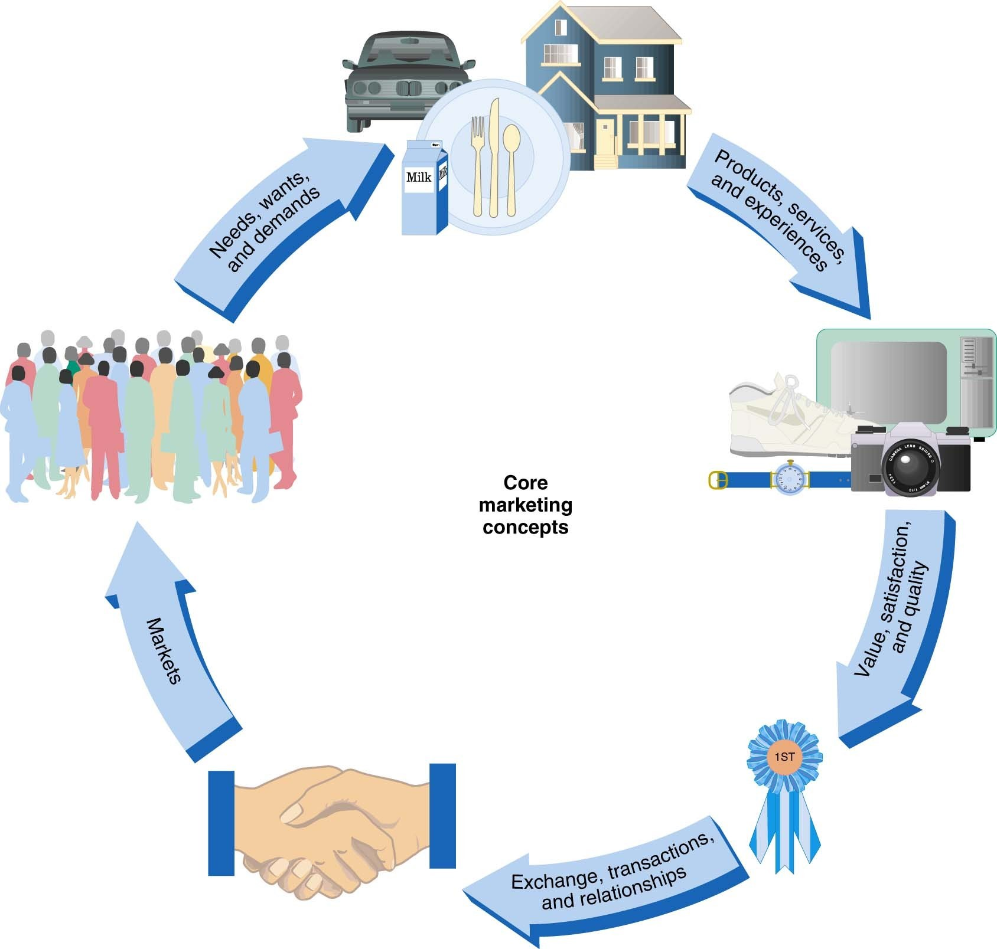
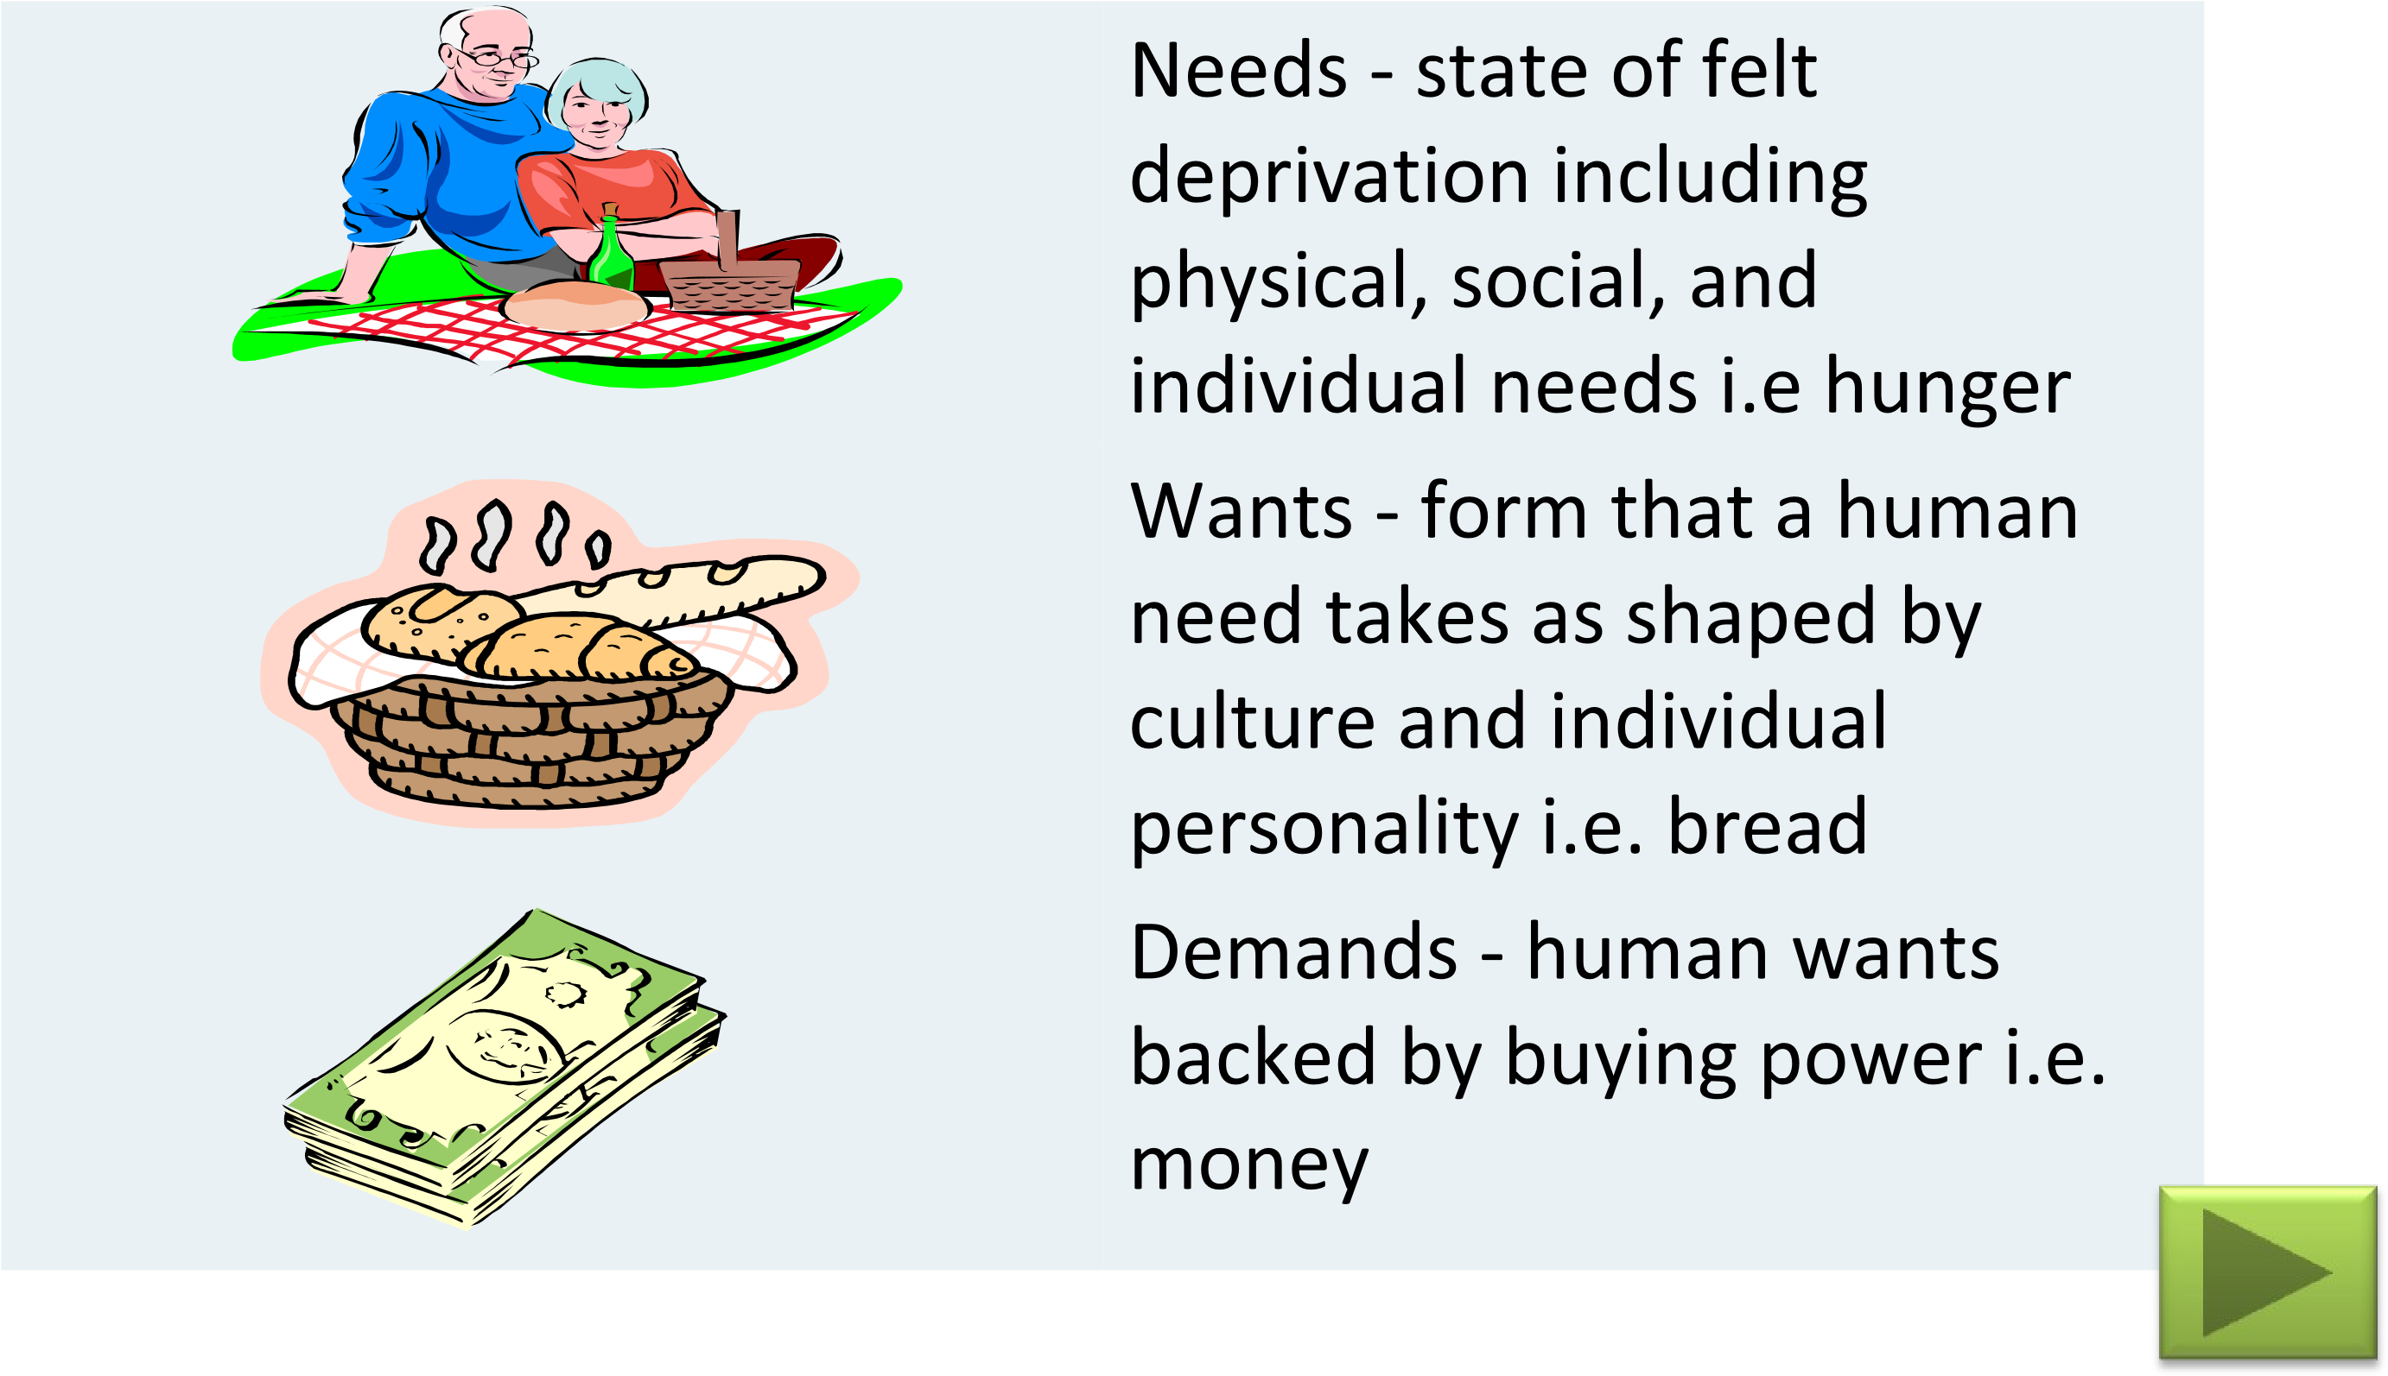
What are Consumers’ Needs, Wants, and Demands?
The Organization’s Focus
Key Issues in Key Issues in
Developing Developing

Competitive AdvantageCompetitive Advantage
CustomerCustomer^{Create Create} ValueValue Build Long-Term Build Long-TermRelationshipsRelationships SatisfactionSatisfactionCustomerCustomerMaintain Maintain
Customer Value
Customer Value
The ratio of benefits to the sacrifice necessary
to obtain those benefits
Customer Value Requirements
■ Offer products that perform
■ Give consumers more than they expect
■ Avoid unrealistic pricing
■ Give the buyer facts
■ Offer organization-wide commitment in service and after-sales support

Customer Satisfaction
Customer Satisfaction
The feeling that a product has met or exceeded
the customer’s expectations.
Maintaining Customer Satisfaction
◆
Meet or exceed customer’s expectations
◆
Focus on delighting customers
◆
Provide solutions to customer’s problems
◆
Cultivate relationships,
NOT one-time transactions
Relationship Marketing
Relationship Marketing
The name of a strategy
that entails forging long-term partnerships with
customers, both individuals and firms.
Relationship Marketing
Requirements
for
Building
Relationships
Requirements
for
Building
Relationships
Who are your customers
What do customers value
How do they prefer to interact
What do they want to buy
Building Long-Term Relationships
◆
Customer-oriented personnel
◆
Effective training programs
◆
Empowered employees
◆
Teamwork

The Concept of Exchange
- Lamb : The idea that people give up something to receive something they would rather have.
- Kotler : The act of obtaining a desired object from someone by offering something in return.
At Least Two PartiesAt Least Two Parties
Something of ValueSomething of Value
Necessary Conditions Necessary Conditions
^{for Exchange}for Exchange Communication and DeliveryCommunication and Delivery
Freedom to Accept or RejectFreedom to Accept or Reject
Desire to Deal With Other PartyDesire to Deal With Other Party
Exchange may not take place even
if conditions are met;
An agreement must be reached; and
Marketing occurs even if exchange does not take place.

Marketing Management Philosophies
Focus on internal capabilities of the firm.
Production Concept
Selling Concept
Marketing Concept
Societal Marketing Concept
Focus on aggressive sales techniques and believe that high sales result in high profits
Focus on satisfying customer needs and wants while meeting objectives
Focus on satisfying customer needs and wants while enhancing individual and societal well-being
The Marketing Concept / Orientation

The Marketing Concept
The idea that the social and economic justification for an organization’s existence is the satisfaction of customer wants and needs while meeting organizational objectives.
The Marketing Concept
◆ Focusing on customer wants and needs to distinguish products from competition
◆ Integrating all the organization’s activities to satisfy customer wants and needs
◆ Achieving the organization’s long-term goals by satisfying customer wants and needs

Achieving a Marketing Orientation
■ Obtain information about customers, copetitor and markets
■ Examine the information from a total business perspective
■ Determine how to deliver superior customer value
■ Implement actions to provide value to customer

Societal Marketing Orientation
✓
Less toxic products
✓
More durable products
✓
Products with reusable
or recyclable materials
Societal Marketing Orientation
Marketing that preserves or enhances an
individual’s and society’s long-term best
interests
Review: Marketing Management
Philosophies
Orientation Focus
Production What can we make or do best?
SalesSales How can we sell more aggressively?
MarketingMarketing What do customerswant and need?
SocietalSocietal What do customers want and need, and how can we benefit society?

Sales vs Market Orientation
Sales Orientation | Market Orientation

- Organization Focus
- What type of business organization is in?
- To whom the product is directed?
- Firm’s primary goal
- Ways to achieve the goal

Inward –fulfill organization’s Outward – fulfill wants and
needs. | preferences of customers.
Selling goods and services. | Satisfying customers needs and wants and delivering superior value.
Everybody. | Specific groups of people.
Achieve profit through maximum sales volume. | Achieve profit through customer satisfaction.
Through intensive promotion. | Through coordinated marketing and interfunctional activities.

Marketing Process
- A marketing process include all the marketing’s role and activities in the organization.
- The marketing process include the process of:-
  - Analyzing marketing opportunities and developing the organization’s mission and objectives.
  - Selecting target markets.
  - Developing the marketing strategy by developing marketing mix
(4 P’s).
    - Product , Price, Promotion, and Place.
1) Managing the marketing effort.
    - Include analysis, planning, implementation, and control.
    - Can be done by SWOT analysis (strengths, weaknesses, opportunities, threats).
Defining a Firm’s Business
- Use “customer benefits” instead of
“goods/services”
- Ensures a customer focus
- Encourages innovation and creativity
- Stimulates an awareness of changesin customer preference
Why Study Marketing?
- Plays an important role in society
- Vital to business survival, profits and growth
- Offers career opportunities
- Affects your life every day
Why Study Marketing?
Vital Marketing Activities for Organizations
- Assess the wants and satisfaction of customers
- Design and manage product offerings
- Determine prices and pricing policies
- Develop distribution strategies
- Communicate with present and potiential customer
Trends in Marketing
