People’s Democratic Republic of Algeria
Ministry of Higher Education and Scientific Research
University of Tlemcen
Faculty of Letters & Languages
Department of Spanish

Module: English
Coefficient: 1
Teacher: Lila ALLAL

An introductory lecture to ESP
- What is ESP?
The term of ESP stands for “English as specific purposes” is a branch of English language teaching tailored specific purposes or fields. Unlike general English language teaching, ESP is designed to meet the particular needs of learners who require English for their work, academic studies, or specific domains.
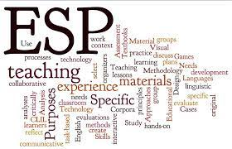

- Significance of ESP:
ESP plays a crucial role in helping learners develop the language skills necessary to function effectively within their professional or academic contexts. Whether it is English for business, medicine, engineering, or any other specialized field, ESP equips learners with the language tools they need to communicate proficiently and confidently.
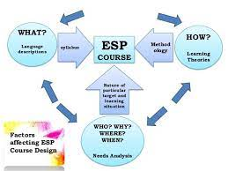

- Examples of ESP fields:
ESP encompasses a wide range of fields and industries, including but not limited to:
- English for Business and Economics
- English for Medicine and Healthcare
- English for Engineering and Technology
- English for Law and Legal Studies
- English for Academic Purposes (EAP)

Why Spanish students study English at university?
1. Professional and Academic Needs:
Many Spanish university students study English to meet specific professional or academic requirements. For instance, they may need English for conducting research, reading academic papers, or writing dissertations in their chosen field of study. This applies to various disciplines such as engineering, medicine, economics, and social sciences.
2. Internationalization of Education:
With the increasing globalization of education, universities in Spain often offer courses and programs taught in English to attract international students and enhance their students' global competitiveness. Therefore, Spanish students may need English not only for their own academic pursuits but also to access a broader range of educational opportunities both domestically and internationally.
3. Career Opportunities:
English proficiency is highly valued in the global job market. Spanish students recognize the importance of English for enhancing their career prospects, especially in fields such as business, tourism, hospitality, and technology, where English is often the lingua franca. Thus, studying English at university equips them with the language skills necessary to succeed in their future careers.
4. Access to Information and Resources:
English is the predominant language of communication in various academic fields, as well as in digital resources, journals, and conferences worldwide. Therefore, Spanish students studying English at university are better equipped to access a wealth of information, resources, and opportunities available in English.
5. Specific English Courses:
Universities may offer specialized English courses tailored to the needs of different disciplines or professions. These courses focus on teaching English language skills and vocabulary relevant to specific academic or professional contexts, making them a form of ESP. For example, a Spanish engineering student might take an English course focusing on technical writing or communication skills for engineers.
In summary, Spanish students studying English at university can be considered participants in ESP, as they are learning English to meet specific professional, academic, and career-related needs within their chosen fields of study.
- Conclusion:
In conclusion, ESP is a specialized approach to English language teaching that addresses the unique linguistic needs of learners within specific professional or academic contexts. By focusing on relevance, authenticity, and specialized language skills, ESP equips learners with the language proficiency necessary to succeed in their chosen fields.

