TEXT Reading/Writing skills

Language summary

Name What's your name? I’m/My name's (Jason Douglas).
Date & Place of Birth When/Where were you born? I was born on July 2nd in London.
Nationality Where are you from?/Where do you come from? I'm British./l come from Britain.
Marital Status Are you married? Yes, I am. /No, I'm not. I'm single.
Address What’s your address?/Where do you live? I live at. . ./My address is (3280 Sunshine Boulevard).
Education Where were you educated?/Where did you go to (school)? I went to. . ./I was educated at Lane End
Secondary School.
Profession What do you do?/What’s your job? I'm an actor. I work in a bank

Information filling:
 | Text 1 | Text 2 | Text 3
Family Name | Montrose. . . . . . . . . . . . | Hooper . . . . . . . . . . . | Mcpherson
First Name(s) | Maria . . . . . . . . . | Stanley . . . . . . . . . . . | Jeannie
Date of Birth | 23rd of March 1943 . . . . . . . . . . | 25th of May 1925 | 11th of December 1938
Place of Birth | Los Angeles . . . | Preston . . . . . . . . | Edinburgh
Nationality | American . . . . | British . . . . . . | Scottish
Address | San Andreas Tower, Sunset Drive  Los Angeles | 26 Poplar Avenue  Preston | 17 Glencoe Road  Edinburgh
Education | Beverly Hills High. . . . . . .  Stanford University . . . . . | Preston Grammar School  Liverpool University | Carnegie Academy for Girls  University of St Andrews
Profession | Actress . . . . . . | English Teacher . . . | Zoologist
Marital Status | Separated . . . . . . . . . . . . . . . | Widower . . . | Engaged

Read the following three texts and complete the forms above.
Text 1 Person autobiography
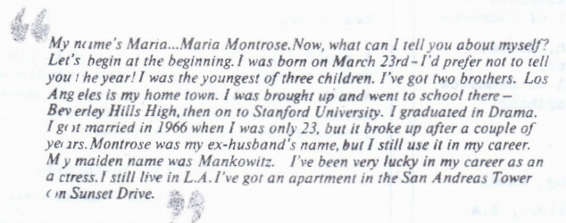
Text 2 Person autobiography
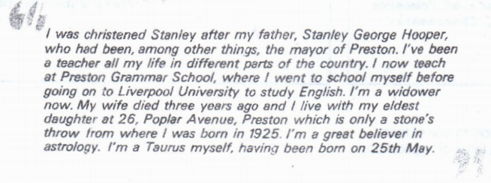
Text 3 Article from Edinburgh Evening News newspaper
