Lecture Two: Levels of Analysis
Dr. ABDAT Yassamina
- Taxonomic Hierarchy
The hierarchy of units better explains the relationship between units such as sentence, clause, group, word and morpheme. According to Longman Dictionary of Contemporary English, hierarchy means, “a system by which the members of an organization are grouped and arranged according to higher and lower ranks, especially official ranks.”
The sentence is considered as the longest structural unit of which full grammatical and phonological descriptions are possible. The linguistic unit contains all the elements (words) which are completely describable in terms of grammatical and phonological rules.
As for the former (grammatical analysis), it starts with the lowest minimum form (morpheme) and moves gradually through successive ranks to the longest unit (sentence)
In the later, phonology analysis starts with the lowest minimum form (phoneme) and moves gradually through syllables to phrase (utterance)
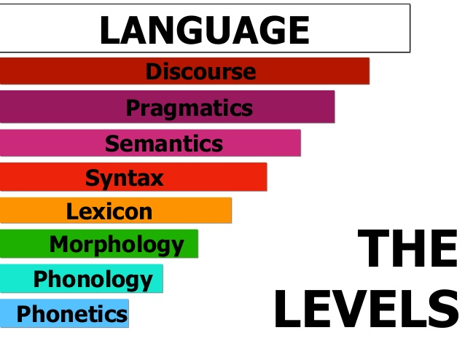
Nathacia, 2018

In grammatical hierarchy, morphemes are the smallest units (of grammar) and the sentences are the highest in rank. Morphemes combine to form words, words combine to form groups, groups combine to form clauses, and clauses combine to form sentences. In other words, a sentence consists of clauses, which consist of group of words and words are formed by the combination of morphemes. In other words, this relationship is a ‘consists of’ relationship if one is thinking downward along the scale, and a ‘constituency relationship’ if one is thinking upwards along the scale . Each unit consists of units of lower rank, or which are next down the scale, and each unit provides the constituents of the unit next above. Words, phrases, clauses and sentences constitute what is called the “Grammatical”.
The present course, as its title suggests, strives to through light upon the linguistic analysis of language in terms of its inner nature, i.e. at micro level which consists of a set of six levels of linguistic analysis that range in depth between the specifics of the sounds we make to form language to the context surrounding speech events. They are (from most specific to the broadest) phonetics, phonology, morphology, syntax, semantics, and pragmatics (with a focus on the first three levels).

Language as Available and Organized Sound: Phonetics &Phonology

- Introduction
This course as its name implies aims to introduce students to basic practical and descriptive levels of the English sound system. The significance of this course's arises from the fact that pronunciation is regarded as one of the most important aspects of learning a language. This includes learning sounds in isolation as well as in connected speech. As regards phonetics, the course covers the vocal tract and its function in producing speech sounds. Consonants and vowels are described in articulatory terms, and students are taught phonetic transcription. With regard to phonology, on the other hand, students study the contrastive sounds of language - phonemes- as well as the phonological processes whereby the pronunciation of such sounds is affected when grouped with other sounds.
It should be pointed out however that in spite of its important role in language learning, the present course is slightly discussed and briefly elaborated as it represents a whole module scheduled to our students at tertiary level.
- Phonetics & Phonology
If the 19th century was an era of comparative and historical philology, the 20th century saw a decisive shift in favour of descriptive or synchronic linguistics. Often seen as the father of what became known as structural linguistics, Ferdinand de Saussure thinking underpins most work undertaken in this century and the last.
Structural linguistics is a synchronic approach to language study in which a language is analyzed as an independent group of formal systems that are composed of elements that are defined in terms of their contrasts ‘similarities and differences) with other elements in the system. It emphasizes the overt formal features of language, principally the phonological, morphological, and syntactic ones. Structural linguistics involves collecting a corpus of utterances and then attempting to classify all of the elements of the corpus at their linguistic levels: the phonemes, morphemes, lexical categories, noun phrases, verb phrases, and sentence types.
  - Phonetics:
Phonetics is a branch of linguistics which studies how speech sounds are produced, how they are transmitted, and how they are perceived. Therefore, phonetics is off three kinds:
- Articulatory phonetics: is concerned with the way in which speech sounds are produced by the vocal organs.
- Acoustic phonetics: studies the physical properties of sound waves.
- Auditory phonetics: examines the way in which speech sounds are identified by the hearer.
Of these, articulatory phonetics is the longest established. Because the most familiar descriptions of speech sounds are based on their articulation, phonetics describes these sounds using the symbols of the International Phonetic Alphabet (IPA).

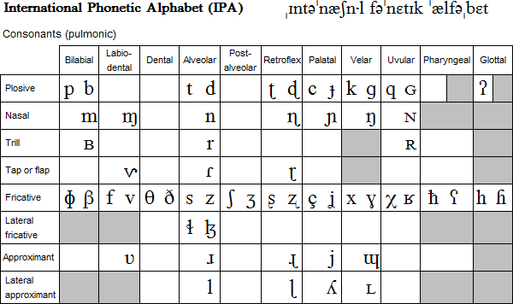

  - Phonology
Phonology is concerned with how speech sounds structure and function in a given language. In other words, phonology considers the grammatical properties of sounds. While phonetics is concerned with the description of how speech sounds are produced, transmitted and perceived, phonology deals with how such sounds are combined together to convey meaning.
In terms of patterning, there are restrictions on the sequences of sounds (phonemes) in every language. In English, for instance, no word begins with zdr- , vzgl- or fsxl, but this is possible in Russian. However, there are English words which begin with the cluster str-. As for Arabic, no word begins with two consonants or ends with two vowels. This implies that there are restrictions on how sounds in different languages are sequenced.
In terms of function, the same speech sound may have different functions in different languages. For example, the glottal stop in English is not a distinctive phoneme; it is rather an allophone. In fact, there are English accents which are characterized by the substitution of the sound /t/ with the glottal stop [Ɂ]; this does not introduce any change in the meaning of the word.
e.g. lot [lɒt] = [lɒɁ]
[Ɂ] in English is no other than an allophone as it does not lead to any semantic difference. This is not the case with, for example, Arabic where the sound /Ɂ/ is a full phoneme. This can be simply illustrated with the following example:
/Ɂlifa/ ≠ /talifa/ (أَلِفَ ≠ تَلِفَ)
Another example which shows the importance of phonology relates to aspiration. For example, the voiceless plosives /p- t- k/ exist in English and Thai. In both languages, they can be realized as aspirated or unaspirated. From a phonetic point of view, they are similar sounds. From a phonological standpoint, they do not behave the same in the two languages. Aspiration is redundant in English as its presence or absence does not introduce any change in the meaning of the word. This is not the case with Thai where aspiration is a distinctive feature.

aspiration [p^{h}-t^{h}-k] (allophones)
English /p-t-k/ are 3 phonemes which can be realized with
no aspiration [p-t-k]

Thai has 6 phonemes: aspirated /p^{h}-t^{h}-k/ and unaspirated /p-t-k/ are not the same. Consider the following examples:
[paa] forest [p^{h}aa] to split
[tam] to pound [t^{h}am] to do
[kat] to bite [k^{h}at] to interrupt
Phonetics is the study of sounds. To understand the mechanics of human languages one has to understand the physiology of the human body. Letters represent sounds in a rather intricate way. This has advantages and disadvantages. To represent sounds by letters in an accurate and uniform way the International Phonetic Alphabet (IPA) was created.
We begin with phonology and phonetics. It is important to understand the difference between phonetics and phonology. Phonetics is the study of actual sounds of human languages, their production and their perception. It is relevant to linguistics for the simple reason that the sounds are the primary physical manifestation of language. Phonology on the other hand is the study of sound systems. The difference is roughly speaking this. There are countless different sounds we can make, but only some count as sounds of a language, say English. Moreover, as far as English is concerned, many perceptibly distinct sounds are not considered ‘different’. The letter /p/, for example, can be pronounced in many different ways, with more emphasis, with more loudness, with different voice onset time, and so on. From a phonetic point of view, these are all different sounds; from a phonological point of view there is only one (English) sound, or phoneme: [p].

Exercise One
Which of the following pairs of words show the same vowel quality? Transcribe each word.
1) back – bake 11) hide - hid
2) pool – pull 12) least - leave
3) school – scope 13) grasp - grass
4) snug – snuff 14) howl - huff
5) cot – caught 15) dump - damp
6) bid – bead 16) fight - flight
7) soap – soak 17) fiend - friend
8) luck – lick 18) key - kick
9) late – lake 19)number - numeral
10) fell - feel

Exercise Two
Mark stresses of the following words. Note that some words have primary and secondary stress. If not sure, you can use a dictionary.
1) daylight 9) restaurant
2) day off 10) responsible
3) day-to-day 11) shoelace
4) day training 12) health club
5) monopolize 13) health centre
6) kangaroo 14) bacteriology
7) midstream 15) changeover
8) midsection 16) prosperity

Exercise Three
Transcribe the following words, as you would pronounce them in isolation. Mark the stresses. Then check your transcription with a dictionary.
1) political 7) anguish
2) development 8) education
3) pearl 9) variable
4) English 10) saliva
5) comprehensible 11) component
6) miniature 12) predator
Questions and tasks:
1. What is the role phonetic transcription? Why is it important to have a standardized phonetic alphabet like the International Phonetic Alphabet?
2. Describe the sound producing system.
3. What is the main difference in articulating voiced and voiceless speech sounds?
Adapted from Masaitiené (2009: 14-15)
Exercise Four
Find minimal pairs of words that would contrast the following English phonemes:
1) /f/ - /v/ 5) /i:/ - /i/
2) /t/ - /d/ 6) /i/ - /ai/
3) /m/ - /n/ 7) /u:/ - /u/
4) /s/ - /z/ 8 /au/ - /ai/

References
  - Chomsky, Noam. Syntactic Structures. The Hague: Mouton, 1957.
  - De Saussure, Ferdinand. Course in General Linguistics, New York: the Philosophical Library, 1959.
  - Sapir, Edward. Language: An Introduction to the Study of Speech, New York: Harcourt Brace, 1921.
  - Raymond Hickey. (2002). Phonetics and Phonology. Cambridge university Press.

Selected Reading
The level which concerns itself with the smallest units of language is phonetics. Phonology on the other hand is the functional classification of the sounds of a particular language. It is the system of sounds by means of which meanings are differentiated in a language and which serve as the building blocks for the higher linguistic levels, e.g. morphology. Phonetics is the study of human sounds in general without saying what function which sounds may have in a particular language. The term ‘phonetics’ is, however, often used with reference to one language when the emphasis is on the pronunciation of this language. For instance, a book on The phonetics of Irish would be about how to pronounce Irish correctly and not necessarily about the functions which the sounds may have in the phonological system of the language. It is customary to divide the field of phonetics into three branches as follows. 1) articulatory phonetics (emission of sounds) 2) acoustic phonetics (transmission of sounds) 3) auditive phonetics (reception of sounds)
Raymond Hickey Phonetics and Phonology ( 2002 :01)

A sound cluster refers to the co-occurrence of more than one sound in the same syllable. Examples may include tr- (try), str (street), ksts (texts), etc

