REPUBLIQUE ALGERIENNE DEMOCRATIQUE POPULAIRE
Abou bek belkaid university
Facolty of technologie
TELEMCEN
Exposition: Differnts types welding techniques
(MIG/TIG/ARC welding)

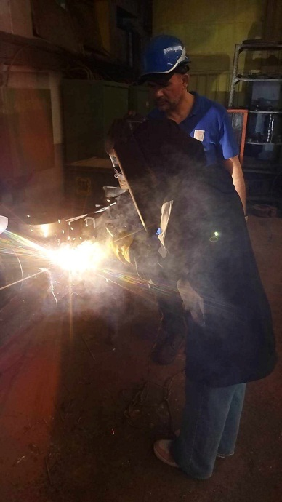
- Introduction:
Hey , I hope that all of you doing well ,So to day I ; m going to do am exposition about “Different types welding technique “and I’ve choose three types to talk about : MIG/TIG and are welding .
Now, Just imagine with me; word without welding, the industry without welding! OMG; I can’t imagine that.
There for the welding is the make peace’s joining together with a lot of the and each one has own super power. So let’s discover these super powers together.
- Firstly, let’s talk about the “ARC welding”
ARC welding is also known as shields metal
ARC welding technique. It involves creating an electric arc between a coated electrode and the work piece. The molten metal then cools and solidifies creating a strong bond.ARC welding is versatile and can be used for various materials, including steel, stainless steel, and cost iron. It’s widely used in contraction, fabrication, and rep
- Secondly, let’s talk about MIG welding of the short metal Inert gas welding
Is a popular welding technique that uses a continuous wire electrode and a shielding gas to create an electric ARC?
The wire electrode is the through a welding gum and the ARC melts the wire and the base metal creating, strong bond.
MIG welding is known for its speed and versititilty making it suitable for a wide range of materials including steel, aluminum and stainless steel, it’s commonly used in automotive, manufacturing, and construction industries.
- Now, Let’s talk about TIG welding also known as “tungutum Inert gas welding”
It amazing technique! It uses a non-consumable tungsten electrode to create an electric ARC that melts the base metal.
A separate filler rod is the added to create the weld. TIG welding offers precise control, making it ideal for them materials and intricate welds. It’s commonly used automotive and art. The process requires skill and patience, but the results are worth it!
Finally, that’s a wrap on our exploration of different welding techniques from MIG to TIG and applications, so next time you’re ready to join metal together, remember to choose the right technique for the job
Thanks for being an awesome audience.

