Module: Linguistics
Level: L1- FILA
Time Allotted: 90 min
Instructor: Dr Fatma KHERBACHE
E-mail: socioling70@gmail.com
Lecture 6: De Saussure’s Theoretical Linguistic Concepts

- Introduction
The comprehensive theoretical framework for the description of language laid down by Ferdinand de Saussure consists of a set of dichotomies (terminological distinctions) specific to linguistic research.
- Langue and Parole: langue is the abstract linguistic system shared by all members of a speech community. It is the general patterns in the speech of a community. In other words, it is the generalized rules of the language. Parole is the speaking act of an individual in a particular situation. Langue is a social product belonging to the community and parole is an individual product. Langue is a linguistic system of regularities underlying speech behaviour while parole is the actual language behaviour.
- Synchrony and Diachrony: synchronic study of language denotes an investigation of the way people speak in a given speech community at a given point in time. In other words, it is a description of the language system (état de langue) at a specific stage of its development for example the study of Modern English and Middle English. Synchronic study of language denotes also the study of language as it exists at the present day. E.g. contemporary English. Diachronic study of language deals with its historical development through time. In other words, the changes that language has undergone over periods of time, for example, the way in which Modern English has evolved from Middle English and Old English.
- Linguistic Sign: Saussure viewed language as a system of signs, which consist of two parts: signified (meaning) and signifier (form). The signified is the concept which is referred to, and the signifier is the label (sound, word, image) used for that concept (mental) (see the figure below).

SIGNIFIED
SIGNIFIER

CAT

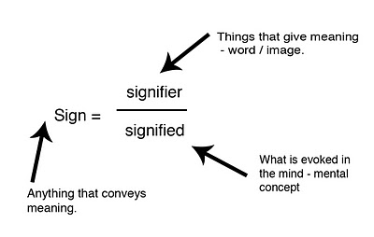
The relationship between a given signified and its signifier is arbitrary. There is nothing in the essence of the signified in the rough diagram above which would lead one to utter the string of sounds spelled by ‘c-a-t’. The following drawing shows the arbitrary relationship between the signifier and signified.
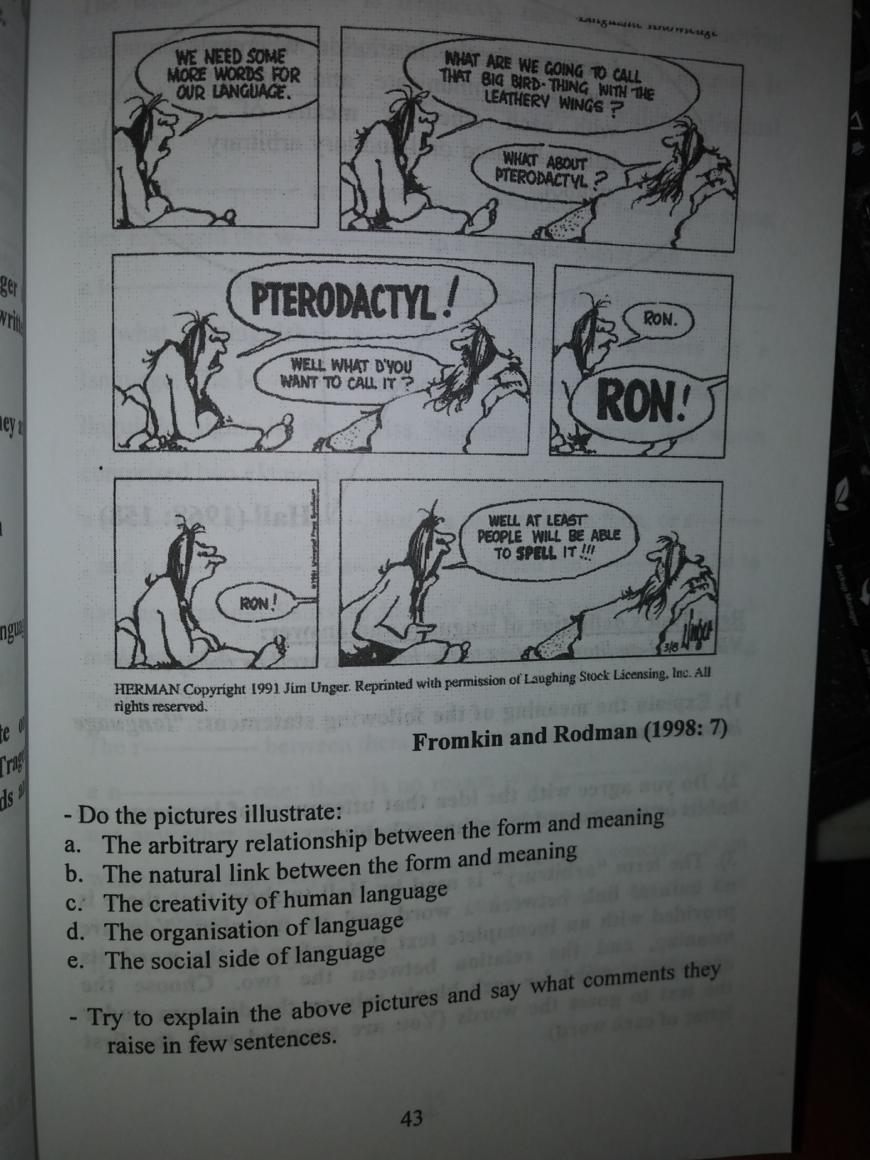

- Syntagmatic and Paradigmatic Relations: syntagmatic relations: the linguistic signs are said to be in syntagmatic relationship when they combine to form a longer unit (syntagma). This one is therefore composed of two or more consecutive units arranged in a linear sequence (horizontal). Paradigmatic relations: the linguistic signs are said to be in paradigmatic relationship when they substitute one for another in a given construction.

Syntagmatic relations

The + boy + likes + the + new + movie
The + girl + hates + the + old + dress
He + drives + the + new + car

Paradigmatic relations
Thus, syntagmatic relations denote co-occurrence (occurring together at the same time), whereas paradigmatic relations denote substitutability.

