Module: Phonetics
Level: L1-FILA
Time Allotted: 90 min
Instructor: Dr Fatma KHERBACHE
E-mail: socioling70@gmail.com
Lecture 10: Nasals and Lateral /l/
Nasals /m/, /n/, /ŋ/
Description
What is particular for nasal consonants is that during their production, the air escapes through the nasal cavity and nostrils while there is a complete closure in the oral cavity when the velum is lowered. There are three (3)types of closures according to place of articulation:
Bilabial /m/: member /’membǝ/
Alveolar /n/: name /neɪm/
Velar /ŋ/: sing /sɪŋ/
N.B the phoneme /ŋ/ is never found in initial position, but only in mid and final position like in singing /’sɪŋɪŋ/. The nasal consonants have the same places of articulation as plosives but the manner is different. They are produced with nasality. The plosives are produced with plosion.
As far as the velar nasal consonant /ŋ/ is concerned, the consonant which follows is variably realised.
- In words ending in ‘nk’ /k/ is always pronounced.
E.g. think /Ɵɪŋk/ bank /bæŋk/
2. But when the letter (g) follows (n), its pronunciation depends on the morphology of the word:
*/g/ is never pronounced in final position. E.g. thing /Ɵɪŋ/, ring /rɪŋ/
* In mid position (g) is pronounced if the word is, at the same time, one morpheme. E.g. finger/’fɪŋgǝ/
one morpheme
*(g) is not pronounced if the word is constituted of two (2) morphemes
E.g. singing /’sɪŋɪŋ/ singer /’sɪŋǝ/
However, there is an exception: (g) is pronounced in mid position with the two morphemes of comparison: er- est
Stronger /’strɒŋgǝ/
The longest /’lɒŋgɪst/
Lateral /l/
Description
This consonant is called a voiced lateral alveolar. It is a lateral consonant because during its production, the air doesn’t flow the usual way along the tongue like other consonants but through the two sides of the tongue which are pulled down, while the tip of the tongue is against the alveolar ridge.
Some Characteristics
- /l/ has two (2) realisations in complementary distribution depending on the context:
- ’clear l’ when followed by a vowel. E.g. alone [ǝ’lǝʊn] – leaf [li:f]: tip of the tongue against the alveolar ridge.
- ‘Dark l’ when followed by a consonant. E.g. milk [mɪɫk] - or in final position e.g. feel [fi:ɫ].
During the production of dark l [ɫ], the back of the tongue is raised towards the velum.
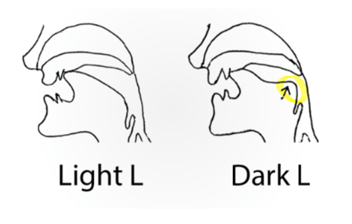
The phoneme /l/ has two realisations:
[l] Clear l
/l/
[ɫ] Dark l
These are two (2) allophones in complementary distribution where one realisation cannot be substituted for the other one.
- The phoneme /l/ is often syllabic in final position when preceded by a consonant.
In final position
/l/ is often syllabic[ɫ̦] +
Preceded by a consonant
E.g. little [‘lɪtɫ̦] /’lɪtl/
3. /l/ is devoiced when preceded by a voiceless consonant
Please [pl̥i:z̥] clean [kl̥i:n]

References
- Crystal, D (2008). A dictionary of linguistics and phonetics. Oxford: Blackwell Publishers.
-Ladefoged, P (2001).A course in phonetics (4th edition) University of California: Los Angeles
- Levis, J.M and Munro, M (2012). Phonetics and phonology: overview. In Chapelle, C.A (ed). The encyclopedia of applied linguistics. 10 volume set (1st edition). Oxford: Wiley-Blackwell
-Linstead, S (11th December, 2014). English spellings don’t match the sounds they are supposed to represent. It’s time to change. https://www.theguardian.com/media/mind-your- language/2014/dec/11/mind-your-language-english-spelling (23 Sep 2022)
- Ogden, R (2009).An introduction to English Phonetics, Oxford: Oxford University Press.
-Raymond Hickey. (2002). Phonetics and Phonology. Cambridge University Press.

-Roach, P (2004). British English: Received Pronunciation. In Journal of the International Phonetic Association, Volume 34, Issue 2, December 2004, pp. 239 – 245. Cambridge: Cambridge University Press.
-Roach, P (2009). English phonetics and phonology: a practical course.
4th ed. Cambridge, UK: Cambridge University Press.
- https://ecampusontario.pressbooks.pub/essentialsoflinguistics2/chapter/3-4-describing-consonants-manner/

