Lecture I
Where Do I live ?
- Task 1 : Prepare a short description of what you can see from your windows at work or at home (any place you are right now), and if possible (this is just optional),take a digital photo of the view, like the pic you see down below.
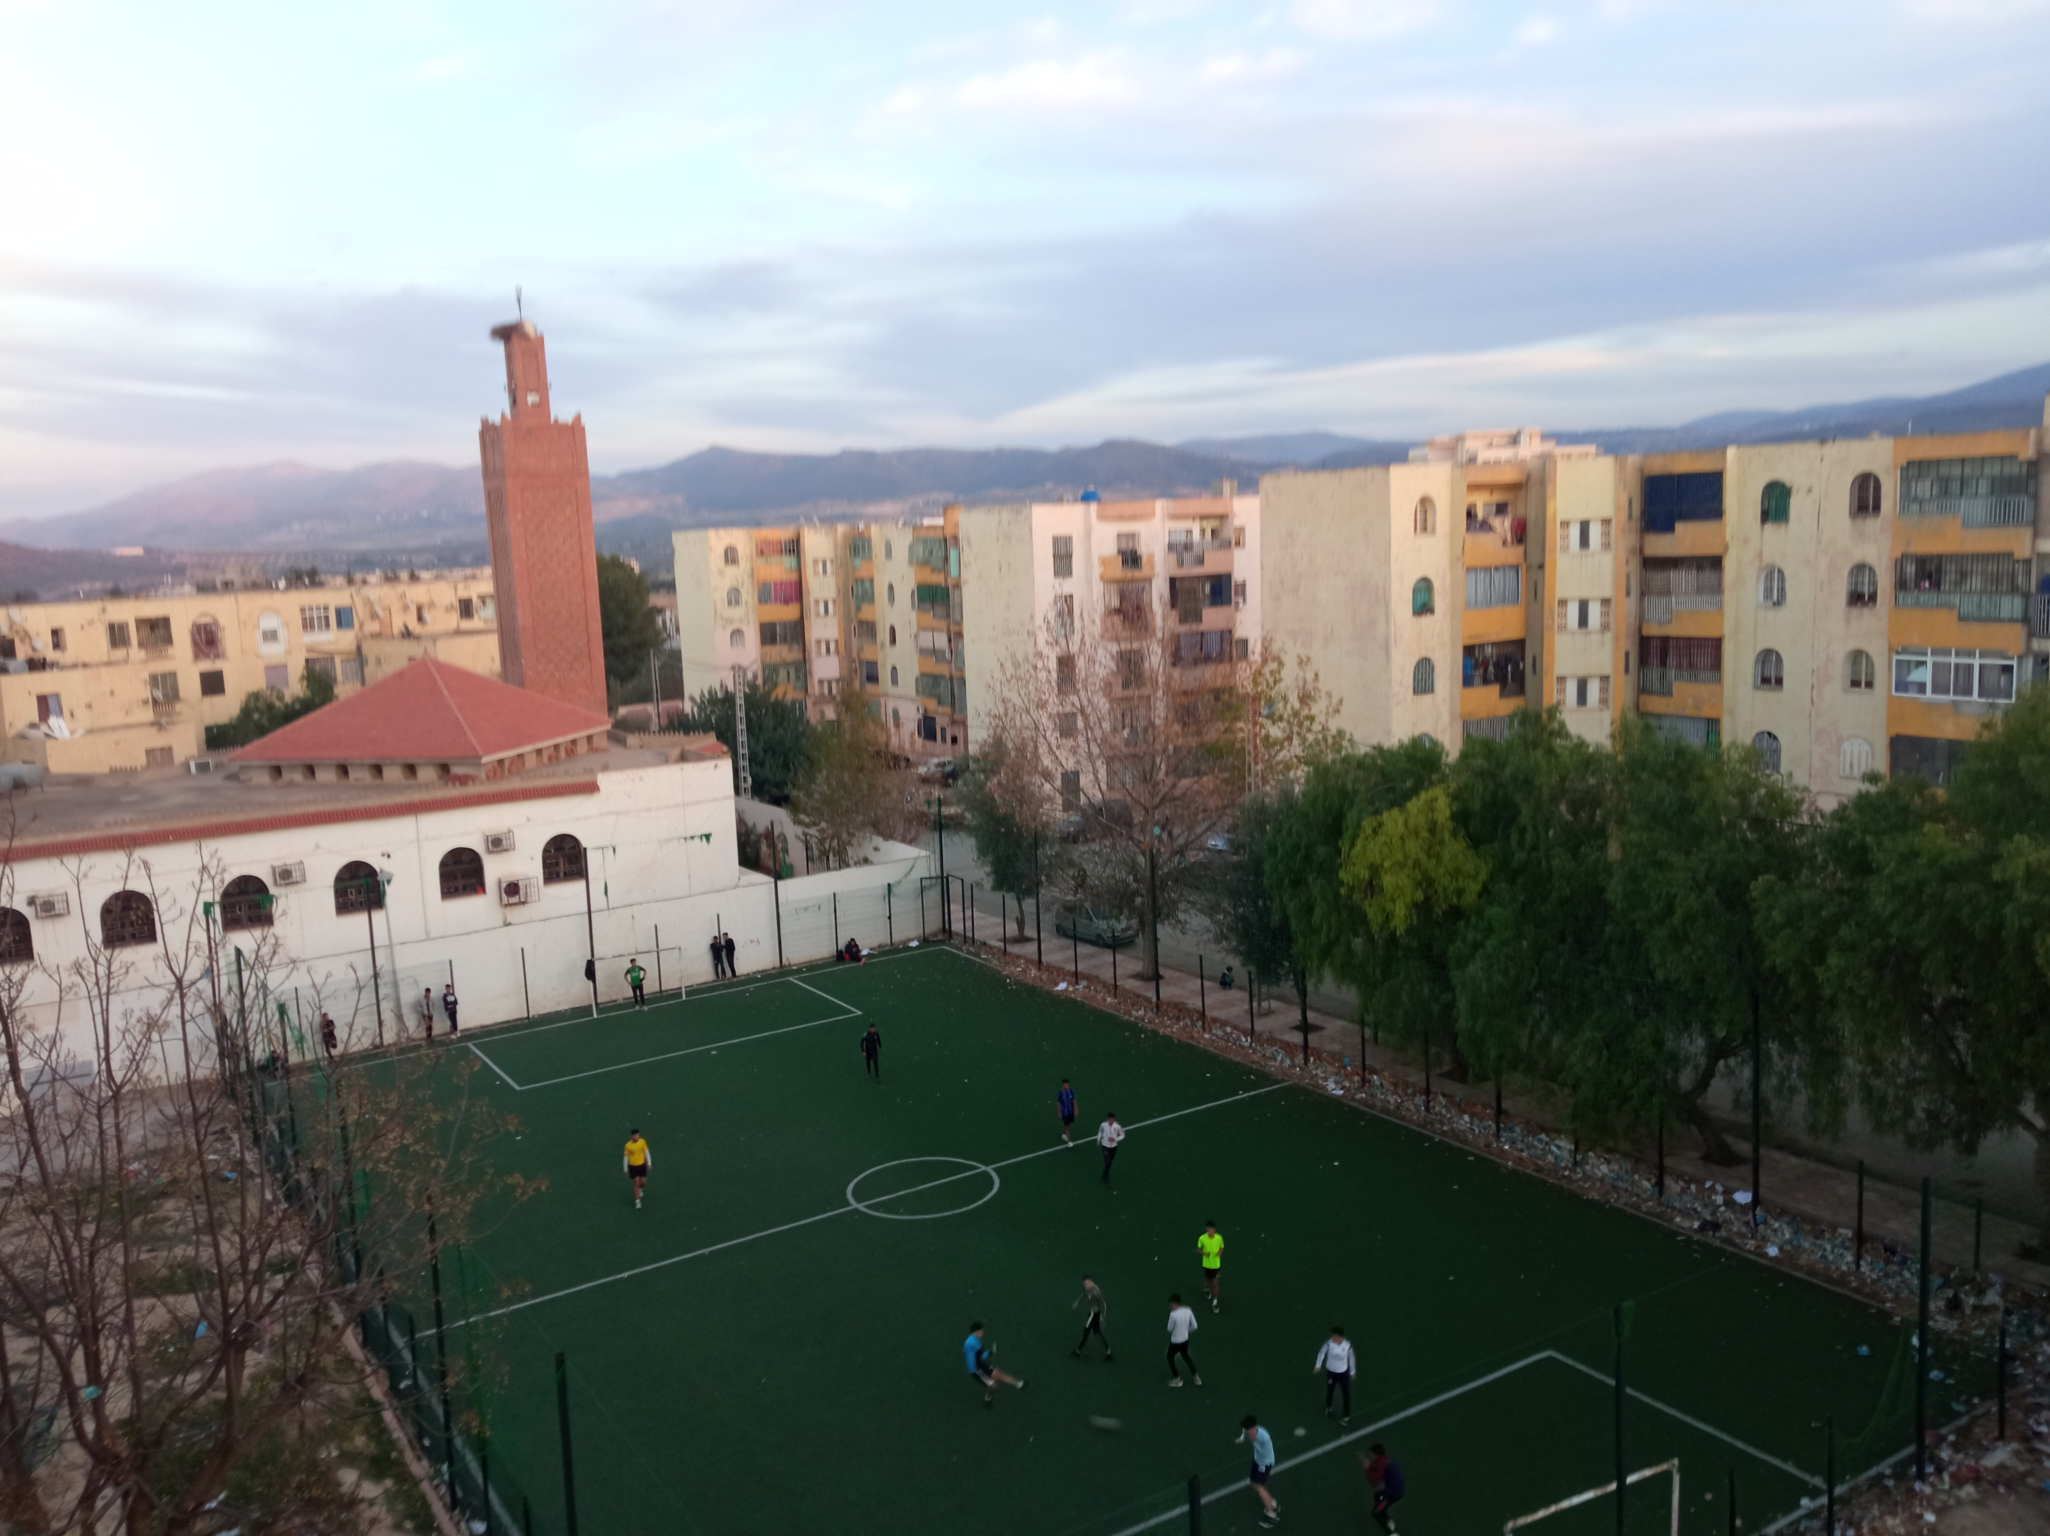
Pic 01
- Purpose: A common complaint of distance or online courses is that learners feel isolated and far away from each others. This activity will allow them to feel physically closer.Moreover, Students will be able to give a full address of the place of their living in English.

