Teacher’s Name: .Souad HAMIDI
Level: .LMD2
Module: ASCC
Course Number: 5
Course Title: The American Government
In 1776, the thirteen colonies were united and became free from their mother country Britain. They wanted to be self-governed, i. e, to govern themselves by themselves.
The Constitution and the Bill of Rights
The 13 colonies are now known as the United States of America.” The Bill of Rights” contains the basic fundamental rights. Delegates from the states met in 1787 to revise the articles of the Confederation which represent the core of the Constitution and which the delegates gradually found insufficient. Moreover, the government was weak in terms of powers of defense, trade and taxation. The purpose of this meeting was not to write the Constitution but to to revise the articles.
The Constitution: is the system of laws and basic principles that USA is governed by. The system of government is composed of three separate branches; each of which has powers over the two others. This system is called “Checks and Balances”
The Separation of powers is a system of government developed by the French political philosopher C. Montesquieu in 1748 by which power is divided among three branches: the legislative, the the executive and the judicial.
The Legislative Branch | The Executive Branch | The Judicial Branch
*Can impeach judges.  *Approves judges. | *Appoints federal judges | *Can declare laws unconstitutional.
*Can override veto.  *Can impeach president | *Can veto legislation.  *Can call Congress back. | * Can declare executive actions unconstitutional.

The power the Supreme Court to declare laws and actions unconstitutional is called the power of judicial review. This power is not in the Constitution itself, but was established in a famous legal case in 1803 called Marbury vs. Madison.
The US Constitution is dynamic, i. e, each time there are new amendments depending on the the changing needs of the nation. It is the Supreme law in the land that guides all governmental groups (Federal, State and Local), they must work within the guidelines of the Constitution.
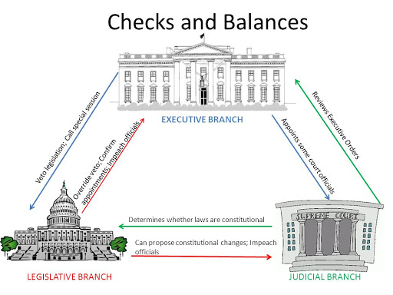
The complete power under the Constitution belongs to “We the People” in fact and in spirit. It is not given neither to the executive branch (the President), nor the legislative branch (Congress), or the Judicial branch (Court)
The Bill of Rights
The first ten amendments to the US Constitution guaranteeing specific rights and liberties and that was ratified in 1791. They are regarded as the fundamental rights of Any American citizen.
The First ten amendments to the US Constitution
- Freedom of religion, speech, press, assembly, and petition.
- Right to keep and bear arms in order to maintain a well-regulated militia.
- No quartering of soldiers.
- Freedom from unreasonable searches and seizures.
- Right to due process of law, freedom from self-incrimination
- Rights of accused persons, e.g., right to a speedy and public trial.
- Right to trial by jury in civil cases.
- Freedom from excessive bail, cruel and unusual punishment.
- Other rights of the people.
- Powers reserved to the states.
The American System of Government
The system of government in the United States is divided into three types; federal, state, country or local.
There is a big complexity of cities’ political and government structure.
Federal: federal government is the dominant actor, from sea to shining sea, i. e, from the Pacific to the Atlantic.
State: 52. All 50 of them, in addition to the District of Columbia and in some regions Puerto Rico each state has its own mayor or governor
Local and their number is 3600; there is another subdivision of states into localities, towns, cities and townships. For example, Massachusetts has 351. There exist 19,400 cities and 16,500 towns throughout the nation

Sources
www.eduplace.com
trumanlibrary.gov/education/three-branches/three-branches-of-government

