TEXT 2 Energy Sources
Pre_read
- Is your home heated in winter and, if so, how? How is your food cooked?
- Which kinds of fuel are used in your country to make electricity for industry and the home?
- Are there any problems or difficulties in getting enough energy or paying for it?
- Do you think the situation will have changed much in a hundred years’ time and, if so, why?

Text
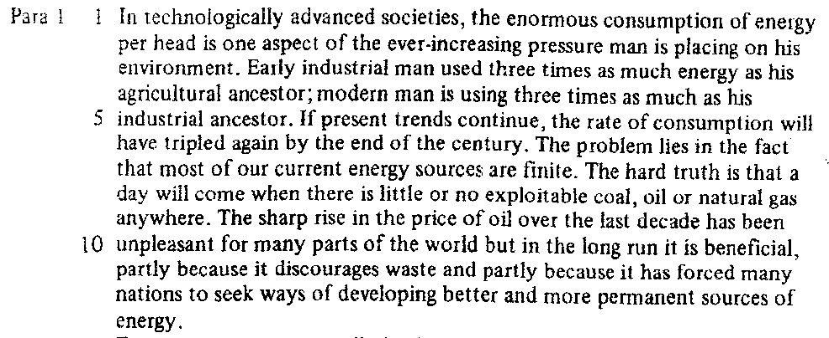

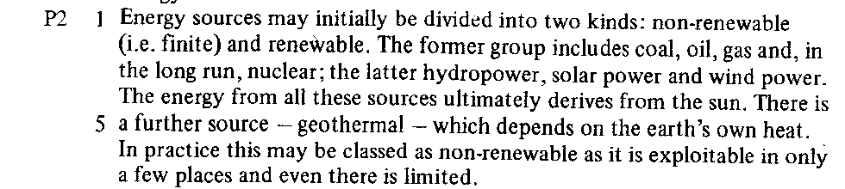
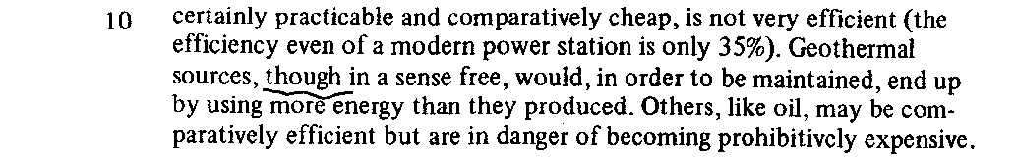
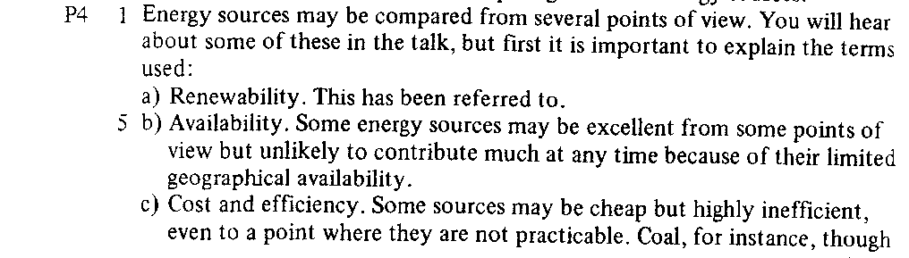
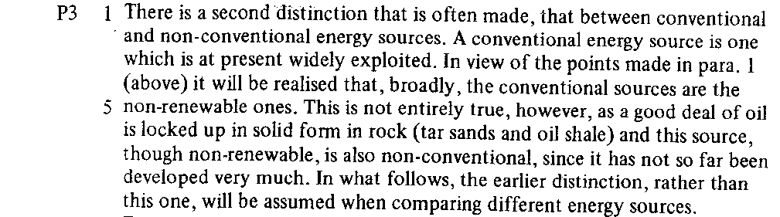

TEXT Study 2

- Content skim :

- Look at the title of the unit and the first sentence of each paragraph. What is the topic of the passage? …………………………………………………………………………..................………………………..................……
…………………………………………………………………………………………………………………………………………………………
- How does it deal with this topic? ………………………………………………………………………….............................
…………………………………………………………………………………………………………………………………………………………
- What is the main division between different kinds? ………………………………………………………………………….
……………………………………………………………………………………………………………………………………………….…………
- How many ways of comparing sources are given? ……………………………………………………………………………
……………………………………………………………………………………………………………………………………………….…………
What is the topic of each paragraph?
Para 1
Para 2
Para 3
Para 4

- Comprehension Scan
Para 1 Line 5 | What are these “trends” ?
Para 1 Line 6 | What is the “problem” ?
Para 1 Line 11 | What “discourages waste ” ?
Para 1 Line 12 | “better and more permanent” than what ?
Para 2 Line 3 | What does “the latter” refer to ?
Para 2 Line 4 | Which sources are included in “all” ?
Para 2 Line 7 | Which word(s) could you add between “there” and “limited” ?
Para 3 Line 1 | What was the first distinction ?
Para 3 Line 3 | What were “the points” made in the first paragraph ?
Para 3 Line 6 | What does “this” refer to ?
Para 3 Line 8 | What is the earlier distinction and what is this one

- Classifying and comparing
Using the grid below, list vertically in the left-hand column all sources of energy mentioned in the text. Then, from information given so far, place à tick (V) in the appropriate box if an energy source has the feature noted at the head of the column. Mark with a cross (X) if it does not. If the information is not provided, leave the box empty.

 | renewable | available | low cost | efficient | non-polluting
- rivers
- seas

