TEXT 1 Earthquakes
Pre_read
- Have you ever experienced an earthquake or seen an active volcano?
- Do you know why such events occur?
- Is the earth really just a very large ball of hard rock?
- If you drilled a hole in the ground and went on drilling deeper and deeper, what would you find?

Text
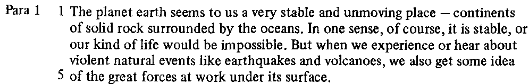
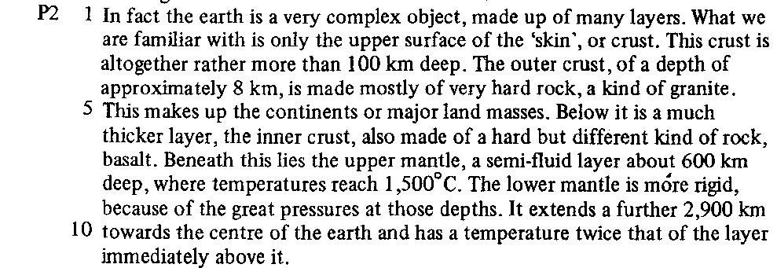
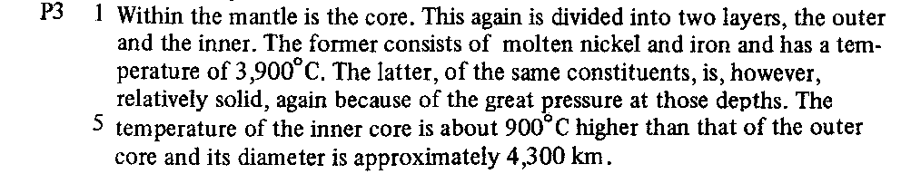

TEXT Study 1

- Content skim :

What is the topic of the passage? …………………………………………………………………………..................
……………………………………………………………………………………………………………………………………………….
What does it list in detail? ………………………………………………………………………….............................
……………………………………………………………………………………………………………………………………………….
How many of these does it mention? …………………………………………………………………………............
……………………………………………………………………………………………………………………………………………….

What is the topic of each paragraph?
Para 1
Para 2
Para 3

- Comprehension Scan
Para 1 Line 2 | What does “it” refer to?
Para 1 Line 5 | What does “its” refer to
Para 2 Line 5 | What does “ This ” refer to
Para 2 Line 5 | What does “it” refer to
Para 2 Line 7 | What does “this” refer to
Para 2 Line 8 | “more rigid” than what
Para 2 Line 10 | What temperature
Para 2 Line 11 | What does “it” refer to
Para 3 Line 1 |  | What do “This” refer to
Para 3 Line 2 |  | What does “the former” refer to
Para 3 Line 2 |  | What layer consists of “molten nickel and iron”
Para 3 Line 3 |  | What does “the latter” refer to
Para 3 Line 3 |  | “relatively solid” than what
Para 3 Line 6 |  | What does “its” refer to

- Identifying and describing
Label the diagram and complete the table below it.
1 ……………………………………………………
2 ……………………………………………………..
3 ……………………………………………………..
4 …………………………………………………….
5 ……………………………………………………
6 …………………………………………………….

Layer | Contituents/Consistency | Temperature | Depth
1
2
3
4
5
6

