TEXT 3 The Whale
Reading
- Does your country border on a sea or ocean where whales can be found?
- What do whales look like and which group of living things do they belong to?
- Are whales killed because, like many sharks, they are dangerous? Do people get eaten by whales?
- Have you ever used or eaten anything that comes from the whale?
- What difference would it make if all the whales disappeared or if men stopped catching them?

Text
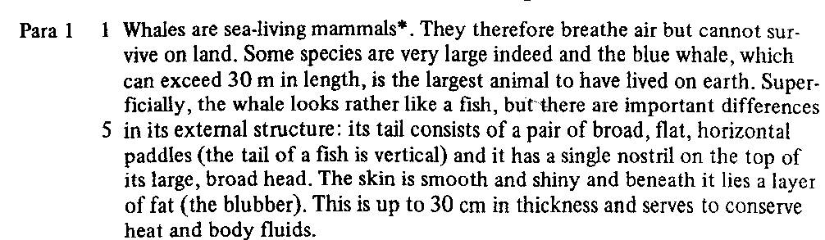
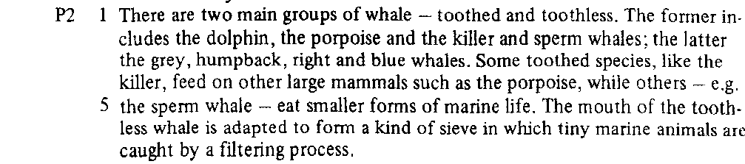
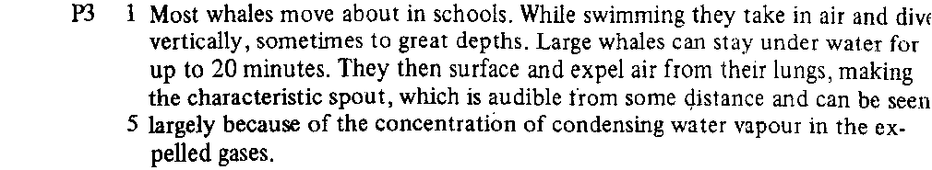
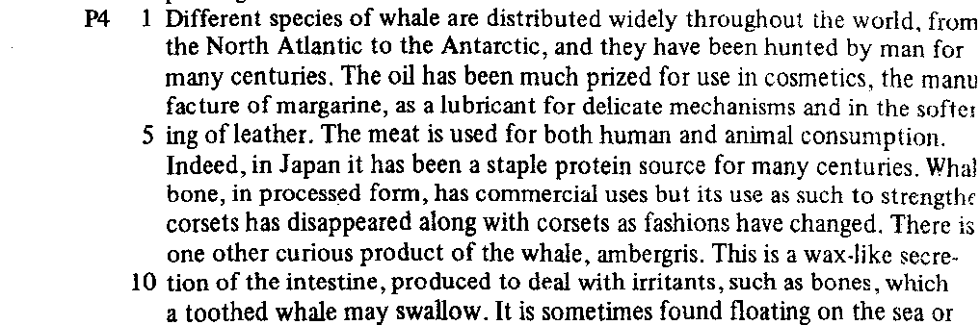
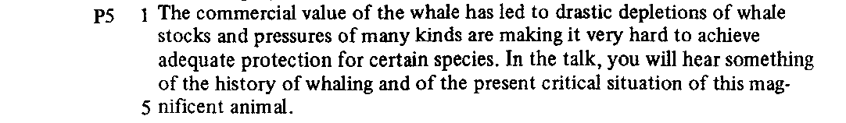
TEXT Study 3
- Content skim :
- What, in general, is the passage about? …………………………………………………………………………..................………………………..................…………………..
…………………………………………………………………………………………………………………………………………………………
- Read the first sentence of each paragraph and decide on the probable topic of each?

Para. 1 | . . . . . . . . . . . . . . . . . . . . . . . . . . . . . . . . . . . . . . . . . . . . . . . . . . . . . . . . . . . . . . . . . .
Para. 2 | . . . . . . . . . . . . . . . . . . . . . . . . . . . . . . . . . . . . . . . . . . . . . . . . . . . . . . . . . . . . . . . . . .
Para. 3 | . . . . . . . . . . . . . . . . . . . . . . . . . . . . . . . . . . . . . . . . . . . . . . . . . . . . . . . . . . . . . . . . . .
Para. 4 | . . . . . . . . . . . . . . . . . . . . . . . . . . . . . . . . . . . . . . . . . . . . . . . . . . . . . . . . . . . . . . . . . .
Para. 5 | . . . . . . . . . . . . . . . . . . . . . . . . . . . . . . . . . . . . . . . . . . . . . . . . . . . . . . . . . . . . . . . . . .

- Comprehension Scan

Para. 1 Line 1 | What do “They” refer to | . . . . . . . . . . . . . . . . . . . . . . . . . . . . . . . . . . . . . . . . . . . .
Para. 1 Line 2 | What does “which” refer to | . . . . . . . . . . . . . . . . . . . . . . . . . . . . . . . . . . . . . . . . . . . .
Para. 1 Line 5 | What does “its” refer to | . . . . . . . . . . . . . . . . . . . . . . . . . . . . . . . . . . . . . . . . . . . .
Para. 1 Line 7 | What does “its” refer to | . . . . . . . . . . . . . . . . . . . . . . . . . . . . . . . . . . . . . . . . . . . .
Para. 1 Line 7 | What does “it” refer to | . . . . . . . . . . . . . . . . . . . . . . . . . . . . . . . . . . . . . . . . . . . .
Para. 1 Line 8 | What does “This” refer to | . . . . . . . . . . . . . . . . . . . . . . . . . . . . . . . . . . . . . . . . . . . .

Para. 2 Line 1 | What does “the former” refer to | . . . . . . . . . . . . . . . . . . . . . . . . . . . . . . . . . . . . . . . . . . . .
Para. 2 Line 2 | What does “the latter” refer to | . . . . . . . . . . . . . . . . . . . . . . . . . . . . . . . . . . . . . . . . . . . .
Para. 2 Line 6 | What does “which” refer to | . . . . . . . . . . . . . . . . . . . . . . . . . . . . . . . . . . . . . . . . . . . .

Para. 3 Line 1 | What do “they” refer to | . . . . . . . . . . . . . . . . . . . . . . . . . . . . . . . . . . . . . . . . . . . .
Para 3 Line 3 | What do “They” refer to | . . . . . . . . . . . . . . . . . . . . . . . . . . . . . . . . . . . . . . . . . . . .
Para. 3 Line 4 | What does “which” refer to | . . . . . . . . . . . . . . . . . . . . . . . . . . . . . . . . . . . . . . . . . . . .

- Guided note-making
When you are satisfied that you understand the passage, complete the following notes :
Whales
- Family: . . . . . . . .. . . . . . . . . . . . . . . . . . . . . . . . . . . . . . . . . . . . . . . . . . . . . . . . .

- Visible characts:

  - . . . . . . . . . . . . . . . . . . . . . . . . . . . . . . . . . . . . . . . . . . . . . . . . . . . . . . .

  - . . . . . . . . . . . . . . . . . . . . . . . . . . . . . . . . . . . . . . . . . . . . . . . . . . . . . . .

  - . . . . . . . . . . . . . . . . . . . . . . . . . . . . . . . . . . . . . . . . . . . . . . . . . . . . . . .

  - . . . . . . . . . . . . . . . . . . . . . . . . . . . . . . . . . . . . . . . . . . . . . . . . . . . . . . .

- Main divs:
- . . . . . . . . . . . . . . . . . . . . . .
e.g. . . . . . . . . . . . . . . . . . . . . . . . . . . . . . . . . . . . . . . . . . . . . . . . . . . . . . . . . . . . . . . . . . .
- . . . . . . . . . . . . . . . . . . . . . .
e.g. . . . . . . . . . . . . . . . . . . . . . . . . . . . . . . . . . . . . . . . . . . . . . . . . . . . . . . . . . . . . . . . . . .

- Food:
  - . . . . . . . . . . . . . . . . . . . . . . . . . . . . . . . . . . . . . . . . . . . . . . . . . . . . . . . . . . . . . . . . . . . . . . . . . . . . .

  - . . . . . . . . . . . . . . . . . . . . . . . . . . . . . . . . . . . . . . . . . . . . . . . . . . . . . . . . . . . . . . . . . . . . . . . . . . . . .

- Behab.: . . . . . . . . . . . . . . . . . . . . . . . . . . . . . . . . . . . . . . . . . . . . . . . . . . . . . . . . . . . . . . . . . . . . . . . . . . . . . . . . . . . . . . . . . . . . . . . . . . . . . . . . . . . . . . . . . . . . . . . . . . . . . . . . . . . . . . . . . . . . . . . . . . . . . . . . . . . . . . . . . . . . .

- Distrib.: . . . . . . . . . . . . . . . . . . . . . . . . . . . . . . . . . . . . . . . . . . . . . . . . . . . . . . . . . . . . . . . . . . . . . . . . . . . . . . . . . . . . . . . . . . . . . . . . . . . . . . . . . . . . . . . . . . . . . . . . . . . . . . . . . . . . . . . . . . . . . . . . . . . . . . . . . . . . . . . . . . . . .

- Vocabulary development
Write down up to five words from the text to do with whales. Look these up in a dictionary; note the pronunciation beside each and write a brief note about the meaning.
- . . . . . . . . . . . .
- . . . . . . . . . . . .
- . . . . . . . . . . . .
- . . . . . . . . . . . .

Find the following link words used in the passage (either between sentences or within two ideas in the same sentence): therefore, but, and beneath, while, then, indeed; look these up in a dictionary; note their pronunciation.
Beside each write a brief note about their function within the text and some of their synonyms from the dictionary if there are any.

