TEXT Study 4 : Silicon Chips
Reading
- Do radios look different now compared with 65 year ago? If so, can you think of any reasons for this?
- Why were there no pocket calculators or digital watches 65 years ago?
- Why are wires for conducting electricity covered in plastic?
- If you dropped a piece of clothing onto an electric fire and it started to burn, how would you put it out?
- How do you control electricity in the home?
- Why is it often important to notice the colour of wires when you attach plug to a piece of electrical equipment?

Text
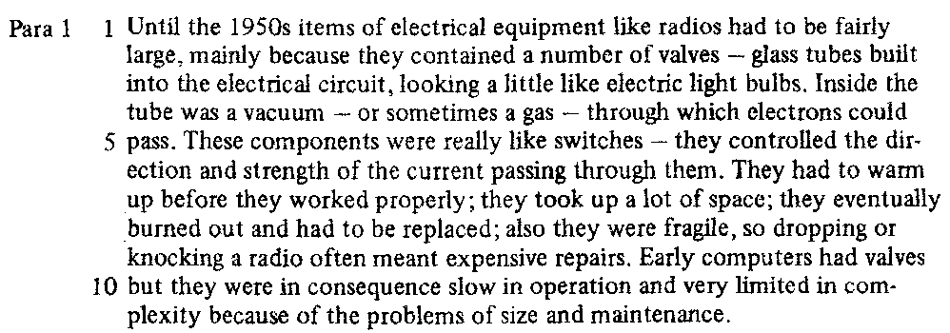
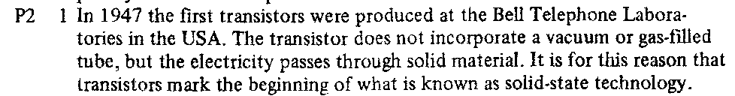
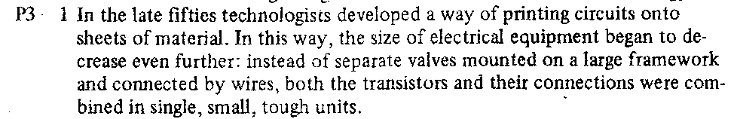

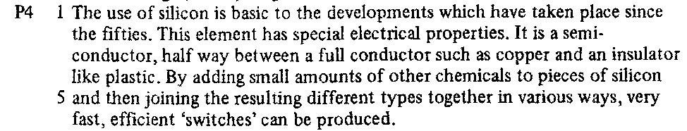
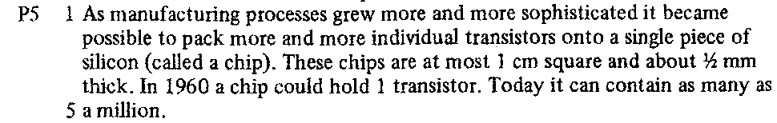
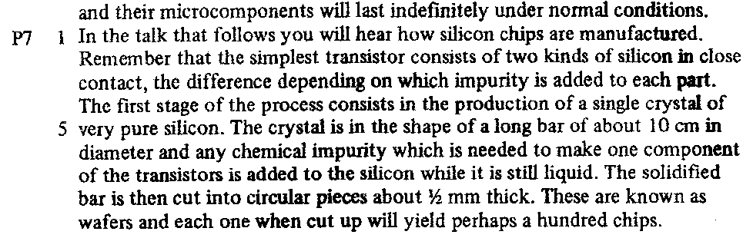
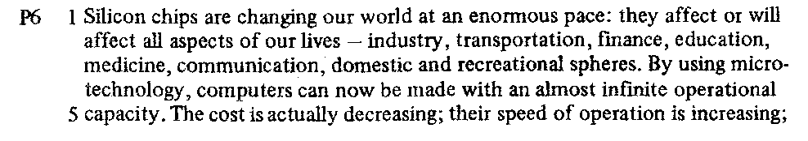

TEXT Study 4
- Content skim :

- Read the first sentence of each paragraph and decide what, in general, is the passage about?
…………………………………………………………………………..................………………………..................…………………..
…………………………………………………………………………………………………………………………………………………………

- What particular development does the passage lead up to?
…………………………………………………………………………..................………………………..................…………………..
…………………………………………………………………………………………………………………………………………………………

- What is the topic of each?

Para. 1 | . . . . . . . . . . . . . . . . . . . . . . . . . . . . . . . . . . . . . . . . . . . . . . . . . . . . . . . . . . . . . . . . . .
Para. 2 | . . . . . . . . . . . . . . . . . . . . . . . . . . . . . . . . . . . . . . . . . . . . . . . . . . . . . . . . . . . . . . . . . .
Para. 3 | . . . . . . . . . . . . . . . . . . . . . . . . . . . . . . . . . . . . . . . . . . . . . . . . . . . . . . . . . . . . . . . . . .
Para. 4 | . . . . . . . . . . . . . . . . . . . . . . . . . . . . . . . . . . . . . . . . . . . . . . . . . . . . . . . . . . . . . . . . . .
Para. 5 | . . . . . . . . . . . . . . . . . . . . . . . . . . . . . . . . . . . . . . . . . . . . . . . . . . . . . . . . . . . . . . . . . .
Para. 6 | . . . . . . . . . . . . . . . . . . . . . . . . . . . . . . . . . . . . . . . . . . . . . . . . . . . . . . . . . . . . . . . . . .
Para. 7 | . . . . . . . . . . . . . . . . . . . . . . . . . . . . . . . . . . . . . . . . . . . . . . . . . . . . . . . . . . . . . . . . . .

- Comprehension Scan
Para 1 Line 5 | Which “components” are referred to
Para 1 Line 7 | What does “they” refer to

Para 2 Line 2 | What does incorporate such a tube
Para 2 Line 3 | “Solid material” rather than what
Para 2 Line 3 | What is the reason referred to

Para 3 Line 4 | Which developments made this possible
Para 3 Line 4 | What does “their” refer to

Para 4 Line 2 | Which element is referred to as “this element”
Para 4 Line 5 | Different types of what?

Para 6 Line 5 | What does “their” refer to
Para 6 Line 6 | What does “their” refer to

Para 7 Line 6 | “Remember” tells that the information has already been given. Site it (where) in the passage
Para 7 Line 6 | What does “which” refer to
Para 7 Line 8 | What does “these” refer to

- Note-making
List five limitations of valve systems. Beside each write any contrasting advantages of solid-state systems mentioned in the text:

- . . . . . . . . . . . . . . . . . . . . . . . . . . . . . . . . . . . . . . . . . . . . . . . . . . . . . . . . . . . . . . . . . .

- . . . . . . . . . . . . . . . . . . . . . . . . . . . . . . . . . . . . . . . . . . . . . . . . . . . . . . . . . . . . . . . . . .

- . . . . . . . . . . . . . . . . . . . . . . . . . . . . . . . . . . . . . . . . . . . . . . . . . . . . . . . . . . . . . . . . . .

- . . . . . . . . . . . . . . . . . . . . . . . . . . . . . . . . . . . . . . . . . . . . . . . . . . . . . . . . . . . . . . . . . .

- . . . . . . . . . . . . . . . . . . . . . . . . . . . . . . . . . . . . . . . . . . . . . . . . . . . . . . . . . . . . . . . . . .

- Identifying

Using information in the final paragraph, label diagrams 1-4. These show the first stages in the production of a silicon chip.


          
          
          
          
          
            
            
            
          

