TEXT Reading/Writing skills

Language summary

Name What's your name? I’m/My name's (Jason Douglas).
Date & Place of Birth When/Where were you born? I was born on July 2nd in London.
Nationality Where are you from?/Where do you come from? I'm British./l come from Britain.
Marital Status Are you married? Yes, I am. /No, I'm not. I'm single.
Address What’s your address?/Where do you live? I live at. . ./My address is (3280 Sunshine Boulevard).
Education Where were you educated?/Where did you go to (school)? I went to. . ./I was educated at Lane End
Secondary School.
Profession What do you do?/What’s your job? I'm an actor. I work in a bank

Information filling:
 | Text 1 | Text 2 | Text 3
Family Name | . . . . . . . . . . . . . . . . . . . . . | . . . . . . . . . . . . . . . . . . . . . | . . . . . . . . . . . . . . . . . . . . .
First Name(s) | . . . . . . . . . . . . . . . . . . . . . | . . . . . . . . . . . . . . . . . . . . . | . . . . . . . . . . . . . . . . . . . . .
Date of Birth | . . . . . . . . . . . . . . . . . . . . . | . . . . . . . . . . . . . . . . . . . . . | . . . . . . . . . . . . . . . . . . . . .
Place of Birth | . . . . . . . . . . . . . . . . . . . . . | . . . . . . . . . . . . . . . . . . . . . | . . . . . . . . . . . . . . . . . . . . .
Nationality | . . . . . . . . . . . . . . . . . . . . . | . . . . . . . . . . . . . . . . . . . . . | . . . . . . . . . . . . . . . . . . . . .
Address | . . . . . . . . . . . . . . . . . . . . .  . . . . . . . . . . . . . . . . . . . . .  . . . . . . . . . . . . . . . . . . . . . | . . . . . . . . . . . . . . . . . . . . .  . . . . . . . . . . . . . . . . . . . . .  . . . . . . . . . . . . . . . . . . . . . | . . . . . . . . . . . . . . . . . . . . .  . . . . . . . . . . . . . . . . . . . . .  . . . . . . . . . . . . . . . . . . . . .
Education | . . . . . . . . . . . . . . . . . . . . .  . . . . . . . . . . . . . . . . . . . . . | . . . . . . . . . . . . . . . . . . . . .  . . . . . . . . . . . . . . . . . . . . . | . . . . . . . . . . . . . . . . . . . . .  . . . . . . . . . . . . . . . . . . . . .
Profession | . . . . . . . . . . . . . . . . . . . . . | . . . . . . . . . . . . . . . . . . . . . | . . . . . . . . . . . . . . . . . . . . .
Marital Status | . . . . . . . . . . . . . . . . . . . . . | . . . . . . . . . . . . . . . . . . . . . | . . . . . . . . . . . . . . . . . . . . .

Read the following three texts and complete the forms above.
Text 1 Person autobiography
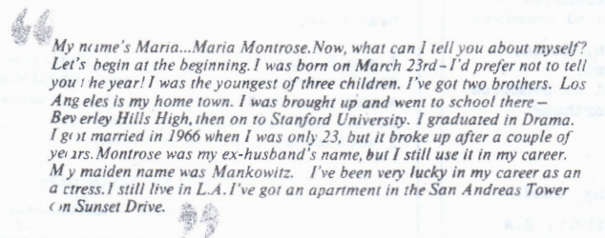
Text 2 Person autobiography
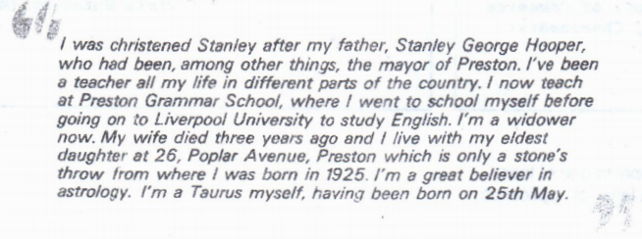
Text 3 Article from Edinburgh Evening News newspaper
