TEXT Writing skills - official letters
Writing Business Letters
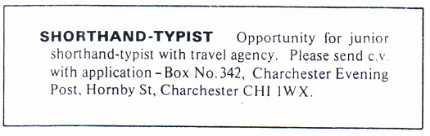
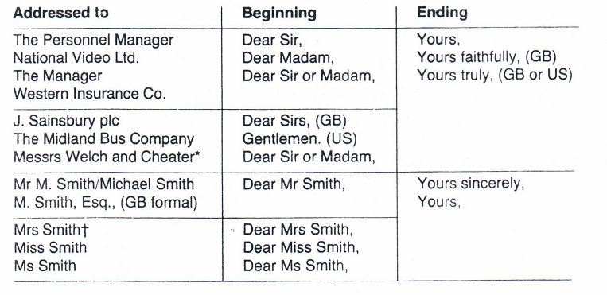
Job advertisements may ask you for a ‘c.v.’ or ‘curriculum vitae'. Look at the advertisement, the curriculum vitae and the letter of application
