Université Abou BekrBelkaïd –Tlemcen-
Faculté des Sciences de la Nature et de la Vie et
des Sciences, de la Terre et de l’Univers
Département de Biologie
Module : Anglais et Communication Scientifique
Master 2 Microbiologie Et Contrôle De Qualité

TEST Pré-requis

Exercise1

Fill in the missing words:
- Keywords: substance, neutralization, antigen, immune.
An -----------is any foreign ----------capable of being recognized by a subject's immune system as "non-self". and capable of triggering an --------------reaction in this subject, which results in the ----------------of this substance.

b) Keywords: actions, receptor, epitope
Following the introduction of such a substance into the body, its -----------is recognized by the membrane -------------of certain cells, which will induce a certain number of-------------.

c) Keywords: macrophage, Th lymphocytes, phagocytosed

At the center of these actions are----------------, also called CD4+ after the name of a glycoprotein in their membrane. Their TCR or T Cell Receptor recognizes the foreign element, which can be presented to it by a CPA or Antigen Presenting Cell: it is a -----------------which had --------------the foreign element, and which has on its membrane fragments of this foreign element.

d) Keywords: immunoglobulin, B lymphocyte
Multiplication and differentiation of B lymphocytes:
A -----------------having recognized the foreign element will undergo clonal multiplication then differentiate into a plasma cell which synthesizes and secretes an antibody, a soluble protein also called--------------, capable of combining specifically with the substance which triggered its production.

Exercise2
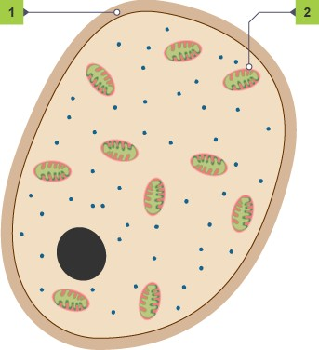
- The diagram below shows a cell. Which of the following is correct?

a) The cell is a bacterial cell, structure 1 is the cell wall and structure 2 is a mitochondrion

b)The cell is a fungal cell, structure 1 is the cell wall and structure 2 is a mitochondrion

c)The cell is a plant cell, structure 1 is the cell wall and structure 2 is a chloroplasts

Exercise3

Fill in the gaps in the paragraph on vaccination using words from the list below.
A vaccination is a way of protecting people against ……… . Vaccinations work by stimulating the ……… system to produce antibodies. Vaccines contain ……… from a pathogen. This antigen is usually a very small quantity of dead, weak or ……… modified pathogen. The vaccine is injected into the body. The injection stimulates white blood cells called ……… to produce the correct antibodies. These antibodies remove the antigen from the body after a few days. ……… lymphocytes remember the antigen. If the real pathogen gets into the body, memory cells create even more antibodies and the ……… is rapidly removed.

lymphocytes disease memory immune antigen pathogen genetically

