-Welding defects :
There are several types of welding defects, including porosities, cracks, inclusions, incomplete welds, distorted welds, overthickness, misaligned welds, poorly cleaned welds, and poorly penetrated welds.

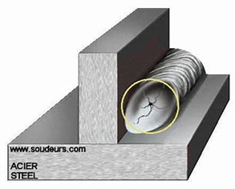
- The cracks :
Are one of the most common welding defects. Cracks can occur
- when the base metal is not heated to the appropriate temperature.
- when the base metal is too thin
- when the weld bead is too Small.
- when the welders did not use the correct welding technique.
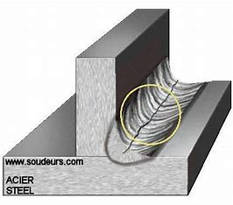
2- the inclusion :
It's a common welding defect that occurs when impurities such as rust, dirt, oil or unmolten metal become trapped in the weld bead. Inclusions can weaken the weld.

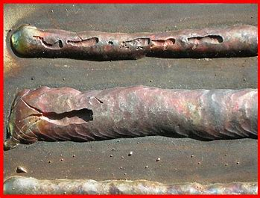
- Incomplete welds :
It's a common welding defect that occurs when the weld bead does not penetrate sufficiently into the base metal. Incomplete welds can weaken the weld and reduce its strength.
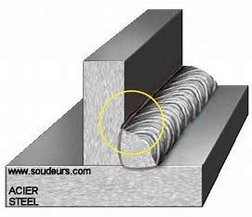
4- Deformed welds :
It's a common welding defect that this produces when the welding is subjected to exessive thermal or mechanical constrained. Deformed weldes that can cause problemes such as cracks…….

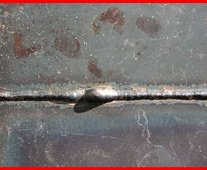

- The overthicness :
It is a commen welding defect that occurs when the welding process is thincker than necessary.
Overthinckness can cause problems such as finishing stesses.
- Malalaigned weldes :
This is a current welding defect that accurs when the parts to be welded are not properly alined. Malalained
welds can cause problems such as cracks reduced resistance.

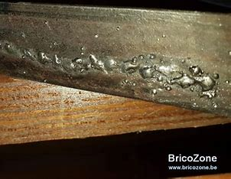

- Poorly cleaned welds :
It is a commen welding defect that occurs when the welding area is not properly cleaned before welding. Unclaned welds could cause problems such as those included.

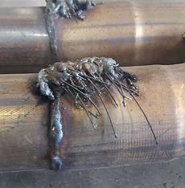

- The poorly penetrated welds :
It is a commen welding defect accurs when the welder cord does not penetate deep enough into the welding part. Poorly penterated welds can cause problems such as poor welding quality.

